UNITED STATES
SECURITIES AND EXCHANGE COMMISSION
Washington, D.C. 20549
______________________
FORM 8-K
CURRENT REPORT
Pursuant to Section 13 OR 15(d) of The
Securities Exchange Act of 1934
Date of Report (Date of earliest event reported): May 8, 2023
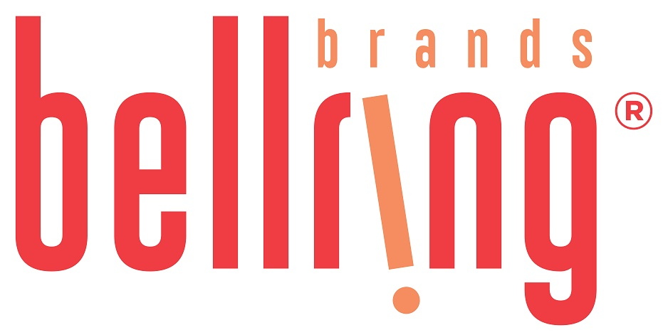
BellRing Brands, Inc.
(Exact name of registrant as specified in its charter)
Delaware |  |  | 001-39093 |  |  |  |  |  | 87-3296749
(State or other jurisdiction of incorporation) |  |  | (Commission File Number) |  |  |  |  |  | (IRS Employer Identification No.)
2503 S. Hanley Road |  |  | St. Louis |  |  | Missouri |  |  | 63144
(Address of Principal Executive Offices) |  |  |  |  |  |  |  |  | (Zip Code)
Registrant’s telephone number, including area code: (314) 644-7600
Check the appropriate box below if the Form 8-K filing is intended to simultaneously satisfy the filing obligation of the registrant under any of the following provisions:
☐ Written communications pursuant to Rule 425 under the Securities Act (17 CFR 230.425)
☐ Soliciting material pursuant to Rule 14a-12 under the Exchange Act (17 CFR 240.14a-12)
☐ Pre-commencement communications pursuant to Rule 14d-2(b) under the Exchange Act (17 CFR 240.14d-2(b))
☐ Pre-commencement communications pursuant to Rule 13e-4(c) under the Exchange Act (17 CFR 240.13e-4(c))
Securities registered pursuant to Section 12(b) of the Act:
Title of each class |  |  | Trading Symbol(s) |  |  | Name of each exchange on which registered
Common Stock, $0.01 par value per share |  |  | BRBR |  |  | New York Stock Exchange
Indicate by check mark whether the registrant is an emerging growth company as defined in Rule 405 of the Securities Act of 1933 (§230.405 of this chapter) or Rule 12b-2 of the Securities Exchange Act of 1934 (§240.12b-2 of this chapter).
Emerging growth company ☐
If an emerging growth company, indicate by check mark if the registrant has elected not to use the extended transition period for complying with any new or revised financial accounting standards provided pursuant to Section 13(a) of the Exchange Act.☐

Item 2.02. Results of Operation and Financial Condition.

On May 8, 2023, BellRing Brands, Inc. (the "Company") issued a press release announcing results for its second fiscal quarter ended March 31, 2023. A copy of the press release is attached hereto as Exhibit 99.1 and incorporated herein by reference.

In addition, on May 8, 2023, the Company published to the "Investor Relations" section of its website, www.bellringbrands.com, a supplemental presentation related to results for its second fiscal quarter ended March 31, 2023. A copy of the presentation is attached hereto as Exhibit 99.2 and incorporated herein by reference.

The information contained in Item 2.02, including Exhibit 99.1 and Exhibit 99.2 attached hereto, shall not be deemed to be "filed" for purposes of Section 18 of the Securities Exchange Act of 1934, as amended (the "Exchange Act"), or otherwise subject to the liabilities of that Section, nor shall they be deemed incorporated by reference into any filings under the Securities Act of 1933, as amended, or the Exchange Act, except as expressly set forth by specific reference in such filing.

Item 9.01. Financial Statements and Exhibits.

(d) Exhibits

Exhibit No. |  |  | Description
99.1 |  |  | Press Release dated May 8, 2023
99.2 |  |  | Second Fiscal Quarter Ended March 31, 2023 Supplemental Presentation
104 |  |  | Cover Page Interactive Data File (the cover page iXBRL tags are embedded within the Inline XBRL document)

Pursuant to the requirements of the Securities Exchange Act of 1934, the registrant has duly caused this report to be signed on its behalf by the undersigned thereunto duly authorized.

Date: May 8, 2023 |  |  | BellRing Brands, Inc.
 |  |  | (Registrant)
 |  |  | By: |  |  | /s/ Paul A. Rode
 |  |  | Name: |  |  | Paul A. Rode
 |  |  | Title: |  |  | Chief Financial Officer

Exhibit 99.1

BellRing Brands Reports Results for the Second Quarter of Fiscal Year 2023; Raises Fiscal Year 2023 Outlook
St. Louis - May 8, 2023 - BellRing Brands, Inc. (NYSE:BRBR) (“BellRing”), a holding company operating in the global convenient nutrition category, today reported results for the second fiscal quarter ended March 31, 2023.
Highlights:
•Second quarter net sales of $385.6 million
•Operating profit of $58.0 million; net earnings available to common stockholders of $30.9 million and Adjusted EBITDA* of $68.0 million
•Raised fiscal year 2023 net sales guidance to $1.61-$1.66 billion and Adjusted EBITDA* guidance to $320-$335 million
*Adjusted EBITDA is a non-GAAP measure. For additional information regarding non-GAAP measures, see the related explanations presented under “Use of Non-GAAP Measures” later in this release. BellRing provides Adjusted EBITDA guidance only on a non-GAAP basis and does not provide a reconciliation of its forward-looking Adjusted EBITDA non-GAAP guidance measure to the most directly comparable GAAP measure due to the inherent difficulty in forecasting and quantifying certain amounts that are necessary for such reconciliation, including the adjustments described under “Outlook” later in this release.
“We delivered a strong performance this quarter, coming in ahead of our expectations. Premier Protein and Dymatize saw robust consumption growth, with both gaining share. Encouragingly, both brands gained new households with increased brand investment and continued category tailwinds. Our powder products were remarkably strong this quarter, aided by brand building investments,” said Darcy H. Davenport, President and Chief Executive Officer of BellRing. “Our shake capacity expansions remain on track, enabling significant future growth. Our momentum in the first half gives us greater confidence to deliver our second half expectations and drives our decision to raise our full year outlook.”
Dollar consumption of Premier Protein ready-to-drink (“RTD”) shakes and Dymatize United States (“U.S.”) powder products increased 21.9% and 38.3%, respectively, in the 13-week period ended April 2, 2023, as compared to the same period in 2022 (inclusive of IRI Multi Outlet including Convenience and management estimates of untracked channels).
Second Quarter Operating Results
Net sales were $385.6 million, an increase of 22.3%, or $70.4 million, compared to the prior year period, driven by 17.8% improvement in price/mix and 4.5% increase in volume.
Premier Protein net sales increased 26.2%, driven by 20.0% improvement in price/mix and 6.2% increase in volume. Premier Protein RTD shake net sales increased 22.5%, driven by 17.3% improvement in price and 5.2% increase in volume. Net sales benefited from higher average net selling prices driven by price increases to offset significant cost inflation. Higher RTD shake production, along with RTD category growth, drove underlying net sales growth.
Dymatize net sales increased 10.5%, driven by 11.9% improvement in price/mix, which was partially offset by 1.4% decrease in volume. Net sales benefited from higher average net selling prices (driven by price increases to offset significant cost inflation), which was partially offset by increased promotional spending. Volume contraction was driven by declines from lapping discontinued products, which was partially offset by organic growth and promotional activities.
Gross profit was $117.1 million, or 30.4% of net sales, an increase of 34.6%, or $30.1 million, compared to $87.0 million, or 27.6% of net sales, in the prior year period. The higher gross profit margin was driven by improved pricing that offset significant cost inflation and lapping logistics inefficiencies in the prior year period (resulting from capacity constraints).
Selling, general and administrative (“SG&A”) expenses were $54.3 million, or 14.1% of net sales, an increase of $5.4 million compared to $48.9 million, or 15.5% of net sales, in the prior year period. SG&A expenses included $0.4 million and $10.3 million in the second quarter of 2023 and 2022, respectively, of costs incurred in connection with BellRing’s separation from Post Holdings, Inc. (“Post”), which were treated as adjustments for non-GAAP measures. SG&A expenses in the second
1
quarter of 2023 included higher marketing and consumer advertising expenses of $7.4 million and higher employee expenses and professional fees.
Operating profit was $58.0 million, an increase of 74.7%, or $24.8 million, compared to $33.2 million in the prior year period.
Net earnings available to common stockholders were $30.9 million, an increase of 2,276.9%, or $29.6 million, compared to $1.3 million in the prior year period. Net earnings available to common stockholders in the prior year period included loss on extinguishment of debt, net of $17.6 million, which is discussed later in this release and was treated as an adjustment for non-GAAP measures, and excluded $2.6 million of net earnings attributable to the Company’s redeemable noncontrolling interest (the “NCI”). Net earnings per diluted share of common stock were $0.23, compared to $0.02 in the prior year period. Adjusted net earnings available to common stockholders* were $31.9 million, or $0.24 per diluted share of common stock*, compared to $14.5 million, or $0.23 per diluted share of common stock*, in the prior year period. Diluted weighted-average shares of common stock outstanding were 134.5 million, compared to 62.9 million in the prior year period, with the increase driven by the Spin-off (see definition below).
Adjusted EBITDA* was $68.0 million, an increase of 33.6%, or $17.1 million, compared to $50.9 million in the prior year period. Adjusted EBITDA in the prior year period included an adjustment for the portion of BellRing Brands, LLC’s (“BellRing LLC”) consolidated net earnings which was allocated to the NCI in the period prior to Post’s distribution to its shareholders of 80.1% of Post’s interest in BellRing (the “Distribution” and, together with the transactions related thereto, the “Spin-off”), resulting in the calculation of Adjusted EBITDA including 100% of BellRing.
*Adjusted net earnings available to common stockholders, Adjusted diluted earnings per share of common stock and Adjusted EBITDA are non-GAAP measures. For additional information regarding non-GAAP measures, see the related explanations presented under “Use of Non-GAAP Measures” later in this release.
Six Month Operating Results
Net sales were $748.3 million, an increase of 20.4%, or $126.6 million, compared to the prior year period driven by 16.7% improvement in price/mix and 3.7% increase in volume. Premier Protein net sales increased 24.5%, driven by 19.0% improvement in price and 5.5% increase in volume. Dymatize net sales increased 6.9%, driven by 16.5% improvement in price/mix, which was partially offset by 9.6% decrease in volume.
Gross profit was $238.9 million, or 31.9% of net sales, an increase of 33.2%, or $59.6 million, compared to $179.3 million, or 28.8% of net sales, in the prior year period. The higher gross profit margin was driven by improved pricing that offset significant cost inflation, lapping logistics inefficiencies in the prior year period (resulting from capacity constraints) and higher production attainment fees received in the current year period from shake contract manufacturers.
SG&A expenses were $96.0 million, or 12.8% of net sales, an increase of $10.3 million compared to $85.7 million, or 13.8% of net sales, in the prior year period. SG&A expenses included $0.7 million and $12.3 million in the six months ended March 31, 2023 and 2022, respectively, of costs incurred in connection with BellRing’s separation from Post, which were treated as adjustments for non-GAAP measures. SG&A expenses in the six months ended March 31, 2023 included higher marketing and consumer advertising expenses of $8.4 million and higher employee expenses and professional fees.
Net earnings available to common stockholders were $75.1 million, an increase of 690.5%, or $65.6 million, compared to $9.5 million in the prior year period. Net earnings available to common stockholders in the prior year period included loss on extinguishment of debt, net of $17.6 million, which is discussed later in this release and was treated as an adjustment for non-GAAP measures, and excluded $33.7 million of net earnings attributable to the NCI. Net earnings per diluted share of common stock were $0.56, compared to $0.19 in the prior year period. Adjusted net earnings available to common stockholders* were $76.8 million, or $0.57 per diluted share of common stock*, compared to $24.5 million, or $0.48 per diluted share of common stock*, in the prior year period. Diluted weighted-average shares of common stock outstanding were 134.8 million, compared to 51.2 million in the prior year period, with the increase driven by the Spin-off.
Adjusted EBITDA* was $152.9 million, an increase of 38.1%, or $42.2 million, compared to $110.7 million in the prior year period. Adjusted EBITDA in the prior year period included an adjustment for the portion of BellRing LLC’s consolidated net earnings which was allocated to the NCI in the period prior to the Spin-off, resulting in the calculation of Adjusted EBITDA including 100% of BellRing.
*Adjusted net earnings available to common stockholders, Adjusted diluted earnings per share of common stock and Adjusted EBITDA are non-GAAP measures. For additional information regarding non-GAAP measures, see the related explanations presented under “Use of Non-GAAP Measures” later in this release.

2
Interest, Loss on Extinguishment of Debt and Income Tax
Interest expense, net was $16.8 million and $8.5 million in the second quarter of 2023 and 2022, respectively, and was $33.5 million and $16.9 million in the six months ended March 31, 2023 and 2022, respectively. The increase in both periods was primarily driven by increases in the aggregate principal amount of debt outstanding and the weighted-average interest rate, both of which resulted from the Spin-off transactions.
Loss on extinguishment of debt, net of $17.6 million was recorded in the three and six months ended March 31, 2022 in connection with BellRing LLC’s repayment of the entire principal amount of its term loan and termination of its prior credit agreement.
Income tax expense was $10.3 million in the second quarter of 2023, an effective income tax rate of 25.0%, compared to $3.2 million in the second quarter of 2022, an effective income tax rate of 45.1%. The decrease in the effective income tax rate in the second quarter of 2023 when compared to the prior year period was primarily driven by lapping certain separation-related expenses incurred in connection with the Spin-off that were treated as non-deductible, partially offset by the inclusion of 100% of the income, gain, loss and deduction of BellRing LLC in the periods subsequent to the Spin-off. Income tax expense was $24.6 million in the six months ended March 31, 2023, an effective income tax rate of 24.7%, compared to $6.1 million in the six months ended March 31, 2022, an effective income tax rate of 12.4%. The increase in the effective income tax rate in the six months ended March 31, 2023 when compared to the prior year period was driven by the inclusion of 100% of the income, gain, loss and deduction of BellRing LLC in the periods subsequent to the Spin-off.
Share Repurchases
During the second quarter of 2023, BellRing repurchased 0.9 million shares for $27.3 million at an average price of $29.74 per share. During the six months ended March 31, 2023, BellRing repurchased 2.7 million shares for $68.5 million at an average price of $25.52 per share.
On May 3, 2023, BellRing’s Board of Directors approved a new $80 million share repurchase authorization, with share repurchases under the new authorization beginning on May 3, 2023. As of May 3, 2023, BellRing had repurchased approximately $48 million under its previous $50 million share repurchase authorization, which became effective on December 5, 2022, and was cancelled effective May 3, 2023.
Repurchases may be made from time to time in the open market, private purchases, through forward, derivative, alternative, accelerated repurchase or automatic purchase transactions, or otherwise. The authorization does not, however, obligate BellRing to acquire any particular amount of shares, and repurchases may be suspended or terminated at any time at BellRing’s discretion. The amount and timing of repurchases are subject to a variety of factors including liquidity, share price, market conditions and legal requirements.
Basis of Presentation
On March 10, 2022, Post’s distribution to its shareholders of 80.1% of its interest in BellRing was completed. From October 21, 2019 through March 10, 2022, BellRing allocated a portion of the consolidated net earnings of BellRing LLC to the NCI, reflecting the entitlement of Post to a portion of the consolidated net earnings. Subsequent to the Spin-off, any remaining ownership of BellRing by Post did not represent a NCI to BellRing LLC. On November 25, 2022, Post transferred its remaining ownership in BellRing to certain financial institutions and, as a result, no longer had ownership of any shares of BellRing’s common stock.
Outlook
For fiscal year 2023, BellRing management has raised its guidance range for net sales to $1.61-$1.66 billion from $1.56-$1.64 billion and Adjusted EBITDA to $320-$335 million from $306-$325 million (resulting in net sales and Adjusted EBITDA growth of 17%-21% and 18%-23%, respectively, over fiscal year 2022). BellRing management now expects fiscal year 2023 capital expenditures of approximately $6 million.
BellRing provides Adjusted EBITDA guidance only on a non-GAAP basis and does not provide a reconciliation of its forward-looking Adjusted EBITDA non-GAAP guidance measure to the most directly comparable GAAP measure due to the inherent difficulty in forecasting and quantifying certain amounts that are necessary for such reconciliation, including adjustments that could be made for separation costs, mark-to-market adjustments on commodity hedges and other charges reflected in BellRing’s reconciliation of historical numbers, the amounts of which, based on historical experience, could be significant. For additional information regarding BellRing’s non-GAAP measures, see the related explanations presented under “Use of Non-GAAP Measures.”

3
Use of Non-GAAP Measures
BellRing uses certain non-GAAP measures in this release to supplement the financial measures prepared in accordance with U.S. generally accepted accounting principles (“GAAP”). These non-GAAP measures include Adjusted net earnings available to common stockholders, Adjusted diluted earnings per share of common stock and Adjusted EBITDA. The reconciliation of each of these non-GAAP measures to the most directly comparable GAAP measure is provided later in this release under “Explanation and Reconciliation of Non-GAAP Measures.”
Management uses certain of these non-GAAP measures, including Adjusted EBITDA, as key metrics in the evaluation of underlying company performance, in making financial, operating and planning decisions and, in part, in the determination of bonuses for its executive officers and employees. Additionally, BellRing is required to comply with certain covenants and limitations that are based on variations of EBITDA in its financing documents. Management believes the use of these non-GAAP measures provides increased transparency and assists investors in understanding the underlying operating performance of BellRing and in the analysis of ongoing operating trends. Non-GAAP measures are not prepared in accordance with GAAP, as they exclude certain items as described later in this release. These non-GAAP measures may not be comparable to similarly titled measures of other companies. For additional information regarding BellRing’s non-GAAP measures, see the related explanations provided under “Explanation and Reconciliation of Non-GAAP Measures” later in this release.
Conference Call to Discuss Earnings Results and Outlook
BellRing will host a conference call on Tuesday, May 9, 2023 at 9:00 a.m. EDT to discuss financial results for the second quarter of fiscal year 2023 and fiscal year 2023 outlook and to respond to questions. Darcy H. Davenport, President and Chief Executive Officer, and Paul A. Rode, Chief Financial Officer, will participate in the call.
Interested parties may join the conference call by registering in advance at the following link: BellRing Q2 2023 Earnings Conference Call. Upon registration, participants will receive a dial-in number and a unique passcode to access the conference call. Interested parties are invited to listen to the webcast of the conference call, which can be accessed by visiting the Investor Relations section of BellRing’s website at www.bellring.com. A slide presentation containing supplemental material will also be available at the same location on BellRing’s website. A webcast replay also will be available for a limited period on BellRing’s website in the Investor Relations section.
Prospective Financial Information
Prospective financial information is necessarily speculative in nature, and it can be expected that some or all of the assumptions underlying the prospective financial information described above will not materialize or will vary significantly from actual results. For further discussion of some of the factors that may cause actual results to vary materially from the information provided above, see “Forward-Looking Statements” below. Accordingly, the prospective financial information provided above is only an estimate of what BellRing’s management believes is realizable as of the date of this release. It also should be recognized that the reliability of any forecasted financial data diminishes the farther in the future that the data is forecasted. In light of the foregoing, the information should be viewed in context and undue reliance should not be placed upon it.
Forward-Looking Statements
Certain matters discussed in this release and on BellRing’s conference call are forward-looking statements, including BellRing’s net sales and Adjusted EBITDA and capital expenditures outlook for fiscal year 2023. These forward-looking statements are sometimes identified from the use of forward-looking words such as “believe,” “should,” “could,” “potential,” “continue,” “expect,” “project,” “estimate,” “predict,” “anticipate,” “aim,” “intend,” “plan,” “forecast,” “target,” “is likely,” “will,” “can,” “may” or “would” or the negative of these terms or similar expressions, and include all statements regarding future performance, earnings projections, events or developments. There are a number of risks and uncertainties that could cause actual results to differ materially from the forward-looking statements made herein. These risks and uncertainties include, but are not limited to, the following:
•BellRing’s dependence on sales from its RTD protein shakes;
•BellRing’s ability to continue to compete in its product categories and its ability to retain its market position and favorable perceptions of its brands;
•disruptions or inefficiencies in BellRing’s supply chain, including as a result of BellRing’s reliance on third party suppliers or manufacturers for the manufacturing of many of its products, pandemics (including the COVID-19 pandemic) and other outbreaks of contagious diseases, labor shortages, fires and evacuations related thereto, changes in weather conditions, natural disasters, agricultural diseases and pests and other events beyond BellRing’s control;
•BellRing’s dependence on a limited number of third party contract manufacturers for the manufacturing of most of its products, including one manufacturer for the majority of its RTD protein shakes;

4
•the ability of BellRing’s third party contract manufacturers to produce an amount of BellRing’s products that enables BellRing to meet customer and consumer demand for the products;
•BellRing’s reliance on a limited number of third party suppliers to provide certain ingredients and packaging;
•significant volatility in the cost or availability of inputs to BellRing’s business (including freight, raw materials, packaging, energy, labor and other supplies);
•the impact of the COVID-19 pandemic, including negative impacts on the global economy and capital markets, the health of BellRing’s employees, BellRing’s ability and the ability of its third party contract manufacturers to manufacture and deliver its products, operating costs, demand for its on-the-go products and its operations generally;
•BellRing’s ability to anticipate and respond to changes in consumer and customer preferences and behaviors and introduce new products;
•consolidation in BellRing’s distribution channels;
•BellRing’s ability to expand existing market penetration and enter into new markets;
•the loss of, a significant reduction of purchases by or the bankruptcy of a major customer;
•legal and regulatory factors, such as compliance with existing laws and regulations, as well as new laws and regulations and changes to existing laws and regulations and interpretations thereof, affecting BellRing’s business, including current and future laws and regulations regarding food safety, advertising, labeling, tax matters and environmental matters;
•fluctuations in BellRing’s business due to changes in its promotional activities and seasonality;
•BellRing’s ability to maintain the net selling prices of its products and manage promotional activities with respect to its products;
•BellRing’s leverage, its ability to obtain additional financing (including both secured and unsecured debt) and its ability to service its outstanding debt (including covenants that restrict the operation of its business);
•the accuracy of BellRing’s market data and attributes and related information;
•changes in estimates in critical accounting judgments;
•uncertain or unfavorable economic conditions that limit customer and consumer demand for BellRing’s products or increase its costs;
•risks related to BellRing’s ongoing relationship with Post following BellRing’s separation from Post and the Spin-off, including BellRing’s obligations under various agreements with Post;
•conflicting interests or the appearance of conflicting interests resulting from certain of BellRing’s directors also serving as officers or directors of Post;
•risks related to the Spin-off, including BellRing’s inability to take certain actions because such actions could jeopardize the tax-free status of the Distribution and BellRing’s possible responsibility for U.S. federal tax liabilities related to the Distribution;
•the ultimate impact litigation or other regulatory matters may have on BellRing;
•risks associated with BellRing’s international business;
•BellRing’s ability to protect its intellectual property and other assets and to continue to use third party intellectual property subject to intellectual property licenses;
•costs, business disruptions and reputational damage associated with information technology failures, cybersecurity incidents and/or information security breaches;
•impairment in the carrying value of goodwill or other intangibles;
•BellRing’s ability to identify, complete and integrate or otherwise effectively execute acquisitions or other strategic transactions and effectively manage its growth;
•BellRing’s ability to satisfy the requirements of Section 404 of the Sarbanes-Oxley Act of 2002;
•significant differences in BellRing’s actual operating results from any guidance BellRing may give regarding its performance;
•BellRing’s ability to hire and retain talented personnel, employee absenteeism, labor strikes, work stoppages or unionization efforts; and
•other risks and uncertainties described in BellRing’s filings with the Securities and Exchange Commission.
These forward-looking statements represent BellRing’s judgment as of the date of this release. BellRing disclaims, however, any intent or obligation to update these forward-looking statements.
About BellRing Brands, Inc.
BellRing Brands, Inc. is a rapidly growing leader in the global convenient nutrition category offering ready-to-drink shake and powder protein products. Its primary brands, Premier Protein® and Dymatize®, appeal to a broad range of consumers and are distributed across a diverse network of channels including club, food, drug, mass, eCommerce, specialty and convenience. BellRing’s commitment to consumers is to strive to make highly effective products that deliver best-in-class nutritionals and superior taste. For more information, visit www.bellring.com.

5

Contact:
Investor Relations
Jennifer Meyer
jennifer.meyer@bellringbrands.com
(415) 814-9388

6
CONDENSED CONSOLIDATED STATEMENTS OF OPERATIONS (Unaudited)
(in millions, except for per share data)
 |  |  | Three Months Ended March 31, |  |  |  |  |  |  |  |  |  |  |  | Six Months Ended March 31,
 |  |  | 2023 |  |  |  |  |  | 2022 |  |  |  |  |  | 2023 |  |  |  |  |  | 2022
Net Sales |  |  | $ | 385.6 |  |  |  |  | $ | 315.2 |  |  |  |  | $ | 748.3 |  |  |  |  | $ | 621.7
Cost of goods sold |  |  | 268.5 |  |  |  |  |  | 228.2 |  |  |  |  |  | 509.4 |  |  |  |  |  | 442.4
Gross Profit |  |  | 117.1 |  |  |  |  |  | 87.0 |  |  |  |  |  | 238.9 |  |  |  |  |  | 179.3
Selling, general and administrative expenses |  |  | 54.3 |  |  |  |  |  | 48.9 |  |  |  |  |  | 96.0 |  |  |  |  |  | 85.7
Amortization of intangible assets |  |  | 4.8 |  |  |  |  |  | 4.9 |  |  |  |  |  | 9.7 |  |  |  |  |  | 9.8
Operating Profit |  |  | 58.0 |  |  |  |  |  | 33.2 |  |  |  |  |  | 133.2 |  |  |  |  |  | 83.8
Interest expense, net |  |  | 16.8 |  |  |  |  |  | 8.5 |  |  |  |  |  | 33.5 |  |  |  |  |  | 16.9
Loss on extinguishment of debt, net |  |  | — |  |  |  |  |  | 17.6 |  |  |  |  |  | — |  |  |  |  |  | 17.6
Earnings before Income Taxes |  |  | 41.2 |  |  |  |  |  | 7.1 |  |  |  |  |  | 99.7 |  |  |  |  |  | 49.3
Income tax expense |  |  | 10.3 |  |  |  |  |  | 3.2 |  |  |  |  |  | 24.6 |  |  |  |  |  | 6.1
Net Earnings Including Redeemable Noncontrolling Interest |  |  | 30.9 |  |  |  |  |  | 3.9 |  |  |  |  |  | 75.1 |  |  |  |  |  | 43.2
Less: Net earnings attributable to redeemable noncontrolling interest |  |  | — |  |  |  |  |  | 2.6 |  |  |  |  |  | — |  |  |  |  |  | 33.7
Net Earnings Available to Common Stockholders |  |  | $ | 30.9 |  |  |  |  | $ | 1.3 |  |  |  |  | $ | 75.1 |  |  |  |  | $ | 9.5
Earnings per share of Common Stock:
Basic |  |  | $ | 0.23 |  |  |  |  | $ | 0.02 |  |  |  |  | $ | 0.56 |  |  |  |  | $ | 0.19
Diluted |  |  | $ | 0.23 |  |  |  |  | $ | 0.02 |  |  |  |  | $ | 0.56 |  |  |  |  | $ | 0.19
Weighted-Average shares of Common Stock Outstanding:
Basic |  |  | 133.4 |  |  |  |  |  | 62.7 |  |  |  |  |  | 134.1 |  |  |  |  |  | 51.0
Diluted |  |  | 134.5 |  |  |  |  |  | 62.9 |  |  |  |  |  | 134.8 |  |  |  |  |  | 51.2

7
CONDENSED CONSOLIDATED BALANCE SHEETS (Unaudited)
(in millions)
 |  |  | March 31, 2023 |  |  |  |  |  | September 30, 2022
ASSETS
Current Assets
Cash and cash equivalents |  |  | $ | 25.5 |  |  |  |  | $ | 35.8
Receivables, net |  |  | 193.8 |  |  |  |  |  | 173.3
Inventories |  |  | 265.5 |  |  |  |  |  | 199.8
Prepaid expenses and other current assets |  |  | 12.2 |  |  |  |  |  | 12.4
Total Current Assets |  |  | 497.0 |  |  |  |  |  | 421.3
Property, net |  |  | 8.3 |  |  |  |  |  | 8.0
Goodwill |  |  | 65.9 |  |  |  |  |  | 65.9
Intangible assets, net |  |  | 193.7 |  |  |  |  |  | 203.3
Other assets |  |  | 7.6 |  |  |  |  |  | 8.7
Total Assets |  |  | $ | 772.5 |  |  |  |  | $ | 707.2
LIABILITIES AND STOCKHOLDERS’ DEFICIT
Current Liabilities
Accounts payable |  |  | $ | 105.0 |  |  |  |  | $ | 93.8
Other current liabilities |  |  | 52.0 |  |  |  |  |  | 49.7
Total Current Liabilities |  |  | 157.0 |  |  |  |  |  | 143.5
Long-term debt |  |  | 970.1 |  |  |  |  |  | 929.5
Deferred income taxes |  |  | 1.3 |  |  |  |  |  | 2.2
Other liabilities |  |  | 7.2 |  |  |  |  |  | 8.2
Total Liabilities |  |  | 1,135.6 |  |  |  |  |  | 1,083.4
Stockholders’ Deficit
Common stock |  |  | 1.4 |  |  |  |  |  | 1.4
Additional paid-in capital |  |  | 12.0 |  |  |  |  |  | 7.0
Accumulated deficit |  |  | (280.5) |  |  |  |  |  | (355.6)
Accumulated other comprehensive loss |  |  | (2.5) |  |  |  |  |  | (4.3)
Treasury stock, at cost |  |  | (93.5) |  |  |  |  |  | (24.7)
Total Stockholders’ Deficit |  |  | (363.1) |  |  |  |  |  | (376.2)
Total Liabilities and Stockholders’ Deficit |  |  | $ | 772.5 |  |  |  |  | $ | 707.2

SELECTED CONDENSED CONSOLIDATED CASH FLOWS INFORMATION (Unaudited)
(in millions)
 |  |  | Six Months Ended March 31,
 |  |  | 2023 |  |  |  |  |  | 2022
Cash provided by (used in):
Operating activities |  |  | $ | 20.3 |  |  |  |  | $ | 17.6
Investing activities |  |  | (0.5) |  |  |  |  |  | (1.1)
Financing activities |  |  | (30.7) |  |  |  |  |  | (99.5)
Effect of exchange rate changes on cash and cash equivalents |  |  | 0.6 |  |  |  |  |  | (0.1)
Net decrease in cash and cash equivalents |  |  | $ | (10.3) |  |  |  |  | $ | (83.1)

8
EXPLANATION AND RECONCILIATION OF NON-GAAP MEASURES
BellRing uses certain non-GAAP measures in this release to supplement the financial measures prepared in accordance with U.S. generally accepted accounting principles (“GAAP”). These non-GAAP measures include Adjusted net earnings available to common stockholders, Adjusted diluted earnings per share of common stock and Adjusted EBITDA. The reconciliation of each of these non-GAAP measures to the most directly comparable GAAP measure is provided in the tables following this section. Non-GAAP measures are not prepared in accordance with GAAP, as they exclude certain items as described below. These non-GAAP measures may not be comparable to similarly titled measures of other companies.
Adjusted net earnings available to common stockholders and Adjusted diluted earnings per share of common stock
BellRing believes Adjusted net earnings available to common stockholders and Adjusted diluted earnings per share of common stock are useful to investors in evaluating BellRing’s operating performance because they exclude items that affect the comparability of BellRing’s financial results and could potentially distort an understanding of the trends in business performance.
Adjusted net earnings available to common stockholders and Adjusted diluted earnings per share of common stock are adjusted for the following items:
a.Loss on extinguishment, net: BellRing has excluded losses recorded on extinguishment of debt, inclusive of the write-off of debt issuance costs and deferred financing fees and the write-off of net unamortized debt discounts, as such losses are inconsistent in amount and frequency. Additionally, BellRing believes that these losses do not reflect expected ongoing future operating expenses and do not contribute to a meaningful evaluation of BellRing’s current operating performance or comparisons of BellRing’s operating performance to other periods.
b.Separation costs: BellRing has excluded certain expenses incurred in connection with (i) Post’s distribution of 80.1% of its interest in BellRing and (ii) secondary offerings of shares of BellRing common stock previously held by Post, as the amount and frequency of such expenses are not consistent. Additionally, BellRing believes that these costs do not reflect expected ongoing future operating expenses and do not contribute to a meaningful evaluation of BellRing’s current operating performance or comparisons of BellRing’s operating performance to other periods.
c.Mark-to-market adjustments on commodity hedges: BellRing has excluded the impact of mark-to-market adjustments on commodity hedges due to the inherent uncertainty and volatility associated with such amounts based on changes in assumptions with respect to fair value estimates. Additionally, these adjustments are primarily non-cash items and the amount and frequency of such adjustments are not consistent.
d.Foreign currency gain/loss on intercompany loans: BellRing has excluded the impact of foreign currency fluctuations related to intercompany loans denominated in currencies other than the functional currency of the respective legal entity in evaluating BellRing’s performance to allow for more meaningful comparisons of performance to other periods.
e.NCI adjustment: BellRing has included an adjustment to reflect the removal of non-GAAP adjustments which are attributable to the NCI in the periods prior to the Spin-off in the calculation of Adjusted net earnings available to common stockholders and Adjusted diluted earnings per share of common stock, as BellRing believes this adjustment contributes to a more meaningful evaluation of BellRing’s current operating performance.
f.Income tax effect on adjustments: BellRing has included the income tax impact of the non-GAAP adjustments using a rate described in the applicable footnote of the reconciliation tables, as BellRing believes that its GAAP effective income tax rate as reported is not representative of the income tax expense impact of the adjustments.
Adjusted EBITDA
BellRing believes that Adjusted EBITDA is useful to investors in evaluating BellRing’s operating performance and liquidity because (i) BellRing believes it is widely used to measure a company’s operating performance without regard to items such as depreciation and amortization, which can vary depending upon accounting methods and the book value of assets, (ii) it presents a measure of corporate performance exclusive of BellRing’s capital structure and the method by which the assets were acquired and (iii) it is a financial indicator of a company’s ability to service its debt, as BellRing is required to comply with certain covenants and limitations that are based on variations of EBITDA in its financing documents. Management uses Adjusted EBITDA to provide forward-looking guidance and to forecast future results.
Adjusted EBITDA reflects adjustments for income tax expense, interest expense, net and depreciation and amortization, and the following adjustments discussed above: loss on extinguishment of debt, net, separation costs, mark-to-market adjustments on commodity hedges and foreign currency gain/loss on intercompany loans. Additionally, Adjusted EBITDA reflects adjustments for the following items:
g.Stock-based compensation: BellRing’s compensation strategy includes the use of BellRing stock-based compensation to attract and retain executives and employees by aligning their long-term compensation interests with BellRing’s stockholders’ investment interests. BellRing’s director compensation strategy includes an election by any director who earns retainers in which the director may elect to defer compensation granted as a director to BellRing common stock,

9
earning a match on the deferral, both of which are stock-settled upon the director’s retirement from the BellRing board of directors. BellRing has excluded stock-based compensation as stock-based compensation can vary significantly based on reasons such as the timing, size and nature of the awards granted and subjective assumptions which are unrelated to operational decisions and performance in any particular period and does not contribute to meaningful comparisons of BellRing’s operating performance to other periods.
h.Net earnings attributable to redeemable noncontrolling interest: BellRing has included adjustments for the portion of its consolidated net earnings which were allocated to the NCI for the periods prior to the Spin-off, allowing for the calculation of Adjusted EBITDA to include 100% of BellRing as BellRing’s management evaluates BellRing’s operating performance on a basis that includes 100% of BellRing.

10
RECONCILIATION OF NET EARNINGS AVAILABLE TO COMMON STOCKHOLDERS
TO ADJUSTED NET EARNINGS AVAILABLE TO COMMON STOCKHOLDERS (Unaudited)
(in millions)
 |  |  |  |  |  | Three Months Ended March 31, |  |  |  |  |  |  |  |  |  |  |  | Six Months Ended March 31,
 |  |  |  |  |  | 2023 |  |  |  |  |  | 2022 |  |  |  |  |  | 2023 |  |  |  |  |  | 2022
Net Earnings Available to Common Stockholders |  |  |  |  |  | $ | 30.9 |  |  |  |  | $ | 1.3 |  |  |  |  | $ | 75.1 |  |  |  |  | $ | 9.5
Adjustments:
 |  |  | Loss on extinguishment of debt, net |  |  | — |  |  |  |  |  | 17.6 |  |  |  |  |  | — |  |  |  |  |  | 17.6
 |  |  | Separation costs |  |  | 0.4 |  |  |  |  |  | 10.3 |  |  |  |  |  | 0.7 |  |  |  |  |  | 12.3
 |  |  | Mark-to-market adjustments on commodity hedges |  |  | 0.8 |  |  |  |  |  | (0.2) |  |  |  |  |  | 2.0 |  |  |  |  |  | (0.5)
 |  |  | Foreign currency loss (gain) on intercompany loans |  |  | — |  |  |  |  |  | 0.1 |  |  |  |  |  | (0.6) |  |  |  |  |  | 0.3
 |  |  | NCI adjustment |  |  | — |  |  |  |  |  | (12.6) |  |  |  |  |  | — |  |  |  |  |  | (12.5)
 |  |  | Total Net Adjustments |  |  | 1.2 |  |  |  |  |  | 15.2 |  |  |  |  |  | 2.1 |  |  |  |  |  | 17.2
Income tax effect on adjustments (1) |  |  |  |  |  | (0.2) |  |  |  |  |  | (2.0) |  |  |  |  |  | (0.4) |  |  |  |  |  | (2.2)
Adjusted Net Earnings Available to Common Stockholders |  |  |  |  |  | $ | 31.9 |  |  |  |  | $ | 14.5 |  |  |  |  | $ | 76.8 |  |  |  |  | $ | 24.5
(1) For the periods subsequent to the Spin-off (October 1, 2022 through March 31, 2023 and March 11, 2022 through March 31, 2022), income tax effect on adjustments was calculated on all items, except for separation costs, using a rate of 24.0%. For the periods prior to the Spin-off (October 1, 2021 through March 10, 2022), income tax effect on adjustments was calculated on all items, except for separation costs and NCI adjustment, using a rate of 7.0%, which represents the effective income tax rate on BellRing’s distributive share from BellRing LLC. For the periods prior to the Spin-off, income tax effect for NCI adjustment was calculated using a rate of 0.0%. For all periods, income tax effect for separation costs was calculated using a rate of 8.0%.

RECONCILIATION OF DILUTED EARNINGS PER SHARE OF COMMON STOCK
TO ADJUSTED DILUTED EARNINGS PER SHARE OF COMMON STOCK (Unaudited)
 |  |  |  |  |  | Three Months Ended March 31, |  |  |  |  |  |  |  |  |  |  |  | Six Months Ended March 31,
 |  |  |  |  |  | 2023 |  |  |  |  |  | 2022 |  |  |  |  |  | 2023 |  |  |  |  |  | 2022
Diluted Earnings per share of Common Stock |  |  |  |  |  | $ | 0.23 |  |  |  |  | $ | 0.02 |  |  |  |  | $ | 0.56 |  |  |  |  | $ | 0.19
Adjustments:
 |  |  | Loss on extinguishment of debt, net |  |  | — |  |  |  |  |  | 0.28 |  |  |  |  |  | — |  |  |  |  |  | 0.34
 |  |  | Separation costs |  |  | — |  |  |  |  |  | 0.16 |  |  |  |  |  | — |  |  |  |  |  | 0.24
 |  |  | Mark-to-market adjustments on commodity hedges |  |  | 0.01 |  |  |  |  |  | — |  |  |  |  |  | 0.01 |  |  |  |  |  | (0.01)
 |  |  | NCI adjustment |  |  | — |  |  |  |  |  | (0.20) |  |  |  |  |  | — |  |  |  |  |  | (0.24)
 |  |  | Total Net Adjustments |  |  | 0.01 |  |  |  |  |  | 0.24 |  |  |  |  |  | 0.01 |  |  |  |  |  | 0.33
Income tax effect on adjustments (1) |  |  |  |  |  | — |  |  |  |  |  | (0.03) |  |  |  |  |  | — |  |  |  |  |  | (0.04)
Adjusted Diluted Earnings per share of Common Stock |  |  |  |  |  | $ | 0.24 |  |  |  |  | $ | 0.23 |  |  |  |  | $ | 0.57 |  |  |  |  | $ | 0.48
(1) For the periods subsequent to the Spin-off (October 1, 2022 through March 31, 2023 and March 11, 2022 through March 31, 2022), income tax effect on adjustments was calculated on all items, except for separation costs, using a rate of 24.0%. For the periods prior to the Spin-off (October 1, 2021 through March 10, 2022), income tax effect on adjustments was calculated on all items, except for separation costs and NCI adjustment, using a rate of 7.0%, which represents the effective income tax rate on BellRing’s distributive share from BellRing LLC. For the periods prior to the Spin-off, income tax effect for NCI adjustment was calculated using a rate of 0.0%. For all periods, income tax effect for separation costs was calculated using a rate of 8.0%.

11
RECONCILIATION OF NET EARNINGS AVAILABLE TO COMMON STOCKHOLDERS
TO ADJUSTED EBITDA (Unaudited)
(in millions)
 |  |  | Three Months Ended March 31, |  |  |  |  |  |  |  |  |  |  |  | Six Months Ended March 31,
 |  |  | 2023 |  |  |  |  |  | 2022 |  |  |  |  |  | 2023 |  |  |  |  |  | 2022
Net Earnings Available to Common Stockholders |  |  | $ | 30.9 |  |  |  |  | $ | 1.3 |  |  |  |  | $ | 75.1 |  |  |  |  | $ | 9.5
Income tax expense |  |  | 10.3 |  |  |  |  |  | 3.2 |  |  |  |  |  | 24.6 |  |  |  |  |  | 6.1
Interest expense, net |  |  | 16.8 |  |  |  |  |  | 8.5 |  |  |  |  |  | 33.5 |  |  |  |  |  | 16.9
Depreciation and amortization |  |  | 5.2 |  |  |  |  |  | 5.3 |  |  |  |  |  | 10.5 |  |  |  |  |  | 10.6
Loss on extinguishment of debt, net |  |  | — |  |  |  |  |  | 17.6 |  |  |  |  |  | — |  |  |  |  |  | 17.6
Separation costs |  |  | 0.4 |  |  |  |  |  | 10.3 |  |  |  |  |  | 0.7 |  |  |  |  |  | 12.3
Stock-based compensation |  |  | 3.6 |  |  |  |  |  | 2.2 |  |  |  |  |  | 7.1 |  |  |  |  |  | 4.2
Mark-to-market adjustments on commodity hedges |  |  | 0.8 |  |  |  |  |  | (0.2) |  |  |  |  |  | 2.0 |  |  |  |  |  | (0.5)
Foreign currency loss (gain) on intercompany loans |  |  | — |  |  |  |  |  | 0.1 |  |  |  |  |  | (0.6) |  |  |  |  |  | 0.3
Net earnings attributable to redeemable noncontrolling interest |  |  | — |  |  |  |  |  | 2.6 |  |  |  |  |  | — |  |  |  |  |  | 33.7
Adjusted EBITDA |  |  | $ | 68.0 |  |  |  |  | $ | 50.9 |  |  |  |  | $ | 152.9 |  |  |  |  | $ | 110.7
Adjusted EBITDA as a percentage of Net Sales |  |  | 17.6 |  | % |  |  |  | 16.1 |  | % |  |  |  | 20.4 |  | % |  |  |  | 17.8 |  | %



12
Investor Presentation November 2022 May 8, 2023 Second Quarter Fiscal Year 2023 Supplemental Presentation

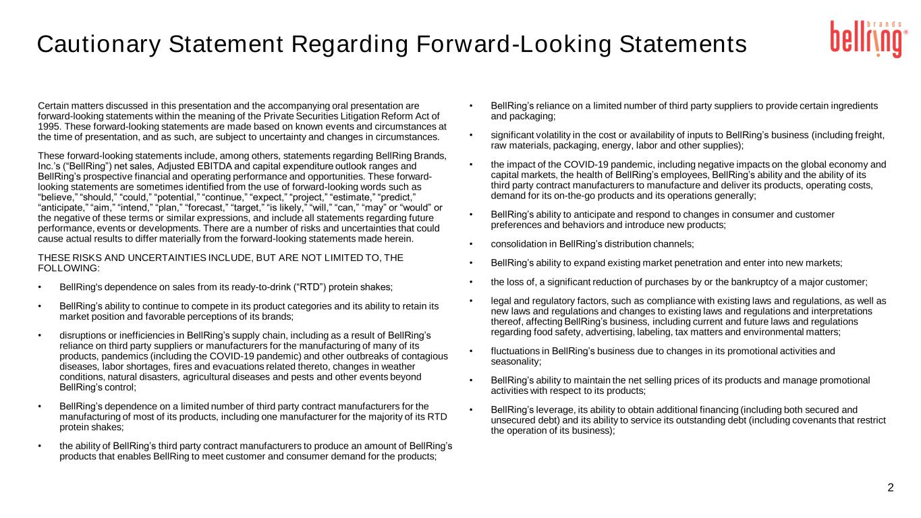
2 Certain matters discussed in this presentation and the accompanying oral presentation are forward-looking statements within the meaning of the Private Securities Litigation Reform Act of 1995. These forward-looking statements are made based on known events and circumstances at the time of presentation, and as such, are subject to uncertainty and changes in circumstances. These forward-looking statements include, among others, statements regarding BellRing Brands, Inc.’s (“BellRing”) net sales, Adjusted EBITDA and capital expenditure outlook ranges and BellRing’s prospective financial and operating performance and opportunities. These forward- looking statements are sometimes identified from the use of forward-looking words such as “believe,” “should,” “could,” “potential,” “continue,” “expect,” “project,” “estimate,” “predict,” “anticipate,” “aim,” “intend,” “plan,” “forecast,” “target,” “is likely,” “will,” “can,” “may” or “would” or the negative of these terms or similar expressions, and include all statements regarding future performance, events or developments. There are a number of risks and uncertainties that could cause actual results to differ materially from the forward-looking statements made herein. THESE RISKS AND UNCERTAINTIES INCLUDE, BUT ARE NOT LIMITED TO, THE FOLLOWING: • BellRing's dependence on sales from its ready-to-drink (“RTD”) protein shakes; • BellRing’s ability to continue to compete in its product categories and its ability to retain its market position and favorable perceptions of its brands; • disruptions or inefficiencies in BellRing’s supply chain, including as a result of BellRing’s reliance on third party suppliers or manufacturers for the manufacturing of many of its products, pandemics (including the COVID-19 pandemic) and other outbreaks of contagious diseases, labor shortages, fires and evacuations related thereto, changes in weather conditions, natural disasters, agricultural diseases and pests and other events beyond BellRing’s control; • BellRing’s dependence on a limited number of third party contract manufacturers for the manufacturing of most of its products, including one manufacturer for the majority of its RTD protein shakes; • the ability of BellRing’s third party contract manufacturers to produce an amount of BellRing’s products that enables BellRing to meet customer and consumer demand for the products; • BellRing’s reliance on a limited number of third party suppliers to provide certain ingredients and packaging; • significant volatility in the cost or availability of inputs to BellRing’s business (including freight, raw materials, packaging, energy, labor and other supplies); • the impact of the COVID-19 pandemic, including negative impacts on the global economy and capital markets, the health of BellRing’s employees, BellRing’s ability and the ability of its third party contract manufacturers to manufacture and deliver its products, operating costs, demand for its on-the-go products and its operations generally; • BellRing’s ability to anticipate and respond to changes in consumer and customer preferences and behaviors and introduce new products; • consolidation in BellRing’s distribution channels; • BellRing’s ability to expand existing market penetration and enter into new markets; • the loss of, a significant reduction of purchases by or the bankruptcy of a major customer; • legal and regulatory factors, such as compliance with existing laws and regulations, as well as new laws and regulations and changes to existing laws and regulations and interpretations thereof, affecting BellRing’s business, including current and future laws and regulations regarding food safety, advertising, labeling, tax matters and environmental matters; • fluctuations in BellRing’s business due to changes in its promotional activities and seasonality; • BellRing’s ability to maintain the net selling prices of its products and manage promotional activities with respect to its products; • BellRing’s leverage, its ability to obtain additional financing (including both secured and unsecured debt) and its ability to service its outstanding debt (including covenants that restrict the operation of its business); Cautionary Statement Regarding Forward-Looking Statements

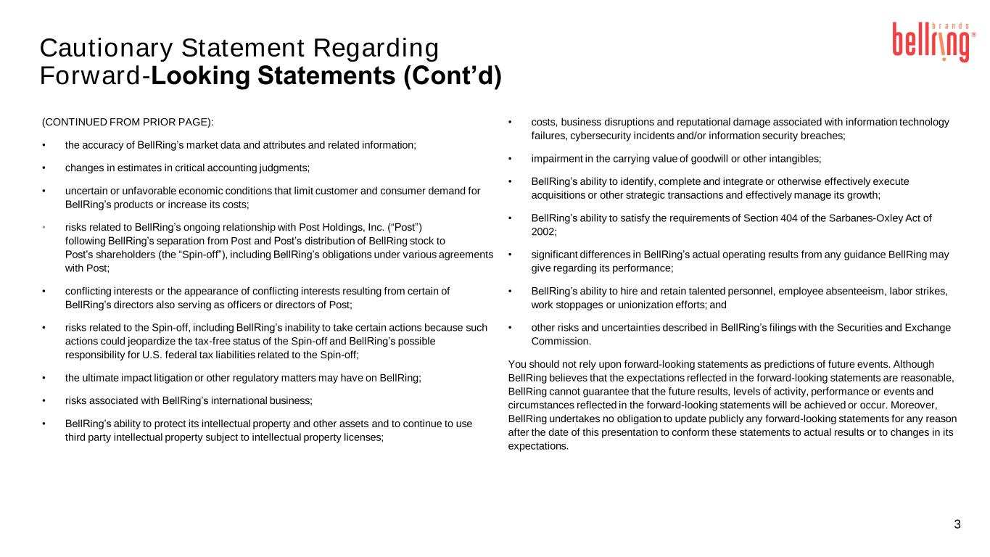
Cautionary Statement Regarding Forward-Looking Statements (Cont’d) 3 (CONTINUED FROM PRIOR PAGE): • the accuracy of BellRing’s market data and attributes and related information; • changes in estimates in critical accounting judgments; • uncertain or unfavorable economic conditions that limit customer and consumer demand for BellRing’s products or increase its costs; • risks related to BellRing’s ongoing relationship with Post Holdings, Inc. (“Post”) following BellRing’s separation from Post and Post’s distribution of BellRing stock to Post’s shareholders (the “Spin-off”), including BellRing’s obligations under various agreements with Post; • conflicting interests or the appearance of conflicting interests resulting from certain of BellRing’s directors also serving as officers or directors of Post; • risks related to the Spin-off, including BellRing’s inability to take certain actions because such actions could jeopardize the tax-free status of the Spin-off and BellRing’s possible responsibility for U.S. federal tax liabilities related to the Spin-off; • the ultimate impact litigation or other regulatory matters may have on BellRing; • risks associated with BellRing’s international business; • BellRing’s ability to protect its intellectual property and other assets and to continue to use third party intellectual property subject to intellectual property licenses; • costs, business disruptions and reputational damage associated with information technology failures, cybersecurity incidents and/or information security breaches; • impairment in the carrying value of goodwill or other intangibles; • BellRing’s ability to identify, complete and integrate or otherwise effectively execute acquisitions or other strategic transactions and effectively manage its growth; • BellRing’s ability to satisfy the requirements of Section 404 of the Sarbanes-Oxley Act of 2002; • significant differences in BellRing’s actual operating results from any guidance BellRing may give regarding its performance; • BellRing’s ability to hire and retain talented personnel, employee absenteeism, labor strikes, work stoppages or unionization efforts; and • other risks and uncertainties described in BellRing’s filings with the Securities and Exchange Commission. You should not rely upon forward-looking statements as predictions of future events. Although BellRing believes that the expectations reflected in the forward-looking statements are reasonable, BellRing cannot guarantee that the future results, levels of activity, performance or events and circumstances reflected in the forward-looking statements will be achieved or occur. Moreover, BellRing undertakes no obligation to update publicly any forward-looking statements for any reason after the date of this presentation to conform these statements to actual results or to changes in its expectations.

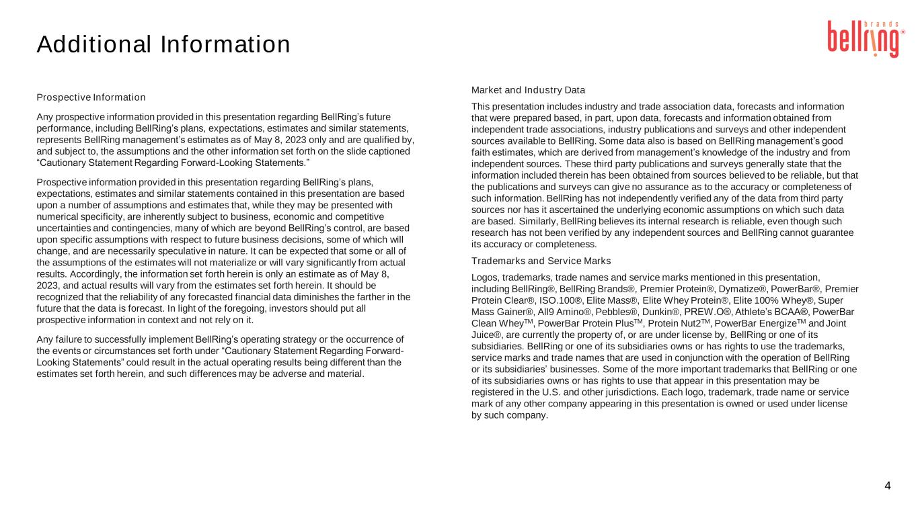
Additional Information 4 Prospective Information Any prospective information provided in this presentation regarding BellRing’s future performance, including BellRing’s plans, expectations, estimates and similar statements, represents BellRing management’s estimates as of May 8, 2023 only and are qualified by, and subject to, the assumptions and the other information set forth on the slide captioned “Cautionary Statement Regarding Forward-Looking Statements.” Prospective information provided in this presentation regarding BellRing’s plans, expectations, estimates and similar statements contained in this presentation are based upon a number of assumptions and estimates that, while they may be presented with numerical specificity, are inherently subject to business, economic and competitive uncertainties and contingencies, many of which are beyond BellRing’s control, are based upon specific assumptions with respect to future business decisions, some of which will change, and are necessarily speculative in nature. It can be expected that some or all of the assumptions of the estimates will not materialize or will vary significantly from actual results. Accordingly, the information set forth herein is only an estimate as of May 8, 2023, and actual results will vary from the estimates set forth herein. It should be recognized that the reliability of any forecasted financial data diminishes the farther in the future that the data is forecast. In light of the foregoing, investors should put all prospective information in context and not rely on it. Any failure to successfully implement BellRing’s operating strategy or the occurrence of the events or circumstances set forth under “Cautionary Statement Regarding Forward- Looking Statements” could result in the actual operating results being different than the estimates set forth herein, and such differences may be adverse and material. Market and Industry Data This presentation includes industry and trade association data, forecasts and information that were prepared based, in part, upon data, forecasts and information obtained from independent trade associations, industry publications and surveys and other independent sources available to BellRing. Some data also is based on BellRing management’s good faith estimates, which are derived from management’s knowledge of the industry and from independent sources. These third party publications and surveys generally state that the information included therein has been obtained from sources believed to be reliable, but that the publications and surveys can give no assurance as to the accuracy or completeness of such information. BellRing has not independently verified any of the data from third party sources nor has it ascertained the underlying economic assumptions on which such data are based. Similarly, BellRing believes its internal research is reliable, even though such research has not been verified by any independent sources and BellRing cannot guarantee its accuracy or completeness. Trademarks and Service Marks Logos, trademarks, trade names and service marks mentioned in this presentation, including BellRing®, BellRing Brands®, Premier Protein®, Dymatize®, PowerBar®, Premier Protein Clear®, ISO.100®, Elite Mass®, Elite Whey Protein®, Elite 100% Whey®, Super Mass Gainer®, All9 Amino®, Pebbles®, Dunkin®, PREW.O®, Athlete’s BCAA®, PowerBar Clean WheyTM, PowerBar Protein PlusTM, Protein Nut2TM, PowerBar EnergizeTM and Joint Juice®, are currently the property of, or are under license by, BellRing or one of its subsidiaries. BellRing or one of its subsidiaries owns or has rights to use the trademarks, service marks and trade names that are used in conjunction with the operation of BellRing or its subsidiaries’ businesses. Some of the more important trademarks that BellRing or one of its subsidiaries owns or has rights to use that appear in this presentation may be registered in the U.S. and other jurisdictions. Each logo, trademark, trade name or service mark of any other company appearing in this presentation is owned or used under license by such company.

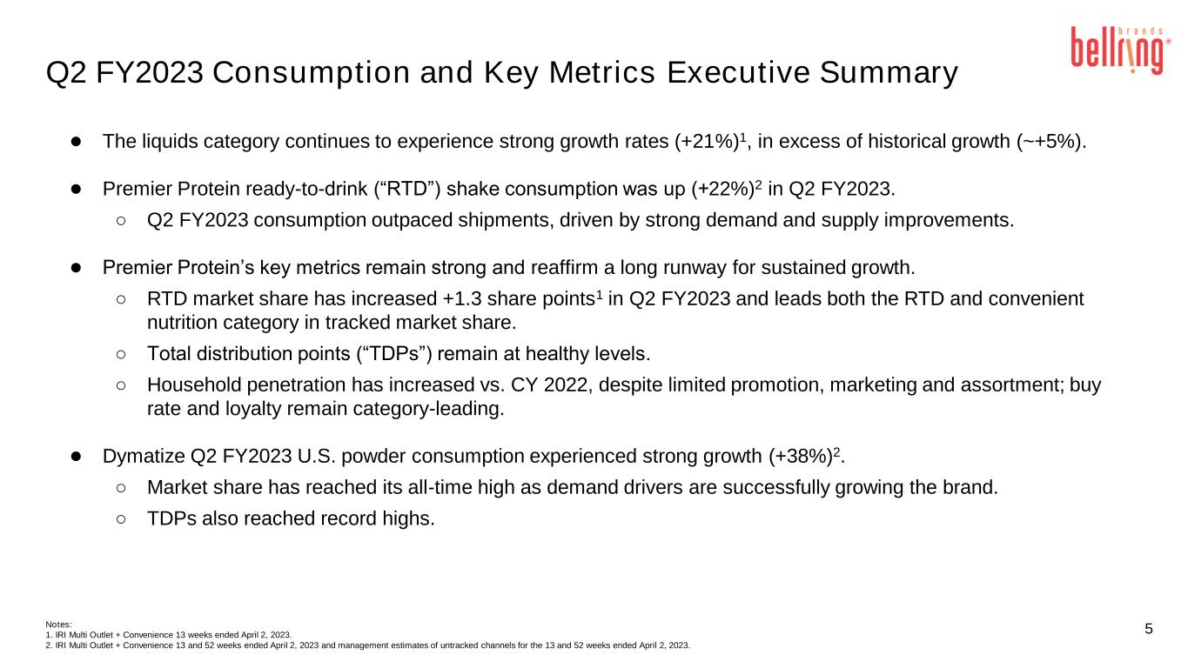
5 Q2 FY2023 Consumption and Key Metrics Executive Summary ● The liquids category continues to experience strong growth rates (+21%)1, in excess of historical growth (~+5%). ● Premier Protein ready-to-drink (“RTD”) shake consumption was up (+22%)2 in Q2 FY2023. ○ Q2 FY2023 consumption outpaced shipments, driven by strong demand and supply improvements. ● Premier Protein’s key metrics remain strong and reaffirm a long runway for sustained growth. ○ RTD market share has increased +1.3 share points1 in Q2 FY2023 and leads both the RTD and convenient nutrition category in tracked market share. ○ Total distribution points (“TDPs”) remain at healthy levels. ○ Household penetration has increased vs. CY 2022, despite limited promotion, marketing and assortment; buy rate and loyalty remain category-leading. ● Dymatize Q2 FY2023 U.S. powder consumption experienced strong growth (+38%)2. ○ Market share has reached its all-time high as demand drivers are successfully growing the brand. ○ TDPs also reached record highs. Notes: 1. IRI Multi Outlet + Convenience 13 weeks ended April 2, 2023. 2. IRI Multi Outlet + Convenience 13 and 52 weeks ended April 2, 2023 and management estimates of untracked channels for the 13 and 52 weeks ended April 2, 2023.

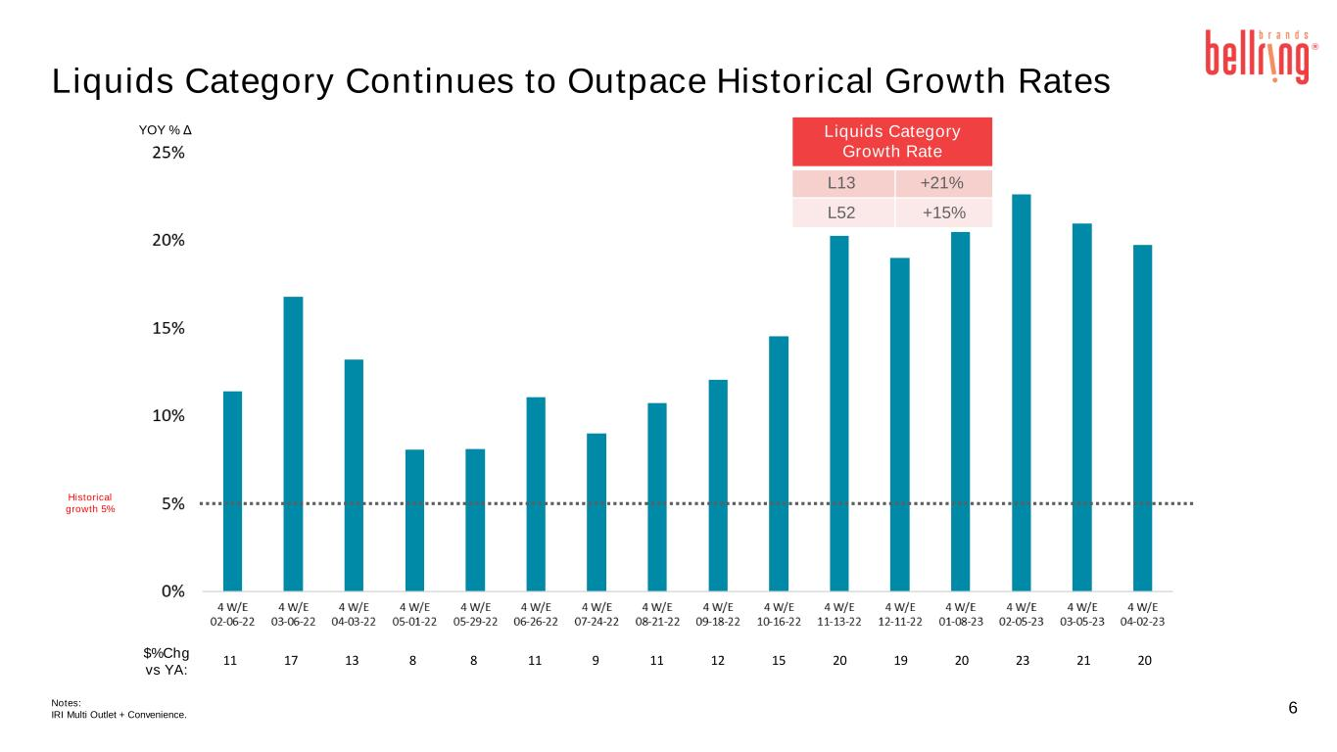
6 Liquids Category Continues to Outpace Historical Growth Rates 11 17 13 8 8 11 9 11 12 15 20 19 20 23 21 20 Liquids Category Growth Rate L13 +21% L52 +15% YOY % Δ Historical growth 5% $%Chg vs YA: Notes: IRI Multi Outlet + Convenience.

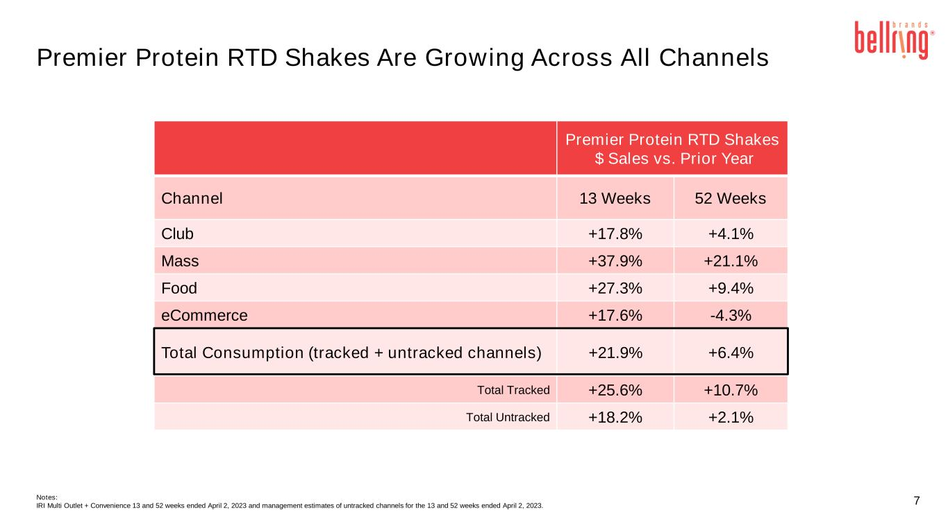
7 Premier Protein RTD Shakes Are Growing Across All Channels Premier Protein RTD Shakes $ Sales vs. Prior Year Channel 13 Weeks 52 Weeks Club +17.8% +4.1% Mass +37.9% +21.1% Food +27.3% +9.4% eCommerce +17.6% -4.3% Total Consumption (tracked + untracked channels) +21.9% +6.4% Total Tracked +25.6% +10.7% Total Untracked +18.2% +2.1% Notes: IRI Multi Outlet + Convenience 13 and 52 weeks ended April 2, 2023 and management estimates of untracked channels for the 13 and 52 weeks ended April 2, 2023.

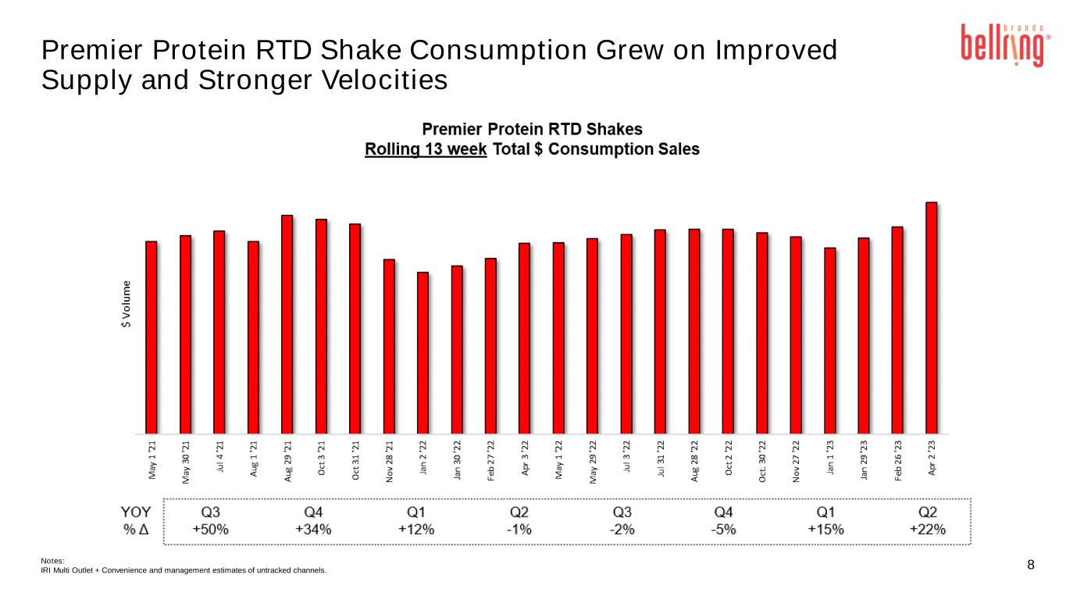
8 Premier Protein RTD Shake Consumption Grew on Improved Supply and Stronger Velocities Notes: IRI Multi Outlet + Convenience and management estimates of untracked channels.

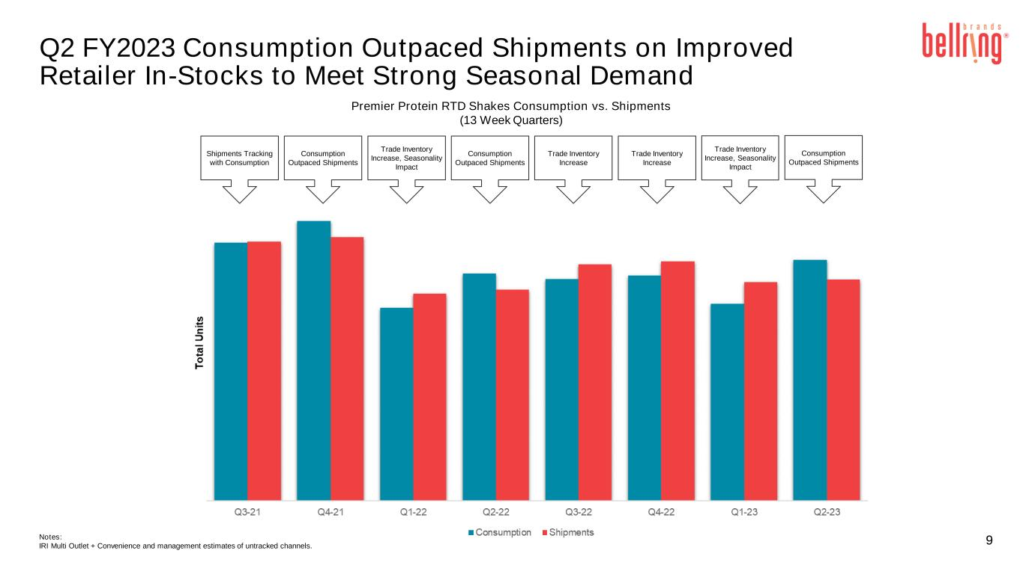
9Notes: IRI Multi Outlet + Convenience and management estimates of untracked channels. Shipments Tracking with Consumption Trade Inventory Increase, Seasonality Impact Consumption Outpaced Shipments Trade Inventory Increase Trade Inventory Increase Consumption Outpaced Shipments Premier Protein RTD Shakes Consumption vs. Shipments (13 Week Quarters) Consumption Outpaced Shipments Trade Inventory Increase, Seasonality Impact Q2 FY2023 Consumption Outpaced Shipments on Improved Retailer In-Stocks to Meet Strong Seasonal Demand

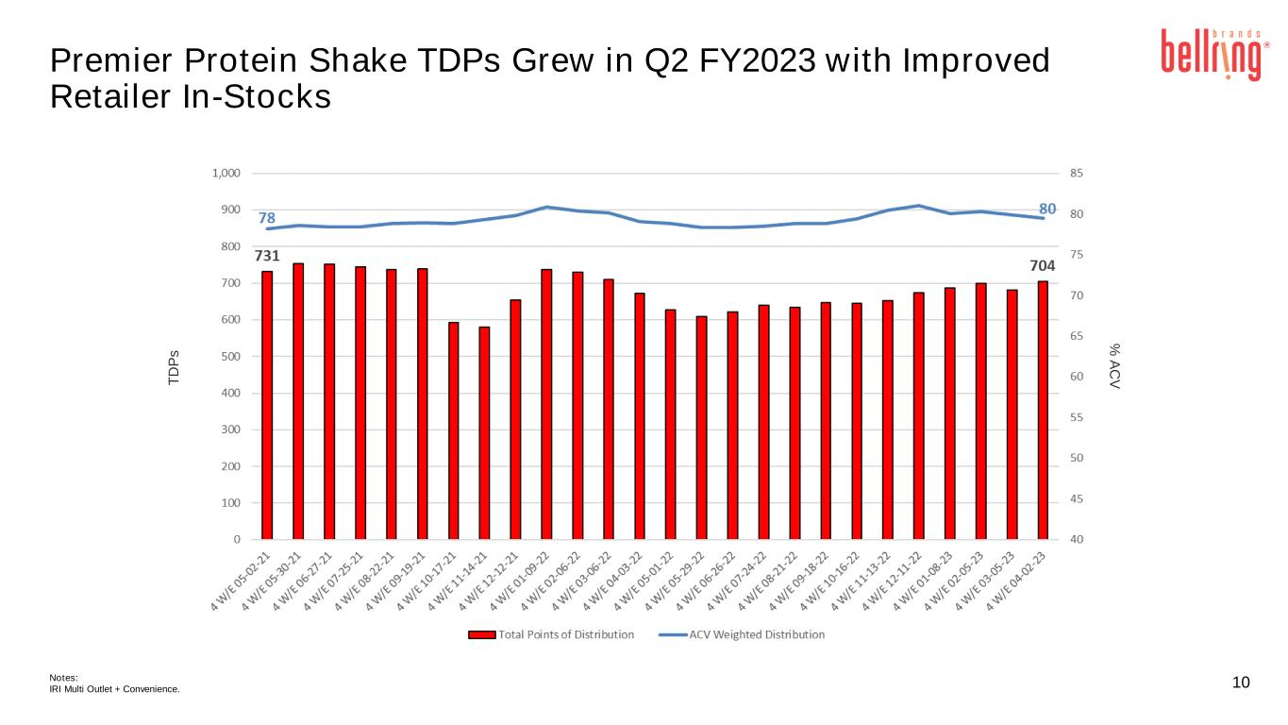
10 Premier Protein Shake TDPs Grew in Q2 FY2023 with Improved Retailer In-Stocks T D P s % A C V Notes: IRI Multi Outlet + Convenience.

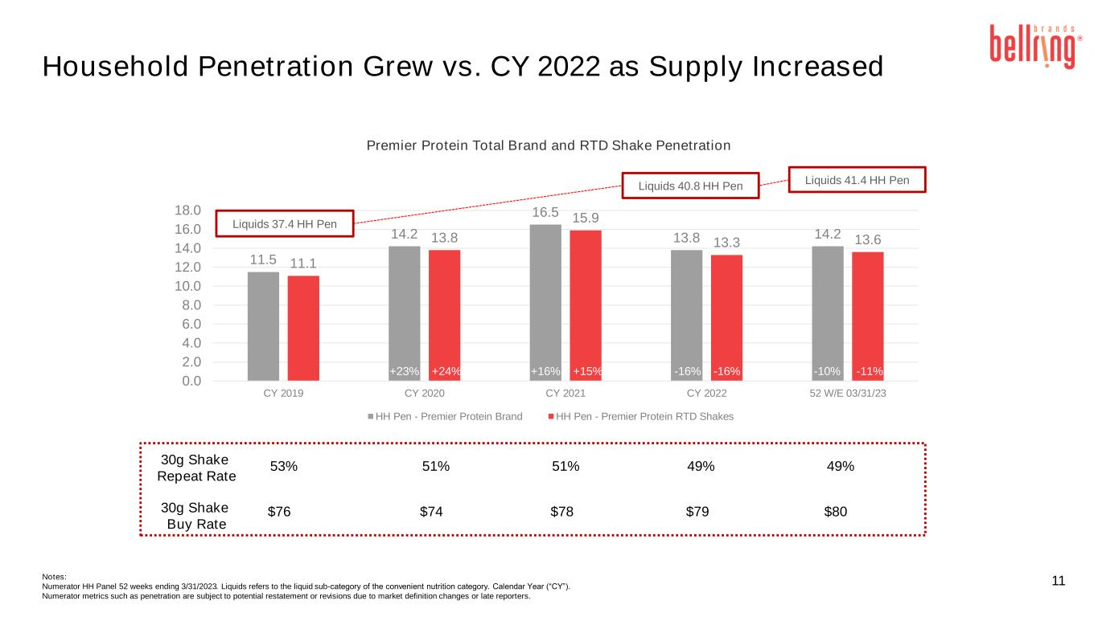
Notes: Numerator HH Panel 52 weeks ending 3/31/2023. Liquids refers to the liquid sub-category of the convenient nutrition category. Calendar Year (“CY”). Numerator metrics such as penetration are subject to potential restatement or revisions due to market definition changes or late reporters. 11 Household Penetration Grew vs. CY 2022 as Supply Increased 11.5 14.2 16.5 13.8 14.2 11.1 13.8 15.9 13.3 13.6 0.0 2.0 4.0 6.0 8.0 10.0 12.0 14.0 16.0 18.0 CY 2019 CY 2020 CY 2021 CY 2022 52 W/E 03/31/23 Premier Protein Total Brand and RTD Shake Penetration HH Pen - Premier Protein Brand HH Pen - Premier Protein RTD Shakes 30g Shake Repeat Rate 30g Shake Buy Rate 53% $76 51% $74 51% $78 49% $79 49% $80 Liquids 37.4 HH Pen Liquids 41.4 HH Pen Liquids 40.8 HH Pen +23% +24% +16% +15% -16% -16% -10% -11%

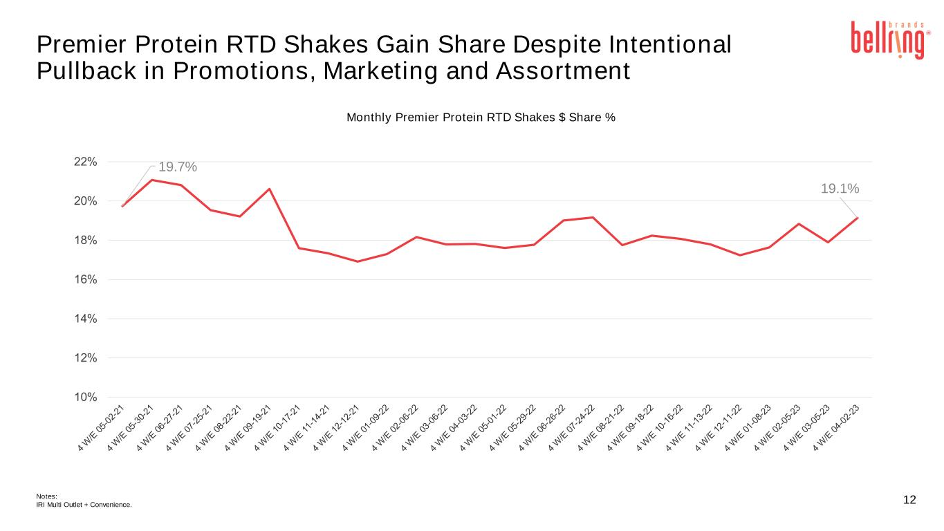
12 Premier Protein RTD Shakes Gain Share Despite Intentional Pullback in Promotions, Marketing and Assortment Monthly Premier Protein RTD Shakes $ Share % Notes: IRI Multi Outlet + Convenience. 19.7% 19.1%

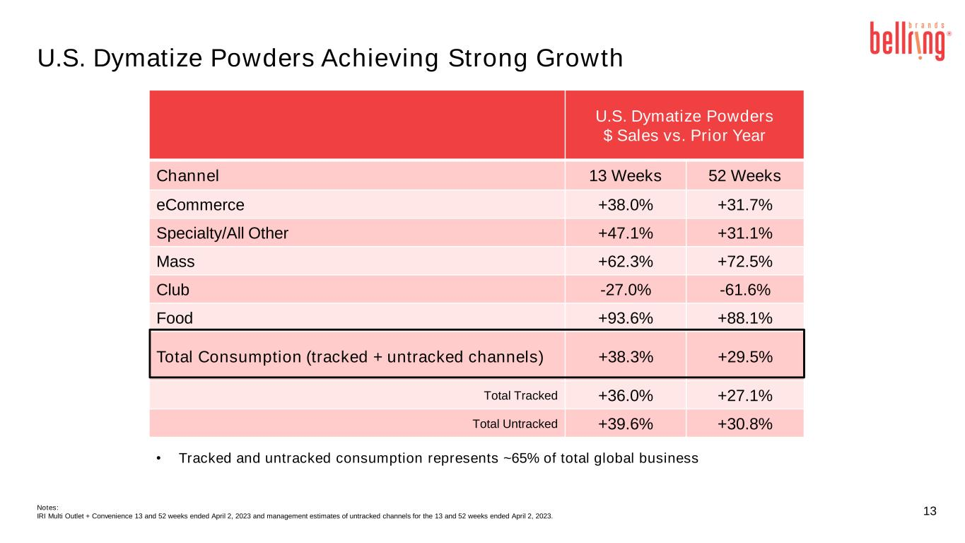
13 • Tracked and untracked consumption represents ~65% of total global business U.S. Dymatize Powders $ Sales vs. Prior Year Channel 13 Weeks 52 Weeks eCommerce +38.0% +31.7% Specialty/All Other +47.1% +31.1% Mass +62.3% +72.5% Club -27.0% -61.6% Food +93.6% +88.1% Total Consumption (tracked + untracked channels) +38.3% +29.5% Total Tracked +36.0% +27.1% Total Untracked +39.6% +30.8% Notes: IRI Multi Outlet + Convenience 13 and 52 weeks ended April 2, 2023 and management estimates of untracked channels for the 13 and 52 weeks ended April 2, 2023. U.S. Dymatize Powders Achieving Strong Growth

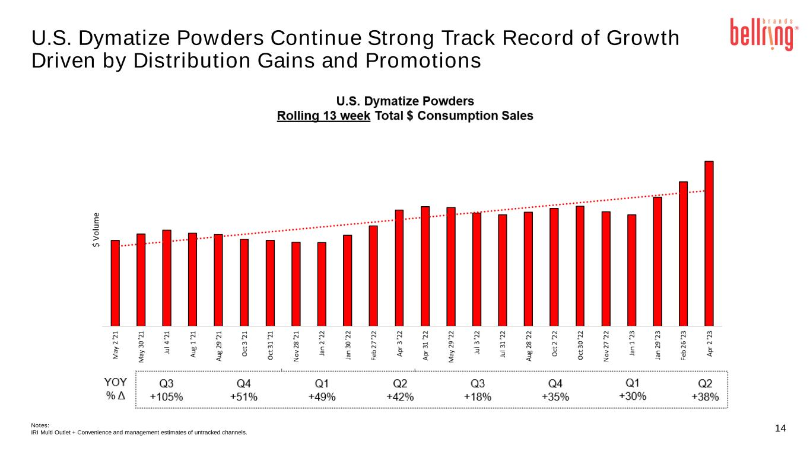
14 U.S. Dymatize Powders Continue Strong Track Record of Growth Driven by Distribution Gains and Promotions Notes: IRI Multi Outlet + Convenience and management estimates of untracked channels.

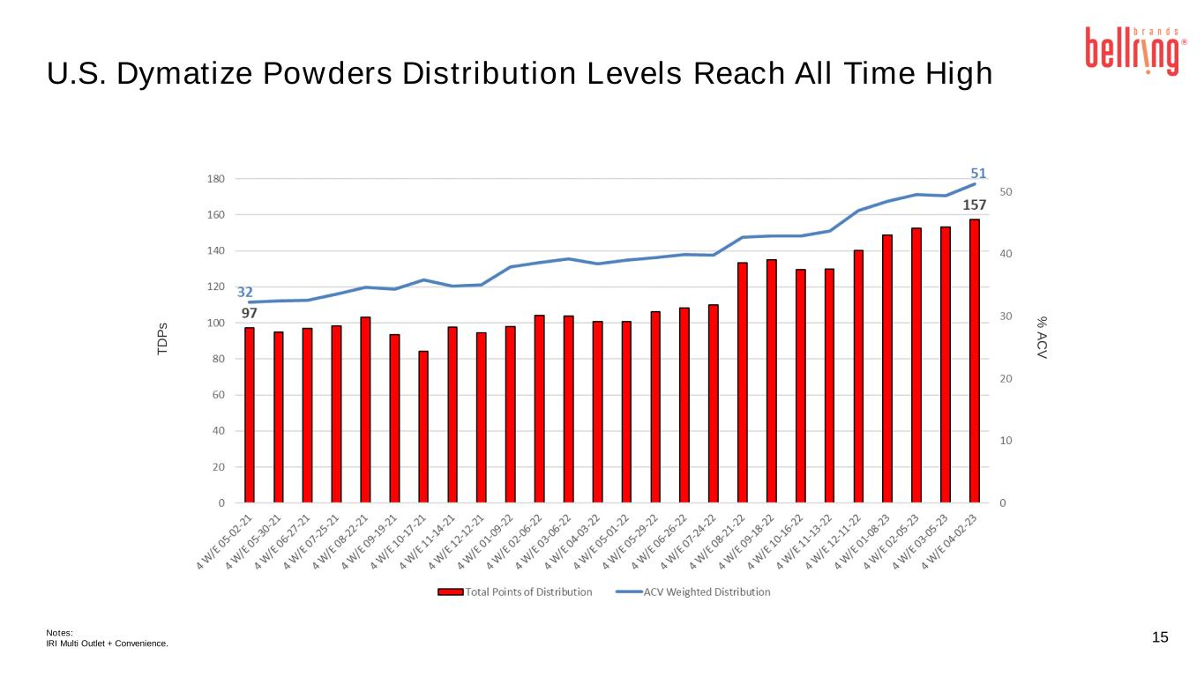
15 U.S. Dymatize Powders Distribution Levels Reach All Time High T D P s % A C V Notes: IRI Multi Outlet + Convenience.



