UNITED STATES
SECURITIES AND EXCHANGE COMMISSION
Washington, D.C. 20549
______________________
FORM 8-K
CURRENT REPORT
Pursuant to Section 13 OR 15(d) of The
Securities Exchange Act of 1934
Date of Report (Date of earliest event reported): August 5, 2024
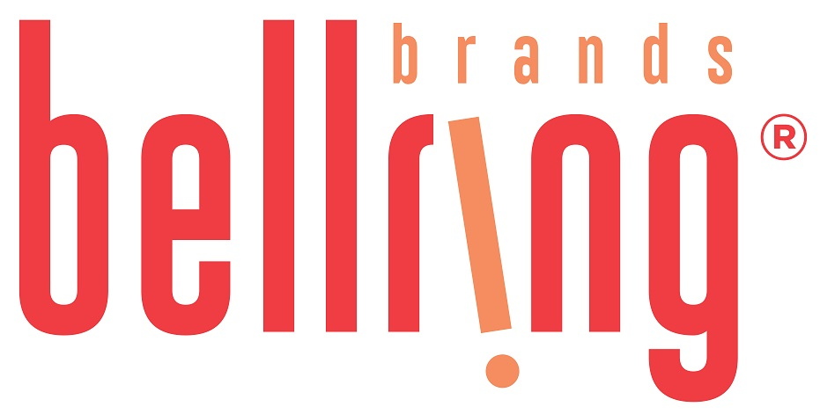
BellRing Brands, Inc.
(Exact name of registrant as specified in its charter)
Delaware |  |  | 001-39093 |  |  |  |  |  | 87-3296749
(State or other jurisdiction of incorporation) |  |  | (Commission File Number) |  |  |  |  |  | (IRS Employer Identification No.)
2503 S. Hanley Road |  |  | St. Louis |  |  | Missouri |  |  | 63144
(Address of Principal Executive Offices) |  |  |  |  |  |  |  |  | (Zip Code)
Registrant’s telephone number, including area code: (314) 644-7600
Check the appropriate box below if the Form 8-K filing is intended to simultaneously satisfy the filing obligation of the registrant under any of the following provisions:
☐ Written communications pursuant to Rule 425 under the Securities Act (17 CFR 230.425)
☐ Soliciting material pursuant to Rule 14a-12 under the Exchange Act (17 CFR 240.14a-12)
☐ Pre-commencement communications pursuant to Rule 14d-2(b) under the Exchange Act (17 CFR 240.14d-2(b))
☐ Pre-commencement communications pursuant to Rule 13e-4(c) under the Exchange Act (17 CFR 240.13e-4(c))
Securities registered pursuant to Section 12(b) of the Act:
Title of each class |  |  | Trading Symbol(s) |  |  | Name of each exchange on which registered
Common Stock, $0.01 par value per share |  |  | BRBR |  |  | New York Stock Exchange
Indicate by check mark whether the registrant is an emerging growth company as defined in Rule 405 of the Securities Act of 1933 (§230.405 of this chapter) or Rule 12b-2 of the Securities Exchange Act of 1934 (§240.12b-2 of this chapter).
Emerging growth company ☐
If an emerging growth company, indicate by check mark if the registrant has elected not to use the extended transition period for complying with any new or revised financial accounting standards provided pursuant to Section 13(a) of the Exchange Act.☐

Item 2.02. Results of Operation and Financial Condition.

On August 5, 2024, BellRing Brands, Inc. (the "Company") issued a press release announcing results for its third fiscal quarter ended June 30, 2024. A copy of the press release is attached hereto as Exhibit 99.1 and incorporated herein by reference.

In addition, on August 5, 2024, the Company published to the "Investor Relations" section of its website, www.bellringbrands.com, a supplemental presentation related to results for its third fiscal quarter ended June 30, 2024. A copy of the presentation is attached hereto as Exhibit 99.2 and incorporated herein by reference.

The information contained in Item 2.02, including Exhibit 99.1 and Exhibit 99.2 attached hereto, shall not be deemed to be "filed" for purposes of Section 18 of the Securities Exchange Act of 1934, as amended (the "Exchange Act"), or otherwise subject to the liabilities of that Section, nor shall they be deemed incorporated by reference into any filings under the Securities Act of 1933, as amended, or the Exchange Act, except as expressly set forth by specific reference in such filing.

9.01. Financial Statements and Exhibits.

(d) Exhibits

Exhibit No. |  |  | Description
99.1 |  |  | Press Release dated August 5, 2024
99.2 |  |  | Third Fiscal Quarter Ended June 30, 2024 Supplemental Presentation
104 |  |  | Cover Page Interactive Data File (the cover page iXBRL tags are embedded within the Inline XBRL document)

Pursuant to the requirements of the Securities Exchange Act of 1934, the registrant has duly caused this report to be signed on its behalf by the undersigned thereunto duly authorized.

Date: August 5, 2024 |  |  | BellRing Brands, Inc.
 |  |  | (Registrant)
 |  |  | By: |  |  | /s/ Paul A. Rode
 |  |  | Name: |  |  | Paul A. Rode
 |  |  | Title: |  |  | Chief Financial Officer

Exhibit 99.1

BellRing Brands Reports Results for the Third Quarter of Fiscal Year 2024; Raises Fiscal Year 2024 Outlook
St. Louis - August 5, 2024 - BellRing Brands, Inc. (NYSE:BRBR) (“BellRing”), a holding company operating in the global convenient nutrition category, today reported results for the third fiscal quarter ended June 30, 2024.
Highlights:
•Third quarter net sales of $515.4 million
•Operating profit of $111.6 million, net earnings of $73.7 million and Adjusted EBITDA* of $119.5 million
•Raised fiscal year 2024 net sales outlook to $1.96-$2.00 billion and Adjusted EBITDA* outlook to $430-$440 million
*Adjusted EBITDA is a non-GAAP measure. For additional information regarding non-GAAP measures, see the related explanations presented under “Use of Non-GAAP Measures” later in this release. BellRing provides Adjusted EBITDA guidance only on a non-GAAP basis and does not provide a reconciliation of its forward-looking Adjusted EBITDA non-GAAP guidance measure to the most directly comparable GAAP measure due to the inherent difficulty in forecasting and quantifying certain amounts that are necessary for such reconciliation, including the adjustments described under “Outlook” later in this release.
“We are pleased with our third quarter performance, with results ahead of our expectations and shake production delivering to plan. Premier Protein achieved all time highs for household penetration and shake distribution points as we broaden our formats and package sizes. Consumption growth for Premier Protein shakes was strong and accelerated in June and continued into July on better in stocks and distribution gains,” said Darcy H. Davenport, President and Chief Executive Officer of BellRing. “Lastly, we saw greater-than-expected margins primarily lifted by favorability in powder input costs. Our strong third quarter performance and visibility to the fourth quarter gives us confidence to raise our outlook for the year.”
Dollar consumption of Premier Protein ready-to-drink (“RTD”) shakes and Premier Protein powder products increased 9.6% and 43.6%, respectively, and Dymatize powder products decreased 11.3% in the 13-week period ended June 30, 2024, as compared to the same period in 2023 (inclusive of Circana United States (“U.S.”) Multi Outlet including Convenience and management estimates of untracked channels). For additional information regarding consumption metrics, see the supplemental slide presentation on BellRing’s website, which can be accessed by visiting the Investor Relations section.
Third Quarter Operating Results
Net sales were $515.4 million, an increase of 15.6%, or $69.5 million, compared to the prior year period, driven by 18.4% increase in volume and 2.8% decrease in price/mix.
Premier Protein net sales increased 19.8%, driven by 19.2% increase in volume and 0.6% increase in price/mix. Premier Protein RTD shake net sales increased 18.5%, driven by 19.4% increase in volume and 0.9% decrease in price/mix. Volume gains were driven by organic growth and distribution gains.
Dymatize net sales decreased 2.6%, driven by 4.4% increase in volume which was offset by a 7.0% decrease in price/mix. Volume gains were driven by strength in the international channel, which was partially offset by changes in domestic distribution and display activity when compared to the prior year period. The decrease in price/mix was driven by promotional activity and unfavorable mix.
Gross profit was $189.9 million, or 36.8% of net sales, an increase of 39.6%, or $53.9 million, compared to $136.0 million, or 30.5% of net sales, in the prior year period. Gross profit included mark-to-market adjustments on commodity hedges which were favorable by $2.3 million in the third quarter of 2024 and unfavorable by $1.9 million in the third quarter of 2023, and were treated as adjustments for non-GAAP measures. The higher gross profit margin was driven by net input cost deflation.
Selling, general and administrative (“SG&A”) expenses were $74.0 million, or 14.4% of net sales, an increase of $18.9 million compared to $55.1 million, or 12.4% of net sales, in the prior year period. SG&A expenses in the third quarter of 2024 included
1
higher employee expenses and distribution and warehousing expenses on higher volumes, as well as higher marketing and consumer advertising expenses of $3.3 million.
Operating profit was $111.6 million, an increase of 46.8%, or $35.6 million, compared to $76.0 million in the prior year period.
Interest expense, net was $14.4 million and $17.3 million in the third quarter of 2024 and 2023, respectively, with the decline primarily driven by lower borrowings outstanding under the revolving credit facility. Income tax expense was $23.5 million in the third quarter of 2024, an effective income tax rate of 24.2%, compared to $14.4 million in the third quarter of 2023, an effective income tax rate of 24.5%.
Net earnings were $73.7 million, an increase of 66.4%, or $29.4 million, compared to $44.3 million in the prior year period. Net earnings per diluted common share were $0.56, an increase of 69.7%, compared to $0.33 in the prior year period. Adjusted net earnings* were $71.9 million, an increase of 57.3%, compared to $45.7 million in the prior year period. Adjusted net earnings per common share* were $0.54, an increase of 58.8%, compared to $0.34 in the prior year period.
Adjusted EBITDA* was $119.5 million, an increase of 37.5%, or $32.6 million, compared to $86.9 million in the prior year period.
*Adjusted net earnings, Adjusted diluted earnings per common share and Adjusted EBITDA are non-GAAP measures. For additional information regarding non-GAAP measures, see the related explanations presented under “Use of Non-GAAP Measures” later in this release.
Nine Month Operating Results
Net sales were $1,440.4 million, an increase of 20.6%, or $246.2 million, compared to the prior year period, driven by 26.3% increase in volume and 5.7% decrease in price/mix. Premier Protein net sales increased 24.0%, driven by 27.4% increase in volume and 3.4% decrease in price/mix. Dymatize net sales increased 6.1%, driven by 10.6% increase in volume and 4.5% decrease in price/mix.
Gross profit was $502.2 million, or 34.9% of net sales, an increase of 34.0%, or $127.3 million, compared to $374.9 million, or 31.4% of net sales, in the prior year period. The higher gross profit margin was driven by net input cost deflation, which was partially offset by incremental promotional activity.
SG&A expenses were $195.9 million, or 13.6% of net sales, an increase of $44.8 million compared to $151.1 million, or 12.7% of net sales, in the prior year period. SG&A expenses in the nine months ended June 30, 2024 included higher employee expenses and distribution and warehousing expenses on higher volumes, as well as increased marketing and consumer advertising expenses of $7.6 million.
Operating profit was $275.6 million, an increase of 31.7%, or $66.4 million, compared to $209.2 million in the prior year period, and was negatively impacted by $17.4 million of accelerated amortization incurred in connection with the discontinuance of the North American PowerBar business, which was treated as an adjustment for non-GAAP measures.
Interest expense, net was $43.8 million and $50.8 million in the nine months ended June 30, 2024 and 2023, respectively, with the decline primarily driven by lower borrowings outstanding under the revolving credit facility. Income tax expense was $57.0 million in the nine months ended June 30, 2024, compared to $39.0 million in the nine months ended June 30, 2023. The effective income tax rate was 24.6% in both the nine months ended June 30, 2024 and 2023.
Net earnings were $174.8 million, an increase of 46.4%, or $55.4 million, compared to $119.4 million in the prior year period. Net earnings per diluted common share were $1.32, an increase of 48.3%, compared to $0.89 in the prior year period. Adjusted net earnings* were $188.4 million, an increase of 53.7%, compared to $122.6 million in the prior year period. Adjusted diluted earnings per common share* were $1.42, an increase of 56.0%, compared to $0.91 in the prior year period.
Adjusted EBITDA* was $323.7 million, an increase of 35.0%, or $83.9 million, compared to $239.8 million in the prior year period.
*Adjusted net earnings, Adjusted diluted earnings per common share and Adjusted EBITDA are non-GAAP measures. For additional information regarding non-GAAP measures, see the related explanations presented under “Use of Non-GAAP Measures” later in this release.
Share Repurchases
During the third quarter of 2024, BellRing repurchased 1.3 million shares for $73.8 million at an average price of $58.08 per share. During the nine months ended June 30, 2024, BellRing repurchased 1.9 million shares for $106.1 million at an average price of $56.18 per share. As of June 30, 2024, BellRing had $215.6 million remaining under its share repurchase authorization.

2
Outlook
For fiscal year 2024, BellRing management has raised its guidance range for net sales to $1.96-$2.00 billion (from $1.93-$1.99 billion) and Adjusted EBITDA to $430-$440 million (from $400-$420 million) (resulting in net sales and Adjusted EBITDA growth of 18%-20% and 27%-30%, respectively, over fiscal year 2023). BellRing management expects fiscal year 2024 capital expenditures of approximately $4 million.
BellRing provides Adjusted EBITDA guidance only on a non-GAAP basis and does not provide a reconciliation of its forward-looking Adjusted EBITDA non-GAAP guidance measure to the most directly comparable GAAP measure due to the inherent difficulty in forecasting and quantifying certain amounts that are necessary for such reconciliation, including adjustments that could be made for mark-to-market adjustments on commodity hedges and other charges reflected in BellRing’s reconciliations of historical numbers, the amounts of which, based on historical experience, could be significant. For additional information regarding BellRing’s non-GAAP measures, see the related explanations presented under “Use of Non-GAAP Measures.”
Use of Non-GAAP Measures
BellRing uses certain non-GAAP measures in this release to supplement the financial measures prepared in accordance with U.S. generally accepted accounting principles (“GAAP”). These non-GAAP measures include Adjusted net earnings, Adjusted diluted earnings per common share, Adjusted EBITDA and Adjusted EBITDA as a percentage of net sales. The reconciliation of each of these non-GAAP measures to the most directly comparable GAAP measure is provided later in this release under “Explanation and Reconciliation of Non-GAAP Measures.”
Management uses certain of these non-GAAP measures, including Adjusted EBITDA and Adjusted EBITDA as a percentage of net sales, as key metrics in the evaluation of underlying company performance, in making financial, operating and planning decisions and, in part, in the determination of bonuses for its executive officers and employees. Additionally, BellRing is required to comply with certain covenants and limitations that are based on variations of EBITDA in its financing documents. Management believes the use of these non-GAAP measures provides increased transparency and assists investors in understanding the underlying operating performance of BellRing and in the analysis of ongoing operating trends. Non-GAAP measures are not prepared in accordance with GAAP, as they exclude certain items as described later in this release. These non-GAAP measures may not be comparable to similarly titled measures of other companies. For additional information regarding BellRing’s non-GAAP measures, see the related explanations provided under “Explanation and Reconciliation of Non-GAAP Measures” later in this release.
Conference Call to Discuss Earnings Results and Outlook
BellRing will host a conference call on Tuesday, August 6, 2024 at 9:00 a.m. EDT to discuss financial results for the third quarter of fiscal year 2024 and fiscal year 2024 outlook and to respond to questions. Darcy H. Davenport, President and Chief Executive Officer, and Paul A. Rode, Chief Financial Officer, will participate in the call.
Interested parties may join the conference call by registering in advance at the following link: BellRing Q3 2024 Earnings Conference Call. Upon registration, participants will receive a dial-in number and a unique passcode to access the conference call. Interested parties are invited to listen to the webcast of the conference call, which can be accessed by visiting the Investor Relations section of BellRing’s website at www.bellring.com. A slide presentation containing supplemental material will also be available at the same location on BellRing’s website. A webcast replay also will be available for a limited period on BellRing’s website in the Investor Relations section.
Prospective Financial Information
Prospective financial information is necessarily speculative in nature, and it can be expected that some or all of the assumptions underlying the prospective financial information described above will not materialize or will vary significantly from actual results. For further discussion of some of the factors that may cause actual results to vary materially from the information provided above, see “Forward-Looking Statements” below. Accordingly, the prospective financial information provided above is only an estimate of what BellRing’s management believes is realizable as of the date of this release. It also should be recognized that the reliability of any forecasted financial data diminishes the farther in the future that the data is forecasted. In light of the foregoing, the information should be viewed in context and undue reliance should not be placed upon it.
Forward-Looking Statements
Certain matters discussed in this release and on BellRing’s conference call are forward-looking statements, including BellRing’s net sales, Adjusted EBITDA and capital expenditures outlook for fiscal year 2024. These forward-looking statements are sometimes identified from the use of forward-looking words such as “believe,” “should,” “could,” “potential,” “continue,” “expect,” “project,” “estimate,” “predict,” “anticipate,” “aim,” “intend,” “plan,” “forecast,” “target,” “is likely,”

3
“will,” “can,” “may” or “would” or the negative of these terms or similar expressions, and include all statements regarding future performance, earnings projections, events or developments. There are a number of risks and uncertainties that could cause actual results to differ materially from the forward-looking statements made herein. These risks and uncertainties include, but are not limited to, the following:
•BellRing’s dependence on sales from its RTD protein shakes;
•BellRing’s ability to continue to compete in its product categories and its ability to retain its market position and favorable perceptions of its brands;
•disruptions or inefficiencies in BellRing’s supply chain, including as a result of BellRing’s reliance on third-party suppliers or manufacturers for the manufacturing of many of its products, pandemics and other outbreaks of contagious diseases, labor shortages, fires and evacuations related thereto, changes in weather conditions, natural disasters, agricultural diseases and pests and other events beyond BellRing’s control;
•BellRing’s dependence on a limited number of third-party contract manufacturers for the manufacturing of most of its products, including one manufacturer for the majority of its RTD protein shakes;
•the ability of BellRing’s third-party contract manufacturers to produce an amount of BellRing’s products that enables BellRing to meet customer and consumer demand for the products;
•BellRing’s reliance on a limited number of third-party suppliers to provide certain ingredients and packaging;
•significant volatility in the cost or availability of inputs to BellRing’s business (including freight, raw materials, packaging, energy, labor and other supplies);
•BellRing’s ability to anticipate and respond to changes in consumer and customer preferences and behaviors and introduce new products;
•consolidation in BellRing’s distribution channels;
•BellRing’s ability to expand existing market penetration and enter into new markets;
•the loss of, a significant reduction of purchases by or the bankruptcy of a major customer;
•legal and regulatory factors, such as compliance with existing laws and regulations, as well as new laws and regulations and changes to existing laws and regulations and interpretations thereof, affecting BellRing’s business, including current and future laws and regulations regarding food safety, advertising, labeling, tax matters and environmental matters;
•fluctuations in BellRing’s business due to changes in its promotional activities and seasonality;
•BellRing’s ability to maintain the net selling prices of its products and manage promotional activities with respect to its products;
•BellRing’s ability to obtain additional financing (including both secured and unsecured debt) and its ability to service its outstanding debt (including covenants that restrict the operation of its business);
•the accuracy of BellRing’s market data and attributes and related information;
•changes in critical accounting estimates;
•uncertain or unfavorable economic conditions that limit customer and consumer demand for BellRing’s products or increase its costs;
•risks related to BellRing’s ongoing relationship with Post Holdings, Inc. (“Post”) following BellRing’s separation from Post and Post’s distribution of BellRing stock to Post’s shareholders (the “Spin-off”), including BellRing’s obligations under various agreements with Post;
•conflicting interests or the appearance of conflicting interests resulting from certain of BellRing’s directors also serving as officers or directors of Post;
•risks related to the previously completed Spin-off;
•the ultimate impact litigation or other regulatory matters may have on BellRing;
•risks associated with BellRing’s international business;
•BellRing’s ability to protect its intellectual property and other assets and to continue to use third-party intellectual property subject to intellectual property licenses;
•costs, business disruptions and reputational damage associated with technology failures, cybersecurity incidents and corruption of BellRing’s data privacy protections;
•impairment in the carrying value of goodwill or other intangible assets;
•BellRing’s ability to identify, complete and integrate or otherwise effectively execute acquisitions or other strategic transactions and effectively manage its growth;
•BellRing’s ability to hire and retain talented personnel, employee absenteeism, labor strikes, work stoppages or unionization efforts;
•BellRing’s ability to satisfy the requirements of Section 404 of the Sarbanes-Oxley Act of 2002;
•significant differences in BellRing’s actual operating results from any guidance BellRing may give regarding its performance; and
•other risks and uncertainties described in BellRing’s filings with the Securities and Exchange Commission.

4
These forward-looking statements represent BellRing’s judgment as of the date of this release. BellRing disclaims, however, any intent or obligation to update these forward-looking statements.
About BellRing Brands, Inc.
BellRing Brands, Inc. is a rapidly growing leader in the global convenient nutrition category offering ready-to-drink shake and powder protein products. Its primary brands, Premier Protein® and Dymatize®, appeal to a broad range of consumers and are distributed across a diverse network of channels including club, food, drug, mass, eCommerce, specialty and convenience. BellRing’s commitment to consumers is to strive to make highly effective products that deliver best-in-class nutritionals and superior taste. For more information, visit www.bellring.com.

Contact:
Investor Relations
Jennifer Meyer
jennifer.meyer@bellringbrands.com
(415) 814-9388

5
CONDENSED CONSOLIDATED STATEMENTS OF OPERATIONS (Unaudited)
(in millions, except for per share data)
 |  |  | Three Months Ended June 30, |  |  |  |  |  |  |  |  |  |  |  | Nine Months Ended June 30,
 |  |  | 2024 |  |  |  |  |  | 2023 |  |  |  |  |  | 2024 |  |  |  |  |  | 2023
Net Sales |  |  | $ | 515.4 |  |  |  |  | $ | 445.9 |  |  |  |  | $ | 1,440.4 |  |  |  |  | $ | 1,194.2
Cost of goods sold |  |  | 325.5 |  |  |  |  |  | 309.9 |  |  |  |  |  | 938.2 |  |  |  |  |  | 819.3
Gross Profit |  |  | 189.9 |  |  |  |  |  | 136.0 |  |  |  |  |  | 502.2 |  |  |  |  |  | 374.9
Selling, general and administrative expenses |  |  | 74.0 |  |  |  |  |  | 55.1 |  |  |  |  |  | 195.9 |  |  |  |  |  | 151.1
Amortization of intangible assets |  |  | 4.3 |  |  |  |  |  | 4.9 |  |  |  |  |  | 30.7 |  |  |  |  |  | 14.6
Operating Profit |  |  | 111.6 |  |  |  |  |  | 76.0 |  |  |  |  |  | 275.6 |  |  |  |  |  | 209.2
Interest expense, net |  |  | 14.4 |  |  |  |  |  | 17.3 |  |  |  |  |  | 43.8 |  |  |  |  |  | 50.8
Earnings before Income Taxes |  |  | 97.2 |  |  |  |  |  | 58.7 |  |  |  |  |  | 231.8 |  |  |  |  |  | 158.4
Income tax expense |  |  | 23.5 |  |  |  |  |  | 14.4 |  |  |  |  |  | 57.0 |  |  |  |  |  | 39.0
Net Earnings |  |  | $ | 73.7 |  |  |  |  | $ | 44.3 |  |  |  |  | $ | 174.8 |  |  |  |  | $ | 119.4
Earnings per Common Share:
Basic |  |  | $ | 0.57 |  |  |  |  | $ | 0.33 |  |  |  |  | $ | 1.34 |  |  |  |  | $ | 0.89
Diluted |  |  | $ | 0.56 |  |  |  |  | $ | 0.33 |  |  |  |  | $ | 1.32 |  |  |  |  | $ | 0.89
Weighted-Average Common Shares Outstanding:
Basic |  |  | 130.0 |  |  |  |  |  | 132.4 |  |  |  |  |  | 130.7 |  |  |  |  |  | 133.6
Diluted |  |  | 132.1 |  |  |  |  |  | 133.8 |  |  |  |  |  | 132.7 |  |  |  |  |  | 134.5

6
CONDENSED CONSOLIDATED BALANCE SHEETS (Unaudited)
(in millions)
 |  |  | June 30, 2024 |  |  |  |  |  | September 30, 2023
ASSETS
Current Assets
Cash and cash equivalents |  |  | $ | 72.6 |  |  |  |  | $ | 48.4
Receivables, net |  |  | 230.7 |  |  |  |  |  | 168.2
Inventories |  |  | 237.8 |  |  |  |  |  | 194.3
Prepaid expenses and other current assets |  |  | 13.1 |  |  |  |  |  | 13.3
Total Current Assets |  |  | 554.2 |  |  |  |  |  | 424.2
Property, net |  |  | 8.2 |  |  |  |  |  | 8.5
Goodwill |  |  | 65.9 |  |  |  |  |  | 65.9
Intangible assets, net |  |  | 146.1 |  |  |  |  |  | 176.8
Deferred income taxes |  |  | 14.4 |  |  |  |  |  | 4.2
Other assets |  |  | 15.3 |  |  |  |  |  | 12.0
Total Assets |  |  | $ | 804.1 |  |  |  |  | $ | 691.6
LIABILITIES AND STOCKHOLDERS’ DEFICIT
Current Liabilities
Accounts payable |  |  | $ | 113.9 |  |  |  |  | $ | 89.0
Other current liabilities |  |  | 94.0 |  |  |  |  |  | 61.2
Total Current Liabilities |  |  | 207.9 |  |  |  |  |  | 150.2
Long-term debt |  |  | 832.7 |  |  |  |  |  | 856.8
Deferred income taxes |  |  | 0.4 |  |  |  |  |  | 0.4
Other liabilities |  |  | 6.3 |  |  |  |  |  | 7.7
Total Liabilities |  |  | 1,047.3 |  |  |  |  |  | 1,015.1
Stockholders’ Deficit
Common stock |  |  | 1.4 |  |  |  |  |  | 1.4
Additional paid-in capital |  |  | 31.6 |  |  |  |  |  | 19.3
Accumulated deficit |  |  | (15.3) |  |  |  |  |  | (190.1)
Accumulated other comprehensive loss |  |  | (2.8) |  |  |  |  |  | (3.1)
Treasury stock, at cost |  |  | (258.1) |  |  |  |  |  | (151.0)
Total Stockholders’ Deficit |  |  | (243.2) |  |  |  |  |  | (323.5)
Total Liabilities and Stockholders’ Deficit |  |  | $ | 804.1 |  |  |  |  | $ | 691.6

SELECTED CONDENSED CONSOLIDATED CASH FLOWS INFORMATION (Unaudited)
(in millions)
 |  |  | Nine Months Ended June 30,
 |  |  | 2024 |  |  |  |  |  | 2023
Cash provided by (used in):
Operating activities |  |  | $ | 159.5 |  |  |  |  | $ | 130.7
Investing activities |  |  | (0.6) |  |  |  |  |  | (1.0)
Financing activities |  |  | (134.6) |  |  |  |  |  | (139.8)
Effect of exchange rate changes on cash and cash equivalents |  |  | (0.1) |  |  |  |  |  | 0.4
Net increase (decrease) in cash and cash equivalents |  |  | $ | 24.2 |  |  |  |  | $ | (9.7)

7
EXPLANATION AND RECONCILIATION OF NON-GAAP MEASURES
BellRing uses certain non-GAAP measures in this release to supplement the financial measures prepared in accordance with U.S. generally accepted accounting principles (“GAAP”). These non-GAAP measures include Adjusted net earnings, Adjusted diluted earnings per common share, Adjusted EBITDA and Adjusted EBITDA as a percentage of net sales. The reconciliation of each of these non-GAAP measures to the most directly comparable GAAP measure is provided in the tables following this section. Non-GAAP measures are not prepared in accordance with GAAP, as they exclude certain items as described below. These non-GAAP measures may not be comparable to similarly titled measures of other companies.
Adjusted net earnings and Adjusted diluted earnings per common share
BellRing believes Adjusted net earnings and Adjusted diluted earnings per common share are useful to investors in evaluating BellRing’s operating performance because they exclude items that affect the comparability of BellRing’s financial results and could potentially distort an understanding of the trends in business performance.
Adjusted net earnings and Adjusted diluted earnings per common share are adjusted for the following items:
a.Accelerated amortization: BellRing has excluded non-cash accelerated amortization charges recorded in connection with the discontinuation of certain brands or the discontinuation of the use of certain brands in certain regions as the amount and frequency of such charges are not consistent. Additionally, BellRing believes that these charges do not reflect expected ongoing future operating expenses and do not contribute to a meaningful evaluation of BellRing’s current operating performance or comparisons of BellRing’s operating performance to other periods.
b.Mark-to-market adjustments on commodity hedges: BellRing has excluded the impact of mark-to-market adjustments on commodity hedges due to the inherent uncertainty and volatility associated with such amounts based on changes in assumptions with respect to fair value estimates. Additionally, these adjustments are primarily non-cash items and the amount and frequency of such adjustments are not consistent.
c.Foreign currency gain/loss on intercompany loans: BellRing has excluded the impact of foreign currency fluctuations related to intercompany loans denominated in currencies other than the functional currency of the respective legal entity in evaluating BellRing’s performance to allow for more meaningful comparisons of performance to other periods.
d.Separation costs: BellRing has excluded certain expenses incurred in connection with secondary offerings of shares of BellRing common stock previously held by Post, as the amount and frequency of such expenses are not consistent. Additionally, BellRing believes that these costs do not reflect expected ongoing future operating expenses and do not contribute to a meaningful evaluation of BellRing’s current operating performance or comparisons of BellRing’s operating performance to other periods.
e.Income tax effect on adjustments: BellRing has included the income tax impact of the non-GAAP adjustments using a rate described in the applicable footnote of the reconciliation tables, as BellRing believes that its GAAP effective income tax rate as reported is not representative of the income tax expense impact of the adjustments.
Adjusted EBITDA and Adjusted EBITDA as a percentage of net sales
BellRing believes that Adjusted EBITDA is useful to investors in evaluating BellRing’s operating performance and liquidity because (i) BellRing believes it is widely used to measure a company’s operating performance without regard to items such as depreciation and amortization, which can vary depending upon accounting methods and the book value of assets, (ii) it presents a measure of corporate performance exclusive of BellRing’s capital structure and the method by which the assets were acquired and (iii) it is a financial indicator of a company’s ability to service its debt, as BellRing is required to comply with certain covenants and limitations that are based on variations of EBITDA in its financing documents. Management uses Adjusted EBITDA to provide forward-looking guidance and to forecast future results. BellRing believes that Adjusted EBITDA as a percentage of net sales is useful to investors in evaluating BellRing’s operating performance because it allows for more meaningful comparison of operating performance across periods.
Adjusted EBITDA reflects adjustments for income tax expense, interest expense, net and depreciation and amortization including accelerated amortization, and the following adjustments discussed above: mark-to-market adjustments on commodity hedges, foreign currency gain/loss on intercompany loans and separation costs. Additionally, Adjusted EBITDA reflects an adjustment for the following item:
f.Stock-based compensation: BellRing’s compensation strategy includes the use of BellRing stock-based compensation to attract and retain executives and employees by aligning their long-term compensation interests with BellRing’s stockholders’ investment interests. BellRing’s director compensation strategy includes an election by any director who earns retainers in which the director may elect to defer compensation granted as a director to BellRing common stock, earning a match on the deferral, both of which are stock-settled upon the director’s retirement from the BellRing board of directors. BellRing has excluded stock-based compensation as stock-based compensation can vary significantly based on reasons such as the timing, size and nature of the awards granted and subjective assumptions which are

8
unrelated to operational decisions and performance in any particular period and does not contribute to meaningful comparisons of BellRing’s operating performance to other periods.

RECONCILIATION OF NET EARNINGS TO ADJUSTED NET EARNINGS (Unaudited)
(in millions)
 |  |  |  |  |  | Three Months Ended June 30, |  |  |  |  |  |  |  |  |  |  |  | Nine Months Ended June 30,
 |  |  |  |  |  | 2024 |  |  |  |  |  | 2023 |  |  |  |  |  | 2024 |  |  |  |  |  | 2023
Net Earnings |  |  |  |  |  | $ | 73.7 |  |  |  |  | $ | 44.3 |  |  |  |  | $ | 174.8 |  |  |  |  | $ | 119.4
Adjustments:
 |  |  | Accelerated amortization |  |  | — |  |  |  |  |  | — |  |  |  |  |  | 17.4 |  |  |  |  |  | —
 |  |  | Mark-to-market adjustments on commodity hedges |  |  | (2.3) |  |  |  |  |  | 1.9 |  |  |  |  |  | 0.4 |  |  |  |  |  | 3.9
 |  |  | Foreign currency loss (gain) on intercompany loans |  |  | — |  |  |  |  |  | — |  |  |  |  |  | 0.1 |  |  |  |  |  | (0.6)
 |  |  | Separation costs |  |  | — |  |  |  |  |  | — |  |  |  |  |  | — |  |  |  |  |  | 0.7
 |  |  | Total Net Adjustments |  |  | (2.3) |  |  |  |  |  | 1.9 |  |  |  |  |  | 17.9 |  |  |  |  |  | 4.0
Income tax effect on adjustments (1) |  |  |  |  |  | 0.5 |  |  |  |  |  | (0.5) |  |  |  |  |  | (4.3) |  |  |  |  |  | (0.8)
Adjusted Net Earnings |  |  |  |  |  | $ | 71.9 |  |  |  |  | $ | 45.7 |  |  |  |  | $ | 188.4 |  |  |  |  | $ | 122.6
(1) Income tax effect on adjustments was calculated on all items, except for separation costs, using a rate of 24.0%. For the nine months ended June 30, 2023, income tax effect for separation costs was calculated using a rate of 8.0%.

RECONCILIATION OF DILUTED EARNINGS PER COMMON SHARE
TO ADJUSTED DILUTED EARNINGS PER COMMON SHARE (Unaudited)
 |  |  |  |  |  | Three Months Ended June 30, |  |  |  |  |  |  |  |  |  |  |  | Nine Months Ended June 30,
 |  |  |  |  |  | 2024 |  |  |  |  |  | 2023 |  |  |  |  |  | 2024 |  |  |  |  |  | 2023
Diluted Earnings per share of Common Stock |  |  |  |  |  | $ | 0.56 |  |  |  |  | $ | 0.33 |  |  |  |  | $ | 1.32 |  |  |  |  | $ | 0.89
Adjustments:
 |  |  | Accelerated amortization |  |  | — |  |  |  |  |  | — |  |  |  |  |  | 0.13 |  |  |  |  |  | —
 |  |  | Mark-to-market adjustments on commodity hedges |  |  | (0.02) |  |  |  |  |  | 0.01 |  |  |  |  |  | — |  |  |  |  |  | 0.03
 |  |  | Total Net Adjustments |  |  | (0.02) |  |  |  |  |  | 0.01 |  |  |  |  |  | 0.13 |  |  |  |  |  | 0.03
Income tax effect on adjustments (1) |  |  |  |  |  | — |  |  |  |  |  | — |  |  |  |  |  | (0.03) |  |  |  |  |  | (0.01)
Adjusted Diluted Earnings per share of Common Stock |  |  |  |  |  | $ | 0.54 |  |  |  |  | $ | 0.34 |  |  |  |  | $ | 1.42 |  |  |  |  | $ | 0.91
(1) Income tax effect on adjustments was calculated on all items using a rate of 24.0%.

9
RECONCILIATION OF NET EARNINGS TO ADJUSTED EBITDA (Unaudited)
(in millions)
 |  |  | Three Months Ended June 30, |  |  |  |  |  |  |  |  |  |  |  | Nine Months Ended June 30,
 |  |  | 2024 |  |  |  |  |  | 2023 |  |  |  |  |  | 2024 |  |  |  |  |  | 2023
Net Earnings |  |  | $ | 73.7 |  |  |  |  | $ | 44.3 |  |  |  |  | $ | 174.8 |  |  |  |  | $ | 119.4
Income tax expense |  |  | 23.5 |  |  |  |  |  | 14.4 |  |  |  |  |  | 57.0 |  |  |  |  |  | 39.0
Interest expense, net |  |  | 14.4 |  |  |  |  |  | 17.3 |  |  |  |  |  | 43.8 |  |  |  |  |  | 50.8
Depreciation and amortization, including accelerated amortization |  |  | 4.6 |  |  |  |  |  | 5.3 |  |  |  |  |  | 31.8 |  |  |  |  |  | 15.8
Stock-based compensation |  |  | 5.6 |  |  |  |  |  | 3.7 |  |  |  |  |  | 15.8 |  |  |  |  |  | 10.8
Mark-to-market adjustments on commodity hedges |  |  | (2.3) |  |  |  |  |  | 1.9 |  |  |  |  |  | 0.4 |  |  |  |  |  | 3.9
Foreign currency loss (gain) on intercompany loans |  |  | — |  |  |  |  |  | — |  |  |  |  |  | 0.1 |  |  |  |  |  | (0.6)
Separation costs |  |  | — |  |  |  |  |  | — |  |  |  |  |  | — |  |  |  |  |  | 0.7
Adjusted EBITDA |  |  | $ | 119.5 |  |  |  |  | $ | 86.9 |  |  |  |  | $ | 323.7 |  |  |  |  | $ | 239.8
Net Earnings as a percentage of Net Sales |  |  | 14.3 |  | % |  |  |  | 9.9 |  | % |  |  |  | 12.1 |  | % |  |  |  | 10.0 |  | %
Adjusted EBITDA as a percentage of Net Sales |  |  | 23.2 |  | % |  |  |  | 19.5 |  | % |  |  |  | 22.5 |  | % |  |  |  | 20.1 |  | %



10
Investor Presentation November 2022 August 5, 2024 Third Quarter Fiscal Year 2024 Supplemental Presentation

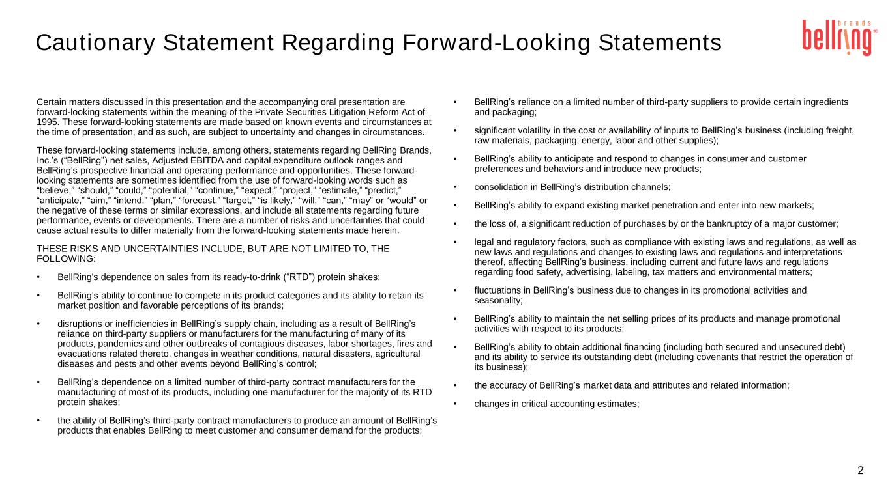
2 Certain matters discussed in this presentation and the accompanying oral presentation are forward-looking statements within the meaning of the Private Securities Litigation Reform Act of 1995. These forward-looking statements are made based on known events and circumstances at the time of presentation, and as such, are subject to uncertainty and changes in circumstances. These forward-looking statements include, among others, statements regarding BellRing Brands, Inc.’s (“BellRing”) net sales, Adjusted EBITDA and capital expenditure outlook ranges and BellRing’s prospective financial and operating performance and opportunities. These forward- looking statements are sometimes identified from the use of forward-looking words such as “believe,” “should,” “could,” “potential,” “continue,” “expect,” “project,” “estimate,” “predict,” “anticipate,” “aim,” “intend,” “plan,” “forecast,” “target,” “is likely,” “will,” “can,” “may” or “would” or the negative of these terms or similar expressions, and include all statements regarding future performance, events or developments. There are a number of risks and uncertainties that could cause actual results to differ materially from the forward-looking statements made herein. THESE RISKS AND UNCERTAINTIES INCLUDE, BUT ARE NOT LIMITED TO, THE FOLLOWING: • BellRing's dependence on sales from its ready-to-drink (“RTD”) protein shakes; • BellRing’s ability to continue to compete in its product categories and its ability to retain its market position and favorable perceptions of its brands; • disruptions or inefficiencies in BellRing’s supply chain, including as a result of BellRing’s reliance on third-party suppliers or manufacturers for the manufacturing of many of its products, pandemics and other outbreaks of contagious diseases, labor shortages, fires and evacuations related thereto, changes in weather conditions, natural disasters, agricultural diseases and pests and other events beyond BellRing’s control; • BellRing’s dependence on a limited number of third-party contract manufacturers for the manufacturing of most of its products, including one manufacturer for the majority of its RTD protein shakes; • the ability of BellRing’s third-party contract manufacturers to produce an amount of BellRing’s products that enables BellRing to meet customer and consumer demand for the products; • BellRing’s reliance on a limited number of third-party suppliers to provide certain ingredients and packaging; • significant volatility in the cost or availability of inputs to BellRing’s business (including freight, raw materials, packaging, energy, labor and other supplies); • BellRing’s ability to anticipate and respond to changes in consumer and customer preferences and behaviors and introduce new products; • consolidation in BellRing’s distribution channels; • BellRing’s ability to expand existing market penetration and enter into new markets; • the loss of, a significant reduction of purchases by or the bankruptcy of a major customer; • legal and regulatory factors, such as compliance with existing laws and regulations, as well as new laws and regulations and changes to existing laws and regulations and interpretations thereof, affecting BellRing’s business, including current and future laws and regulations regarding food safety, advertising, labeling, tax matters and environmental matters; • fluctuations in BellRing’s business due to changes in its promotional activities and seasonality; • BellRing’s ability to maintain the net selling prices of its products and manage promotional activities with respect to its products; • BellRing’s ability to obtain additional financing (including both secured and unsecured debt) and its ability to service its outstanding debt (including covenants that restrict the operation of its business); • the accuracy of BellRing’s market data and attributes and related information; • changes in critical accounting estimates; Cautionary Statement Regarding Forward-Looking Statements

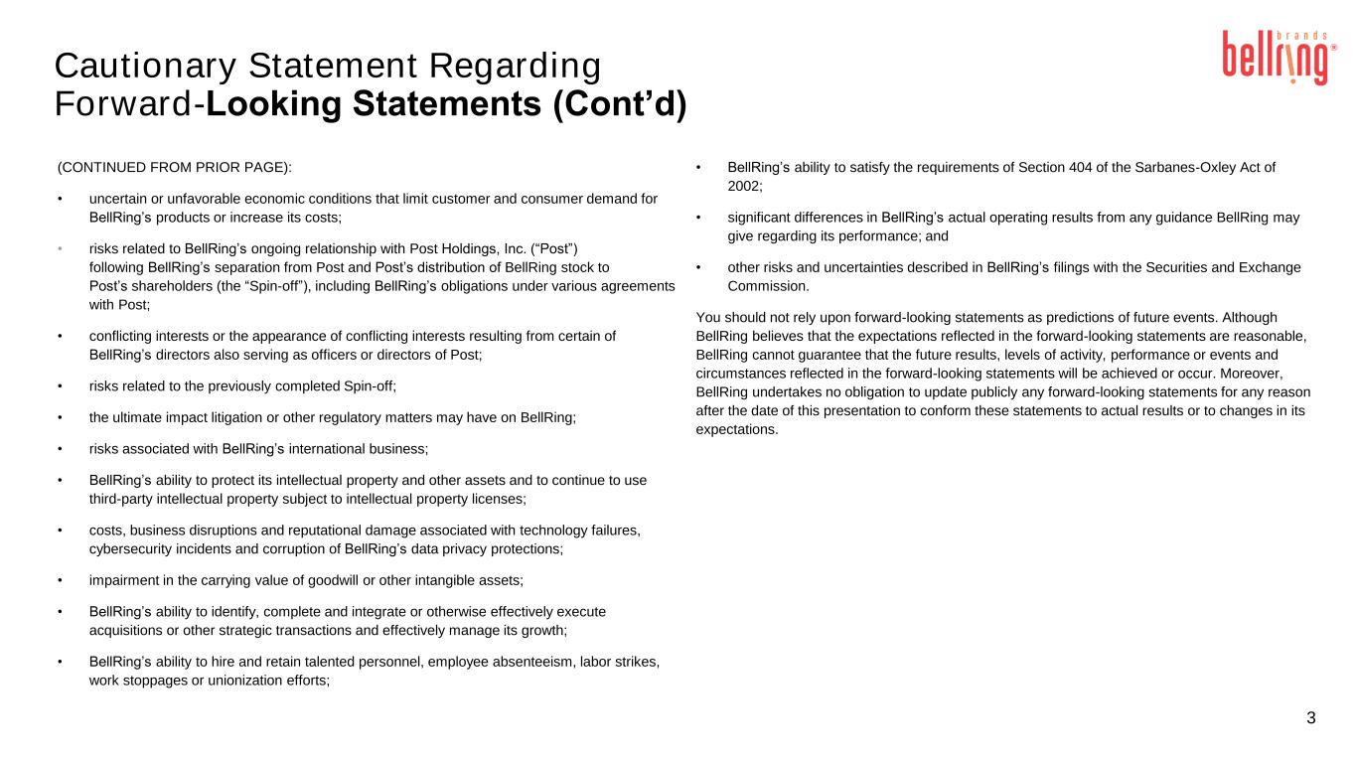
Cautionary Statement Regarding Forward-Looking Statements (Cont’d) 3 (CONTINUED FROM PRIOR PAGE): • uncertain or unfavorable economic conditions that limit customer and consumer demand for BellRing’s products or increase its costs; • risks related to BellRing’s ongoing relationship with Post Holdings, Inc. (“Post”) following BellRing’s separation from Post and Post’s distribution of BellRing stock to Post’s shareholders (the “Spin-off”), including BellRing’s obligations under various agreements with Post; • conflicting interests or the appearance of conflicting interests resulting from certain of BellRing’s directors also serving as officers or directors of Post; • risks related to the previously completed Spin-off; • the ultimate impact litigation or other regulatory matters may have on BellRing; • risks associated with BellRing’s international business; • BellRing’s ability to protect its intellectual property and other assets and to continue to use third-party intellectual property subject to intellectual property licenses; • costs, business disruptions and reputational damage associated with technology failures, cybersecurity incidents and corruption of BellRing’s data privacy protections; • impairment in the carrying value of goodwill or other intangible assets; • BellRing’s ability to identify, complete and integrate or otherwise effectively execute acquisitions or other strategic transactions and effectively manage its growth; • BellRing’s ability to hire and retain talented personnel, employee absenteeism, labor strikes, work stoppages or unionization efforts; • BellRing’s ability to satisfy the requirements of Section 404 of the Sarbanes-Oxley Act of 2002; • significant differences in BellRing’s actual operating results from any guidance BellRing may give regarding its performance; and • other risks and uncertainties described in BellRing’s filings with the Securities and Exchange Commission. You should not rely upon forward-looking statements as predictions of future events. Although BellRing believes that the expectations reflected in the forward-looking statements are reasonable, BellRing cannot guarantee that the future results, levels of activity, performance or events and circumstances reflected in the forward-looking statements will be achieved or occur. Moreover, BellRing undertakes no obligation to update publicly any forward-looking statements for any reason after the date of this presentation to conform these statements to actual results or to changes in its expectations.

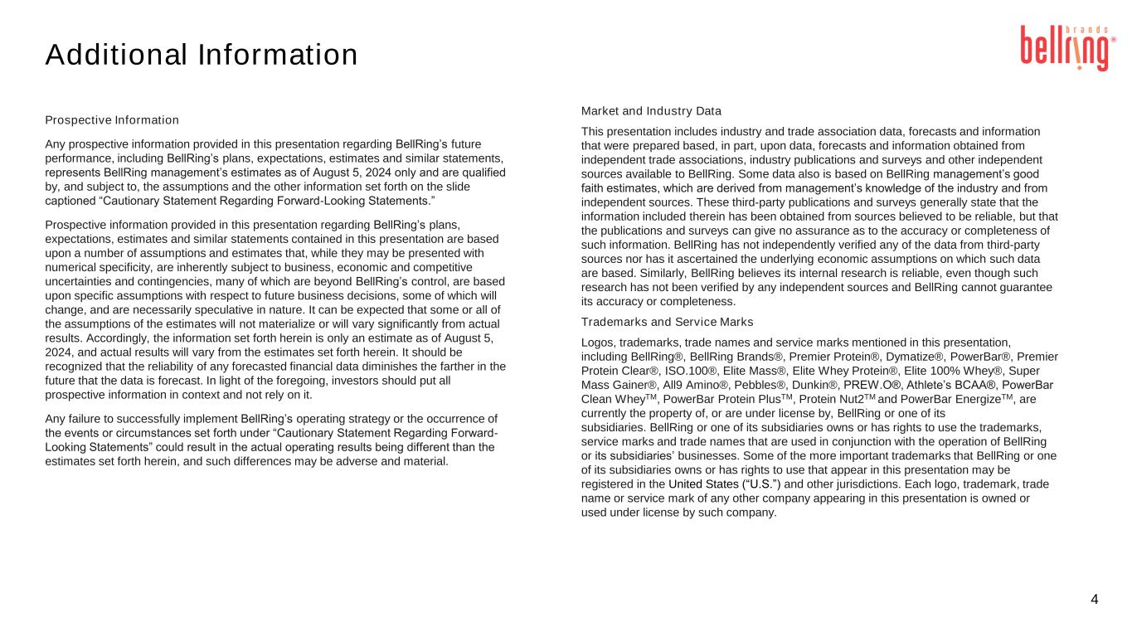
Additional Information 4 Prospective Information Any prospective information provided in this presentation regarding BellRing’s future performance, including BellRing’s plans, expectations, estimates and similar statements, represents BellRing management’s estimates as of August 5, 2024 only and are qualified by, and subject to, the assumptions and the other information set forth on the slide captioned “Cautionary Statement Regarding Forward-Looking Statements.” Prospective information provided in this presentation regarding BellRing’s plans, expectations, estimates and similar statements contained in this presentation are based upon a number of assumptions and estimates that, while they may be presented with numerical specificity, are inherently subject to business, economic and competitive uncertainties and contingencies, many of which are beyond BellRing’s control, are based upon specific assumptions with respect to future business decisions, some of which will change, and are necessarily speculative in nature. It can be expected that some or all of the assumptions of the estimates will not materialize or will vary significantly from actual results. Accordingly, the information set forth herein is only an estimate as of August 5, 2024, and actual results will vary from the estimates set forth herein. It should be recognized that the reliability of any forecasted financial data diminishes the farther in the future that the data is forecast. In light of the foregoing, investors should put all prospective information in context and not rely on it. Any failure to successfully implement BellRing’s operating strategy or the occurrence of the events or circumstances set forth under “Cautionary Statement Regarding Forward- Looking Statements” could result in the actual operating results being different than the estimates set forth herein, and such differences may be adverse and material. Market and Industry Data This presentation includes industry and trade association data, forecasts and information that were prepared based, in part, upon data, forecasts and information obtained from independent trade associations, industry publications and surveys and other independent sources available to BellRing. Some data also is based on BellRing management’s good faith estimates, which are derived from management’s knowledge of the industry and from independent sources. These third-party publications and surveys generally state that the information included therein has been obtained from sources believed to be reliable, but that the publications and surveys can give no assurance as to the accuracy or completeness of such information. BellRing has not independently verified any of the data from third-party sources nor has it ascertained the underlying economic assumptions on which such data are based. Similarly, BellRing believes its internal research is reliable, even though such research has not been verified by any independent sources and BellRing cannot guarantee its accuracy or completeness. Trademarks and Service Marks Logos, trademarks, trade names and service marks mentioned in this presentation, including BellRing®, BellRing Brands®, Premier Protein®, Dymatize®, PowerBar®, Premier Protein Clear®, ISO.100®, Elite Mass®, Elite Whey Protein®, Elite 100% Whey®, Super Mass Gainer®, All9 Amino®, Pebbles®, Dunkin®, PREW.O®, Athlete’s BCAA®, PowerBar Clean WheyTM, PowerBar Protein PlusTM, Protein Nut2TM and PowerBar EnergizeTM, are currently the property of, or are under license by, BellRing or one of its subsidiaries. BellRing or one of its subsidiaries owns or has rights to use the trademarks, service marks and trade names that are used in conjunction with the operation of BellRing or its subsidiaries’ businesses. Some of the more important trademarks that BellRing or one of its subsidiaries owns or has rights to use that appear in this presentation may be registered in the United States (“U.S.”) and other jurisdictions. Each logo, trademark, trade name or service mark of any other company appearing in this presentation is owned or used under license by such company.

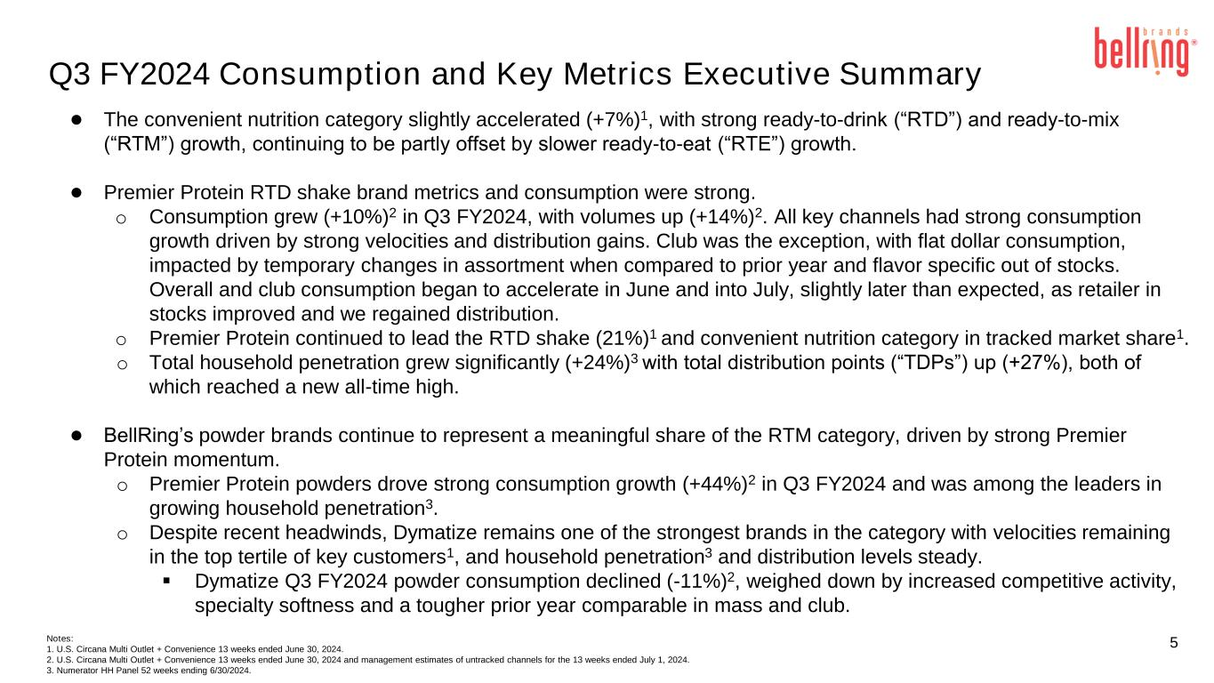
5 Q3 FY2024 Consumption and Key Metrics Executive Summary ● The convenient nutrition category slightly accelerated (+7%)1, with strong ready-to-drink (“RTD”) and ready-to-mix (“RTM”) growth, continuing to be partly offset by slower ready-to-eat (“RTE”) growth. ● Premier Protein RTD shake brand metrics and consumption were strong. o Consumption grew (+10%)2 in Q3 FY2024, with volumes up (+14%)2. All key channels had strong consumption growth driven by strong velocities and distribution gains. Club was the exception, with flat dollar consumption, impacted by temporary changes in assortment when compared to prior year and flavor specific out of stocks. Overall and club consumption began to accelerate in June and into July, slightly later than expected, as retailer in stocks improved and we regained distribution. o Premier Protein continued to lead the RTD shake (21%)1 and convenient nutrition category in tracked market share1. o Total household penetration grew significantly (+24%)3 with total distribution points (“TDPs”) up (+27%), both of which reached a new all-time high. ● BellRing’s powder brands continue to represent a meaningful share of the RTM category, driven by strong Premier Protein momentum. o Premier Protein powders drove strong consumption growth (+44%)2 in Q3 FY2024 and was among the leaders in growing household penetration3. o Despite recent headwinds, Dymatize remains one of the strongest brands in the category with velocities remaining in the top tertile of key customers1, and household penetration3 and distribution levels steady. ▪ Dymatize Q3 FY2024 powder consumption declined (-11%)2, weighed down by increased competitive activity, specialty softness and a tougher prior year comparable in mass and club. Notes: 1. U.S. Circana Multi Outlet + Convenience 13 weeks ended June 30, 2024. 2. U.S. Circana Multi Outlet + Convenience 13 weeks ended June 30, 2024 and management estimates of untracked channels for the 13 weeks ended July 1, 2024. 3. Numerator HH Panel 52 weeks ending 6/30/2024.

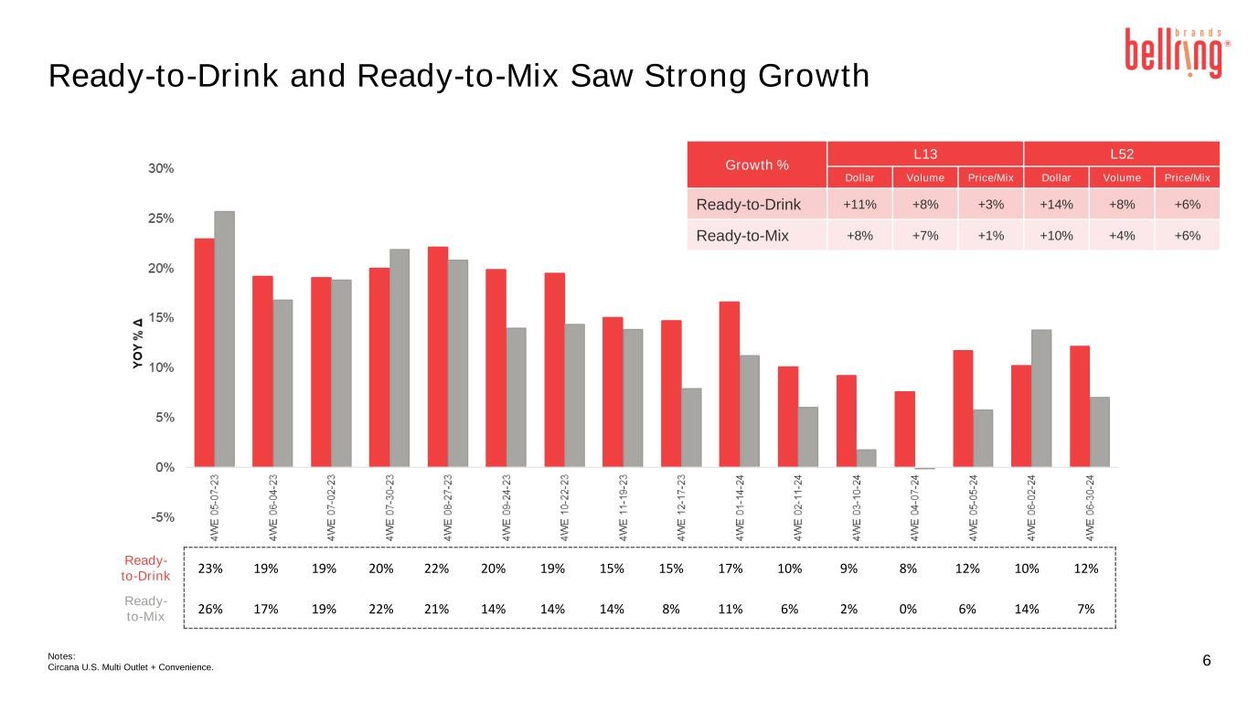
6 Ready-to-Drink and Ready-to-Mix Saw Strong Growth Notes: Circana U.S. Multi Outlet + Convenience. Growth % L13 L52 Dollar Volume Price/Mix Dollar Volume Price/Mix Ready-to-Drink +11% +8% +3% +14% +8% +6% Ready-to-Mix +8% +7% +1% +10% +4% +6% Ready- to-Drink 23% 19% 19% 20% 22% 20% 19% 15% 15% 17% 10% 9% 8% 12% 10% 12% Ready- to-Mix 26% 17% 19% 22% 21% 14% 14% 14% 8% 11% 6% 2% 0% 6% 14% 7%

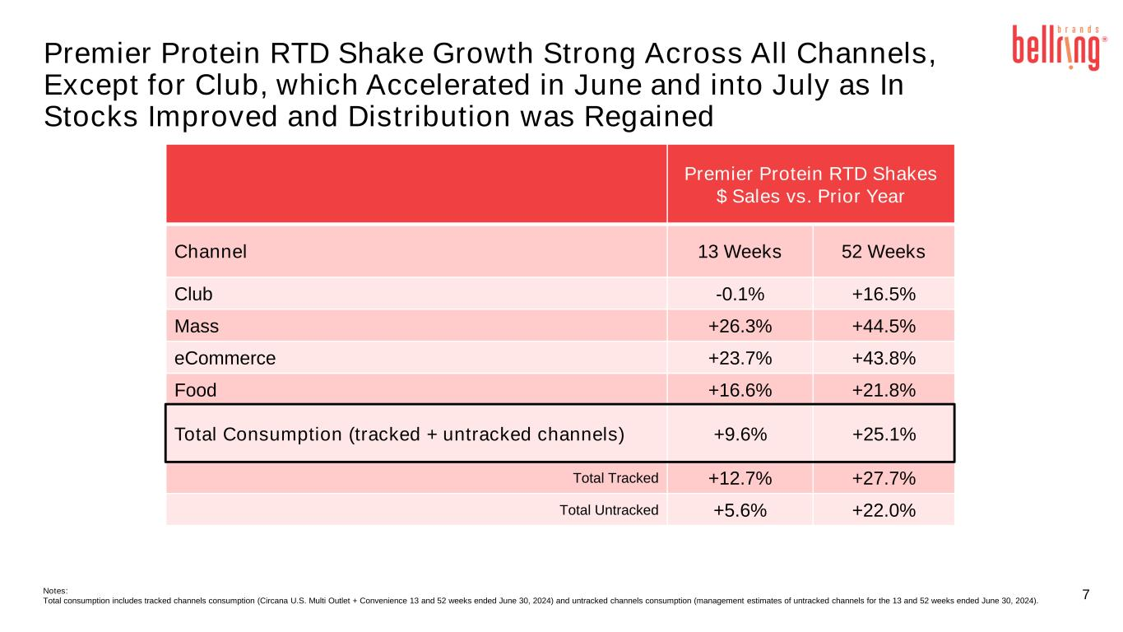
7 Premier Protein RTD Shake Growth Strong Across All Channels, Except for Club, which Accelerated in June and into July as In Stocks Improved and Distribution was Regained Premier Protein RTD Shakes $ Sales vs. Prior Year Channel 13 Weeks 52 Weeks Club -0.1% +16.5% Mass +26.3% +44.5% eCommerce +23.7% +43.8% Food +16.6% +21.8% Total Consumption (tracked + untracked channels) +9.6% +25.1% Total Tracked +12.7% +27.7% Total Untracked +5.6% +22.0% Notes: Total consumption includes tracked channels consumption (Circana U.S. Multi Outlet + Convenience 13 and 52 weeks ended June 30, 2024) and untracked channels consumption (management estimates of untracked channels for the 13 and 52 weeks ended June 30, 2024).

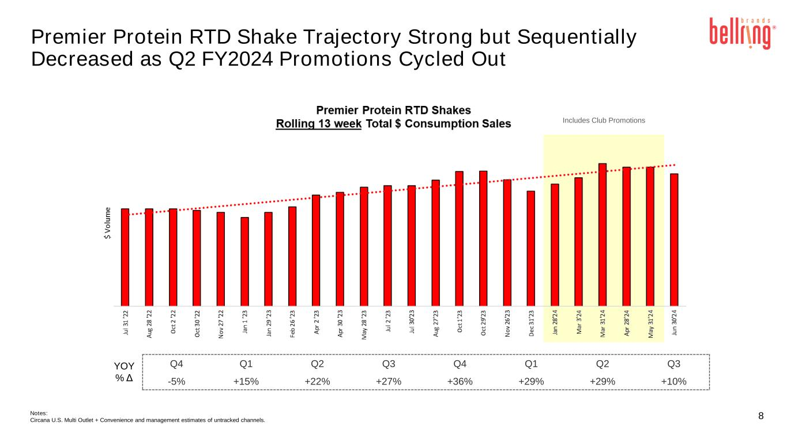
8 Premier Protein RTD Shake Trajectory Strong but Sequentially Decreased as Q2 FY2024 Promotions Cycled Out Notes: Circana U.S. Multi Outlet + Convenience and management estimates of untracked channels. Q4 Q1 Q2 Q3 Q4 Q1 Q2 Q3 -5% +15% +22% +27% +36% +29% +29% +10% YOY % Δ Includes Club Promotions

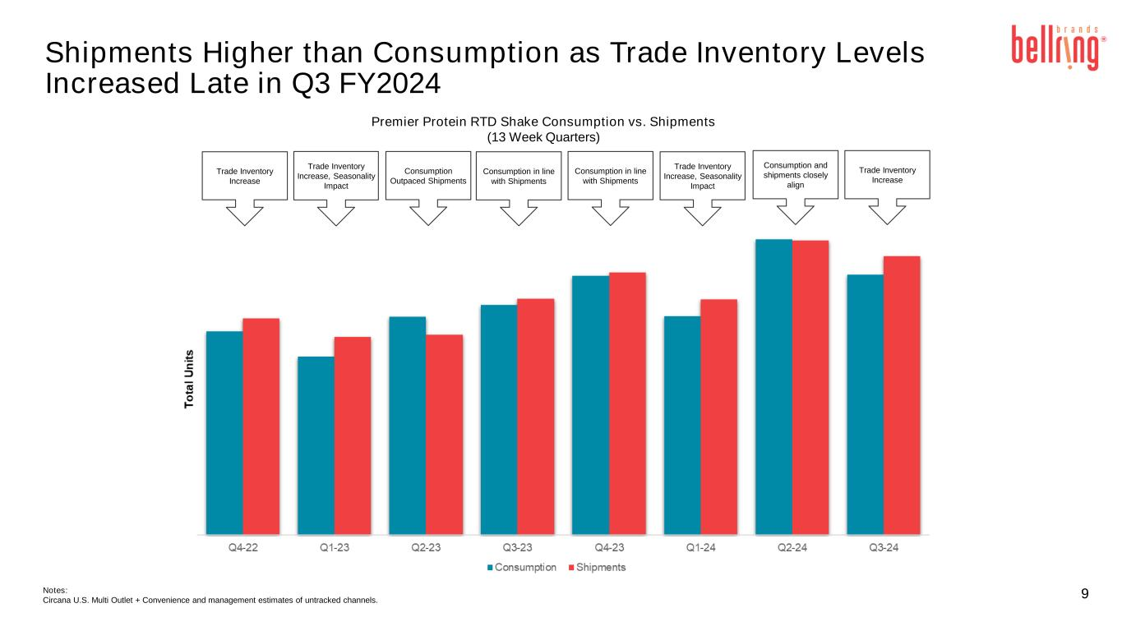
9Notes: Circana U.S. Multi Outlet + Convenience and management estimates of untracked channels. Shipments Higher than Consumption as Trade Inventory Levels Increased Late in Q3 FY2024 Premier Protein RTD Shake Consumption vs. Shipments (13 Week Quarters) Consumption and shipments closely align Trade Inventory Increase, Seasonality Impact Trade Inventory Increase Consumption Outpaced Shipments Consumption in line with Shipments Trade Inventory Increase, Seasonality Impact Consumption in line with Shipments Trade Inventory Increase

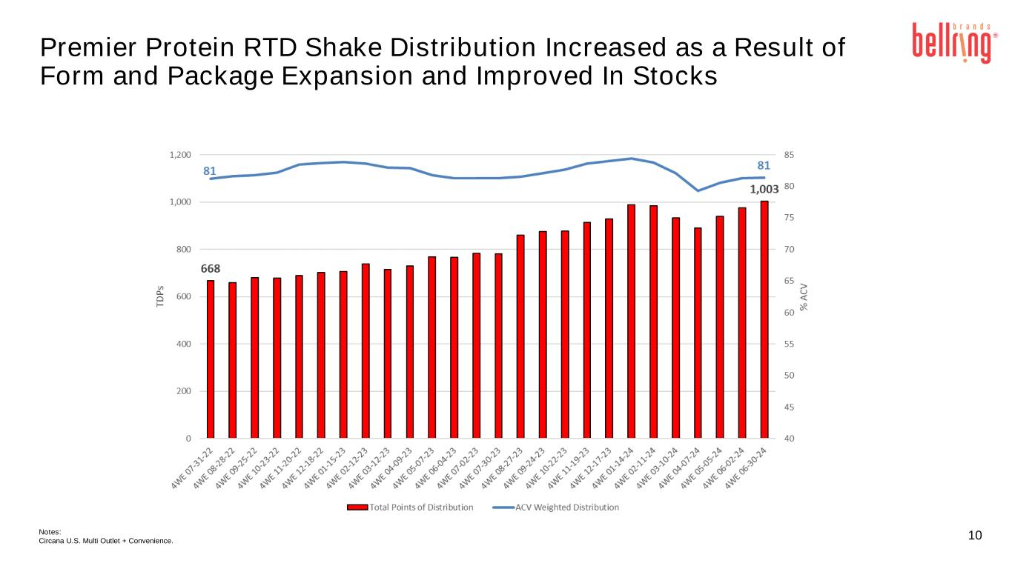
10 Premier Protein RTD Shake Distribution Increased as a Result of Form and Package Expansion and Improved In Stocks Notes: Circana U.S. Multi Outlet + Convenience.

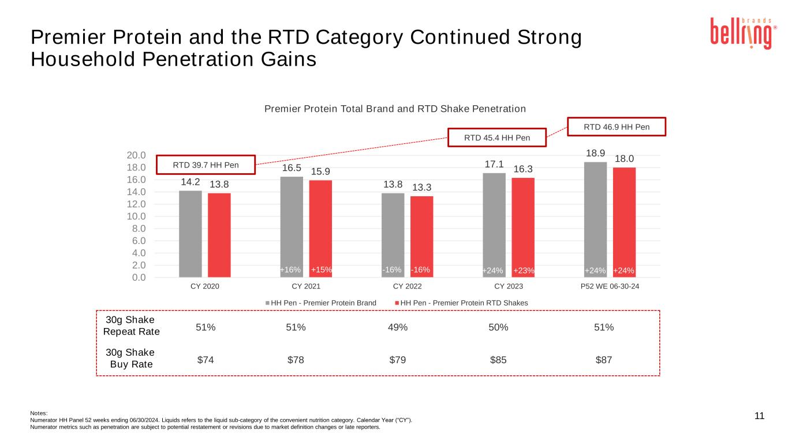
Notes: Numerator HH Panel 52 weeks ending 06/30/2024. Liquids refers to the liquid sub-category of the convenient nutrition category. Calendar Year (“CY”). Numerator metrics such as penetration are subject to potential restatement or revisions due to market definition changes or late reporters. 11 Premier Protein and the RTD Category Continued Strong Household Penetration Gains 14.2 16.5 13.8 17.1 18.9 13.8 15.9 13.3 16.3 18.0 0.0 2.0 4.0 6.0 8.0 10.0 12.0 14.0 16.0 18.0 20.0 CY 2020 CY 2021 CY 2022 CY 2023 P52 WE 06-30-24 Premier Protein Total Brand and RTD Shake Penetration HH Pen - Premier Protein Brand HH Pen - Premier Protein RTD Shakes 30g Shake Repeat Rate 51% 51% 49% 50% 51% 30g Shake Buy Rate $74 $78 $79 $85 $87 RTD 39.7 HH Pen RTD 46.9 HH Pen RTD 45.4 HH Pen +23% +24%+24%+24%+15% -16%-16%+16%

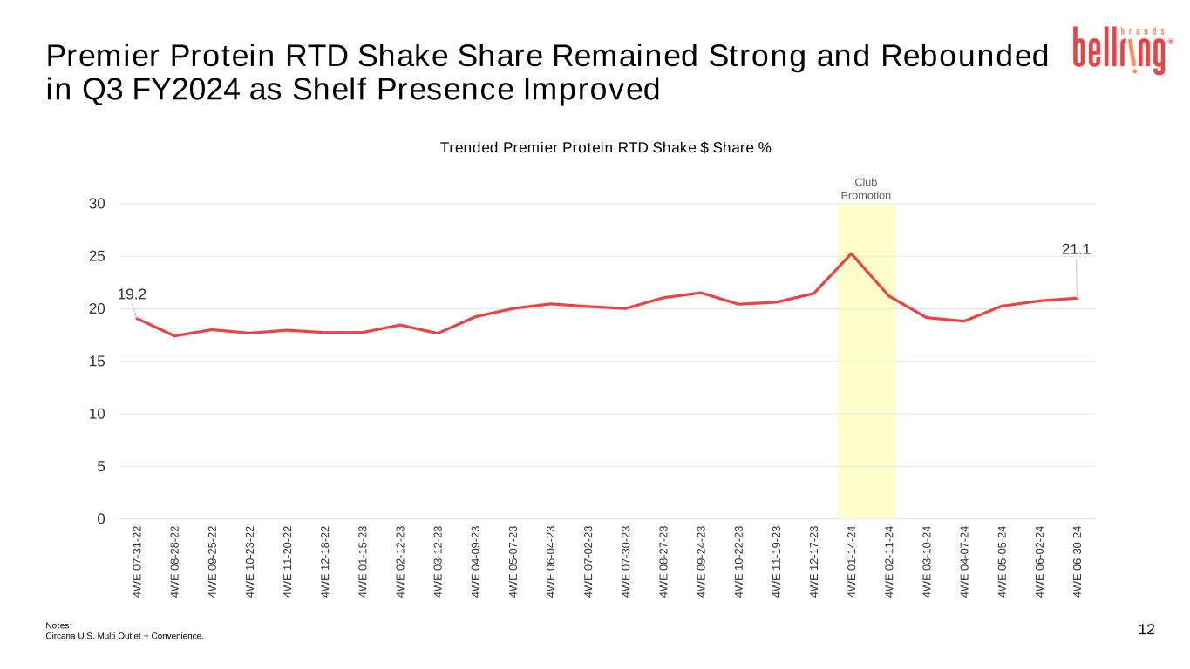
19.2 21.1 0 5 10 15 20 25 30 4 W E 0 7 -3 1 -2 2 4 W E 0 8 -2 8 -2 2 4 W E 0 9 -2 5 -2 2 4 W E 1 0 -2 3 -2 2 4 W E 1 1 -2 0 -2 2 4 W E 1 2 -1 8 -2 2 4 W E 0 1 -1 5 -2 3 4 W E 0 2 -1 2 -2 3 4 W E 0 3 -1 2 -2 3 4 W E 0 4 -0 9 -2 3 4 W E 0 5 -0 7 -2 3 4 W E 0 6 -0 4 -2 3 4 W E 0 7 -0 2 -2 3 4 W E 0 7 -3 0 -2 3 4 W E 0 8 -2 7 -2 3 4 W E 0 9 -2 4 -2 3 4 W E 1 0 -2 2 -2 3 4 W E 1 1 -1 9 -2 3 4 W E 1 2 -1 7 -2 3 4 W E 0 1 -1 4 -2 4 4 W E 0 2 -1 1 -2 4 4 W E 0 3 -1 0 -2 4 4 W E 0 4 -0 7 -2 4 4 W E 0 5 -0 5 -2 4 4 W E 0 6 -0 2 -2 4 4 W E 0 6 -3 0 -2 4 Premier Protein RTD Shake Share Remained Strong and Rebounded in Q3 FY2024 as Shelf Presence Improved 12Notes: Circana U.S. Multi Outlet + Convenience. Trended Premier Protein RTD Shake $ Share % Club Promotion

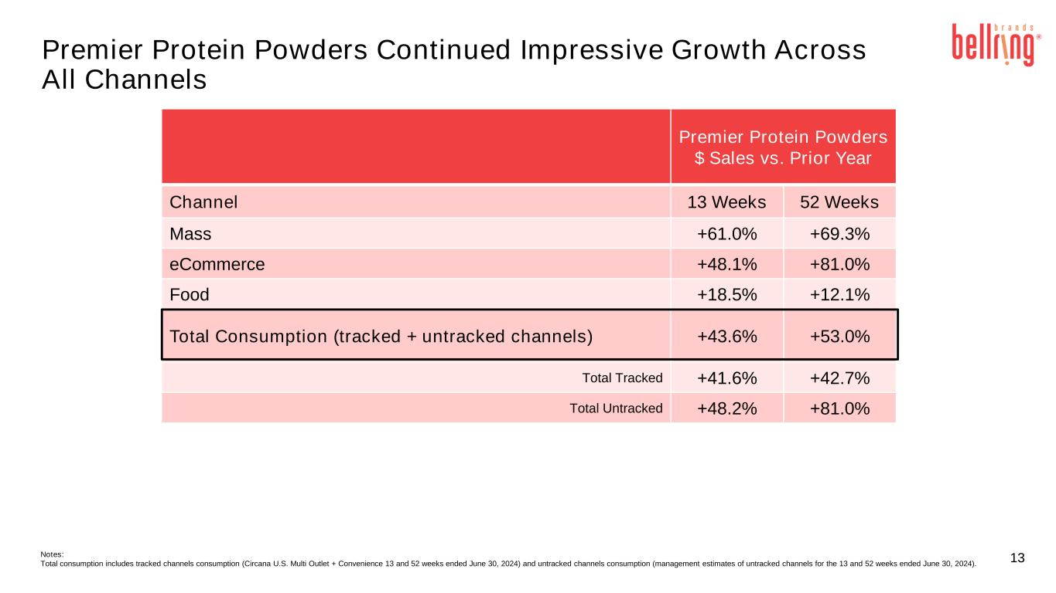
13 Premier Protein Powders Continued Impressive Growth Across All Channels Notes: Total consumption includes tracked channels consumption (Circana U.S. Multi Outlet + Convenience 13 and 52 weeks ended June 30, 2024) and untracked channels consumption (management estimates of untracked channels for the 13 and 52 weeks ended June 30, 2024). Premier Protein Powders $ Sales vs. Prior Year Channel 13 Weeks 52 Weeks Mass +61.0% +69.3% eCommerce +48.1% +81.0% Food +18.5% +12.1% Total Consumption (tracked + untracked channels) +43.6% +53.0% Total Tracked +41.6% +42.7% Total Untracked +48.2% +81.0%

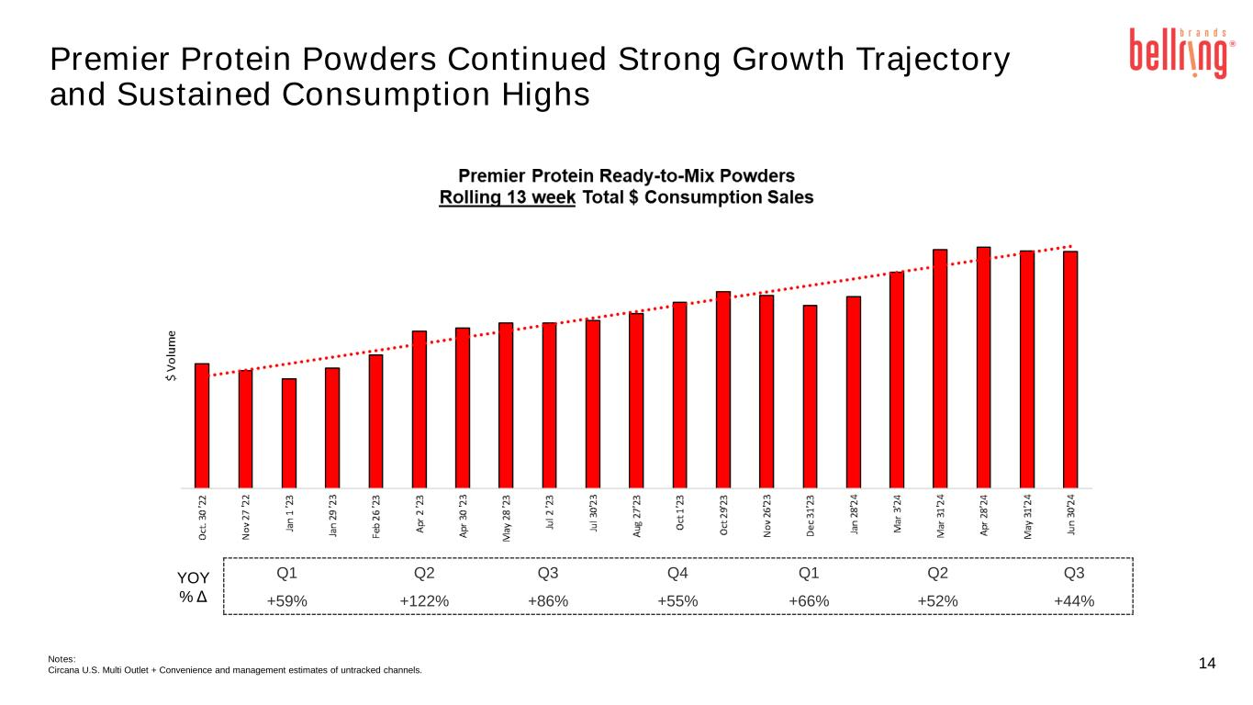
Premier Protein Powders Continued Strong Growth Trajectory and Sustained Consumption Highs 14Notes: Circana U.S. Multi Outlet + Convenience and management estimates of untracked channels. Q1 Q2 Q3 Q4 Q1 Q2 Q3 +59% +122% +86% +55% +66% +52% +44% YOY % Δ

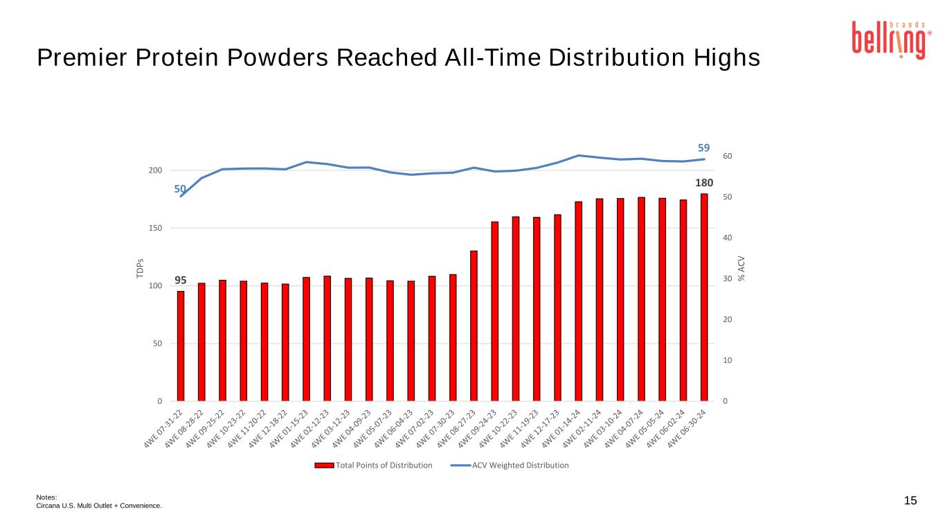
15 Premier Protein Powders Reached All-Time Distribution Highs Notes: Circana U.S. Multi Outlet + Convenience. 95 180 50 59 0 10 20 30 40 50 60 0 50 100 150 200 % A C V TD P s Total Points of Distribution ACV Weighted Distribution

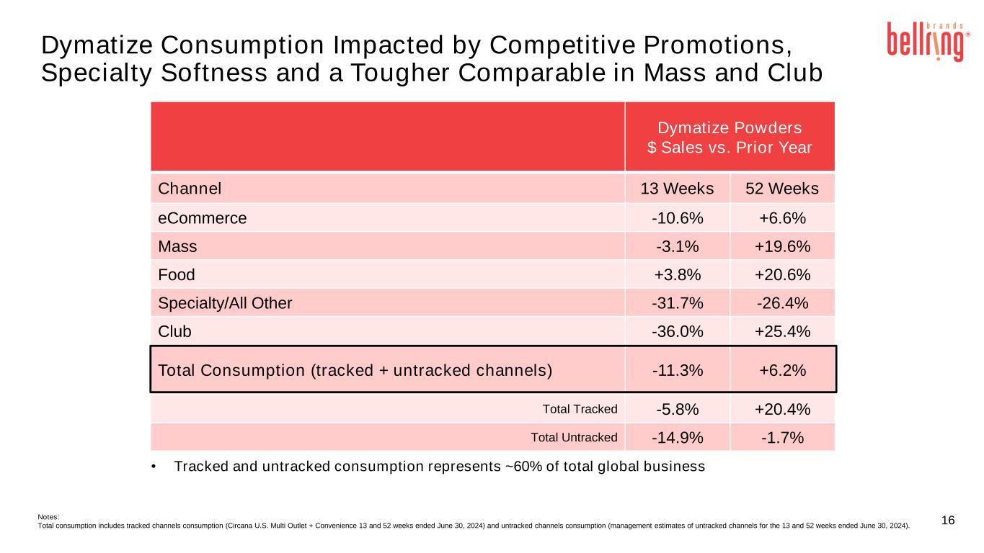
16 • Tracked and untracked consumption represents ~60% of total global business Dymatize Powders $ Sales vs. Prior Year Channel 13 Weeks 52 Weeks eCommerce -10.6% +6.6% Mass -3.1% +19.6% Food +3.8% +20.6% Specialty/All Other -31.7% -26.4% Club -36.0% +25.4% Total Consumption (tracked + untracked channels) -11.3% +6.2% Total Tracked -5.8% +20.4% Total Untracked -14.9% -1.7% Notes: Total consumption includes tracked channels consumption (Circana U.S. Multi Outlet + Convenience 13 and 52 weeks ended June 30, 2024) and untracked channels consumption (management estimates of untracked channels for the 13 and 52 weeks ended June 30, 2024). Dymatize Consumption Impacted by Competitive Promotions, Specialty Softness and a Tougher Comparable in Mass and Club

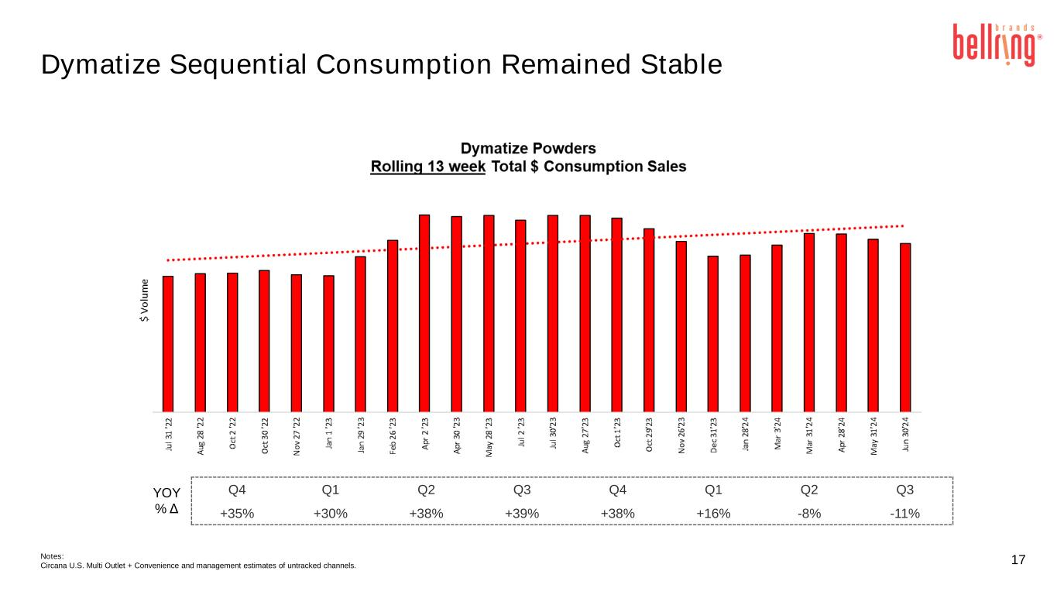
17 Dymatize Sequential Consumption Remained Stable Notes: Circana U.S. Multi Outlet + Convenience and management estimates of untracked channels. Q4 Q1 Q2 Q3 Q4 Q1 Q2 Q3 +35% +30% +38% +39% +38% +16% -8% -11% YOY % Δ

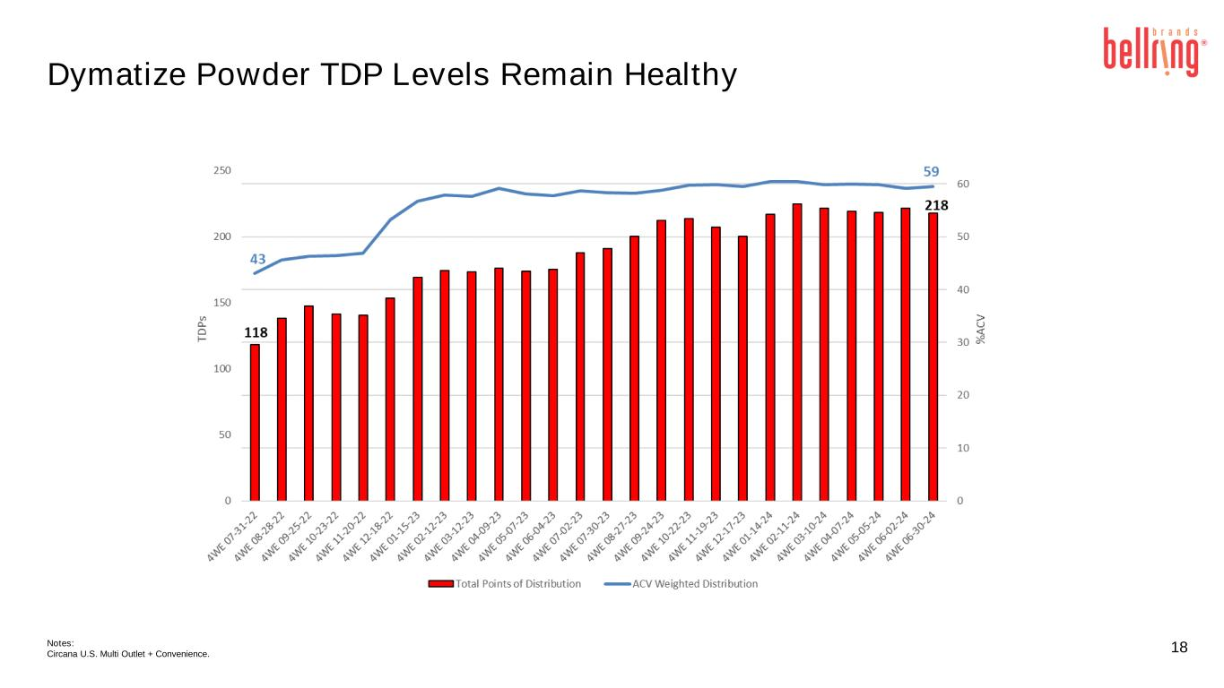
18 Dymatize Powder TDP Levels Remain Healthy Notes: Circana U.S. Multi Outlet + Convenience.

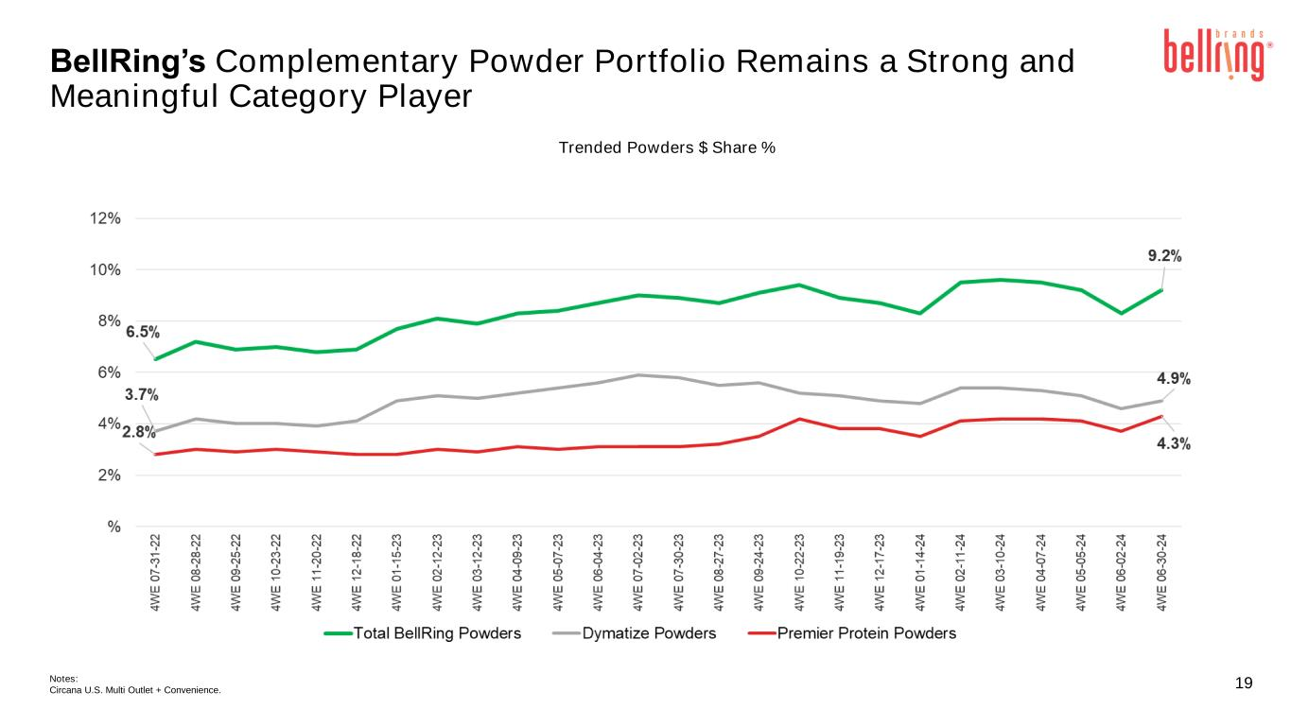
19 Trended Powders $ Share % Notes: Circana U.S. Multi Outlet + Convenience. BellRing’s Complementary Powder Portfolio Remains a Strong and Meaningful Category Player



