UNITED STATES
SECURITIES AND EXCHANGE COMMISSION
Washington, D.C. 20549
______________________
FORM 8-K
CURRENT REPORT
Pursuant to Section 13 OR 15(d) of The
Securities Exchange Act of 1934
Date of Report (Date of earliest event reported): August 4, 2026
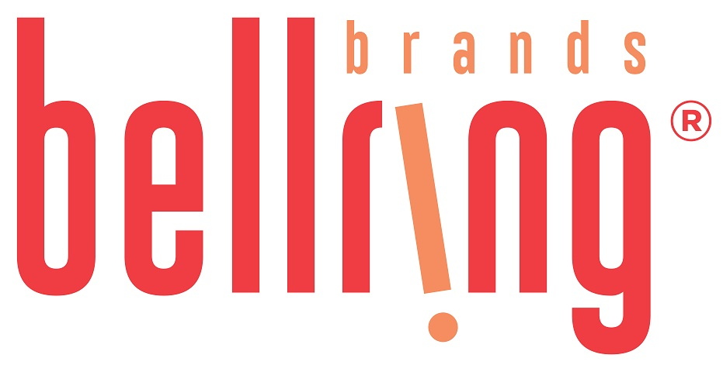
BellRing Brands, Inc.
(Exact name of registrant as specified in its charter)
Delaware |  |  | 001-39093 |  |  |  |  |  | 87-3296749
(State or other jurisdiction of incorporation) |  |  | (Commission File Number) |  |  |  |  |  | (IRS Employer Identification No.)
1 N Brentwood Blvd., Suite 1550 |  |  | St. Louis |  |  | Missouri |  |  | 63105
(Address of Principal Executive Offices) |  |  |  |  |  |  |  |  | (Zip Code)
Registrant’s telephone number, including area code: (314) 644-7652
Check the appropriate box below if the Form 8-K filing is intended to simultaneously satisfy the filing obligation of the registrant under any of the following provisions:
☐ Written communications pursuant to Rule 425 under the Securities Act (17 CFR 230.425)
☐ Soliciting material pursuant to Rule 14a-12 under the Exchange Act (17 CFR 240.14a-12)
☐ Pre-commencement communications pursuant to Rule 14d-2(b) under the Exchange Act (17 CFR 240.14d-2(b))
☐ Pre-commencement communications pursuant to Rule 13e-4(c) under the Exchange Act (17 CFR 240.13e-4(c))
Securities registered pursuant to Section 12(b) of the Act:
Title of each class |  |  | Trading Symbol(s) |  |  | Name of each exchange on which registered
Common Stock, $0.01 par value per share |  |  | BRBR |  |  | New York Stock Exchange
Indicate by check mark whether the registrant is an emerging growth company as defined in Rule 405 of the Securities Act of 1933 (§230.405 of this chapter) or Rule 12b-2 of the Securities Exchange Act of 1934 (§240.12b-2 of this chapter).
Emerging growth company ☐
If an emerging growth company, indicate by check mark if the registrant has elected not to use the extended transition period for complying with any new or revised financial accounting standards provided pursuant to Section 13(a) of the Exchange Act.☐

Item 2.02. Results of Operation and Financial Condition.

On August 4, 2026, BellRing Brands, Inc. (the "Company") issued a press release announcing results for its third fiscal quarter ended June 30, 2026. A copy of the press release is attached hereto as Exhibit 99.1 and incorporated herein by reference.

In addition, on August 4, 2026, the Company published to the "Investor Relations" section of its website, www.bellringbrands.com, a supplemental presentation related to results for its third fiscal quarter ended June 30, 2026. A copy of the presentation is attached hereto as Exhibit 99.2 and incorporated herein by reference.

The information contained in Item 2.02, including Exhibit 99.1 and Exhibit 99.2 attached hereto, shall not be deemed to be "filed" for purposes of Section 18 of the Securities Exchange Act of 1934, as amended (the "Exchange Act"), or otherwise subject to the liabilities of that Section, nor shall they be deemed incorporated by reference into any filings under the Securities Act of 1933, as amended, or the Exchange Act, except as expressly set forth by specific reference in such filing.

9.01. Financial Statements and Exhibits.

(d) Exhibits

Exhibit No. |  |  | Description
99.1 |  |  | Earnings Press Release dated August 4, 2026
99.2 |  |  | Third Fiscal Quarter Ended June 30, 2026 Supplemental Presentation
104 |  |  | Cover Page Interactive Data File (the cover page iXBRL tags are embedded within the Inline XBRL document)

Pursuant to the requirements of the Securities Exchange Act of 1934, the registrant has duly caused this report to be signed on its behalf by the undersigned thereunto duly authorized.

Date: August 4, 2026 |  |  | BellRing Brands, Inc.
 |  |  | (Registrant)
 |  |  | By: |  |  | /s/ Paul A. Rode
 |  |  | Name: |  |  | Paul A. Rode
 |  |  | Title: |  |  | Chief Financial Officer

Exhibit 99.1

BellRing Brands Reports Results for the Third Quarter of Fiscal Year 2026; Updates Fiscal Year 2026 Outlook
St. Louis - August 4, 2026 - BellRing Brands, Inc. (NYSE:BRBR) (“BellRing”), a holding company operating in the global proactive wellness category, today reported results for the third fiscal quarter ended June 30, 2026.
Highlights:
•Third quarter net sales of $570.4 million, up 4% year-over-year
•Operating profit of $65.4 million, net earnings of $34.2 million and Adjusted EBITDA* of $78.3 million, each of which included a pre-tax $10 million inventory-related charge
•Updated fiscal year 2026 net sales outlook of $2.335-$2.375 billion and Adjusted EBITDA* outlook of $275-$295 million, inclusive of full year pre-tax $28 million unfavorable impact of inventory-related actions
*Adjusted EBITDA is a non-GAAP measure. For additional information regarding non-GAAP measures, see the related explanations presented under “Use of Non-GAAP Measures” later in this release. BellRing provides Adjusted EBITDA guidance only on a non-GAAP basis and does not provide a reconciliation of its forward-looking Adjusted EBITDA non-GAAP guidance measure to the most directly comparable GAAP measure due to the inherent difficulty in forecasting and quantifying certain amounts that are necessary for such reconciliation, including the adjustments described under “Outlook” later in this release.
“I am honored to lead BellRing into its next chapter of growth and value creation in a category with attractive long-term fundamentals,” said Michael Axelrod, President and Chief Executive Officer of BellRing, effective July 29, 2026. “Premier Protein is the clear leader in ready-to-drink shakes backed by a powerful brand and deep consumer loyalty. We have a strong foundation and meaningful opportunity to strengthen execution, reinforce our market leadership and deliver more consistent, profitable growth over time. As I begin meeting with our employees, customers and partners, I am energized by the talent across the organization and confident in our ability to create long-term value for shareholders.”
“Our third quarter revenue exceeded our expectations, driven by strong performance from both Premier Protein and Dymatize,” said Paul Rode, Chief Financial Officer of BellRing. “While profitability was impacted by inventory-related charges and continued input cost pressures, the underlying demand trends for our brands remain healthy. Our updated fiscal 2026 outlook reflects these factors, and we are taking decisive actions through pricing, productivity initiatives and disciplined cost management to improve profitability while continuing to invest behind our brands to support long-term growth.”
Third Quarter Consumption Trends
Dollar consumption of Premier Protein ready-to-drink (“RTD”) shakes increased 6.0%, Premier Protein powder products decreased 4.2% and Dymatize powder and RTD products increased 2.7% in the 13-week period ended June 28, 2026, as compared to the same period in 2025 (inclusive of Circana United States (“U.S.”) Multi Outlet Plus with Convenience and management estimates of untracked channels). For additional information regarding consumption metrics, see the supplemental presentation on BellRing’s website, which can be accessed by visiting the Investor Relations section.
Third Quarter Operating Results
Net sales were $570.4 million, an increase of 4.2%, or $22.9 million, compared to the prior year period, driven by 1.7% increase in volume and 2.5% increase in price/mix.
Premier Protein net sales increased 0.7%, driven by 1.5% increase in volume and 0.8% decrease in price/mix. Premier Protein RTD shake net sales increased 1.2%, driven by 3.1% increase in volume and 1.9% decrease in price/mix. Volume gains were driven by distribution gains. Price/mix was negatively impacted by incremental promotional investment.
Dymatize net sales increased 26.7%, driven by 6.0% increase in volume and 20.7% increase in price/mix. Net sales benefited from higher average net selling prices in connection with inflation-driven price increases and international distribution gains.
Gross profit was $163.3 million, or 28.6% of net sales, a decrease of $30.3 million, compared to $193.6 million, or 35.4% of net sales, in the prior year period. Adjusted gross profit* was $157.9 million, or 27.7% of net sales, a decrease of $34.5 million,
1
compared to $192.4 million, or 35.1% of net sales in the prior year period. In the third quarter of 2026, gross profit and adjusted gross profit were impacted by significant input cost inflation (inclusive of tariffs) and higher freight. In addition, gross profit and adjusted gross profit were impacted by a $10.0 million charge for excess shake bottle inventory; this reflected a 180 unfavorable basis point impact to gross margin and adjusted gross margin.
*Adjusted gross profit and adjusted gross profit margin are non-GAAP measures that exclude mark-to-market adjustments on commodity hedges. For additional information regarding non-GAAP measures, see the related explanations presented under “Use of Non-GAAP Measures” later in this release.
Selling, general and administrative (“SG&A”) expenses were $93.7 million, or 16.4% of net sales, a decrease of $50.8 million compared to $144.5 million, or 26.4% of net sales, in the prior year period. SG&A expenses included $5.4 million in reorganization charges in the third quarter of 2026 and a $68.1 million provision for legal matters in the third quarter of 2025, both of which were treated as adjustments for non-GAAP measures. Marketing and consumer advertising expenses were $23.1 million, an increase of $6.7 million compared to the prior year period, driven by increased Premier Protein spend.
Operating profit was $65.4 million, an increase of $20.6 million, compared to $44.8 million in the prior year period with reduced SG&A expenses partly offset by lower gross profit.
Interest expense, net was $19.9 million and $18.4 million in the third quarter of 2026 and 2025, respectively, with the increase primarily driven by higher outstanding borrowings under BellRing’s revolving credit facility. Income tax expense was $11.3 million in the third quarter of 2026 compared to $5.4 million in the third quarter of 2025. The effective income tax rate was 24.8% and 20.5% in the third quarter of 2026 and 2025, respectively, with the increase primarily attributable to discrete tax benefits recognized in the prior year period.
Net earnings were $34.2 million, an increase of $13.2 million, compared to $21.0 million in the prior year period, and were impacted by the current year $10.0 million excess inventory charge. Net earnings per diluted common share were $0.29 compared to $0.16 in the prior year period. Adjusted net earnings* were $35.0 million, a decrease of $35.8 million, compared to $70.8 million in the prior year period. Adjusted diluted earnings per common share* were $0.30 compared to $0.55 in the prior year period.
Adjusted EBITDA* was $78.3 million, a decrease of $42.0 million, compared to $120.3 million in the prior year period, and was impacted by the current year $10.0 million excess inventory charge.
*Adjusted net earnings, Adjusted diluted earnings per common share and Adjusted EBITDA are non-GAAP measures. For additional information regarding non-GAAP measures, see the related explanations presented under “Use of Non-GAAP Measures” later in this release.
Nine Month Operating Results
Net sales were $1,706.4 million, an increase of 2.3%, or $38.0 million, compared to the prior year period, driven by 4.7% increase in volume and 2.4% decrease in price/mix. Premier Protein net sales increased 0.4%, driven by 4.6% increase in volume and 4.2% decrease in price/mix. Premier Protein RTD shake net sales increased 0.5%, driven by 5.2% increase in volume and 4.7% decrease in price/mix. Dymatize net sales increased 13.7%, driven by 9.0% increase in volume and 4.7% increase in price/mix.
Gross profit was $485.8 million, or 28.5% of net sales, a decrease of $97.2 million, compared to $583.0 million, or 34.9% of net sales, in the prior year period. Adjusted gross profit* was $454.7 million, or 26.6% of net sales, a decrease of $138.5 million, compared to $593.2 million, or 35.6% of net sales in the prior year period. In the nine months ended June 30, 2026, gross profit and adjusted gross profit were impacted by significant input cost inflation (inclusive of tariffs), unfavorable price/mix and higher freight. In addition, gross profit and adjusted gross profit were impacted by a $10.0 million charge for excess bottle inventory recorded in the third quarter and an $11.3 million inventory-related charge recorded in the second quarter associated with a third-party supplied ingredient that did not meet BellRing’s quality requirements (the combination of which represented an unfavorable 120 basis point impact to gross profit margin and adjusted gross profit margin.)
*Adjusted gross profit and adjusted gross profit margin are non-GAAP measures that exclude mark-to-market adjustments on commodity hedges. For additional information regarding non-GAAP measures, see the related explanations presented under “Use of Non-GAAP Measures” later in this release.
SG&A expenses were $263.2 million, or 15.4% of net sales, a decrease of $51.9 million, compared to $315.1 million, or 18.9% of net sales, in the prior year period. SG&A expenses included $5.9 million in reorganization charges in the nine months ended June 30, 2026 and a $69.0 million provision for legal matters in the nine months ended June 30, 2025, both of which were treated as adjustments for non-GAAP measures. Marketing and consumer advertising expenses were $71.8 million, an increase of $12.7 million compared to the prior year period, driven by increased Premier Protein spend.
Operating profit was $209.9 million, a decrease of $45.3 million, compared to $255.2 million in the prior year period driven by lower gross profit.

2
Interest expense, net was $60.0 million and $49.3 million in the nine months ended June 30, 2026 and 2025, respectively, with the increase primarily driven by higher outstanding borrowings under BellRing’s revolving credit facility. Income tax expense was $38.1 million in the nine months ended June 30, 2026 compared to $49.3 million in the nine months ended June 30, 2025. The effective income tax rate was 25.4% and 23.9% in the nine months ended June 30, 2026 and 2025, respectively.
Net earnings were $111.8 million, a decrease of $44.8 million, compared to $156.6 million in the prior year period, and were impacted by the current year $21.3 million inventory-related charges as described above. Net earnings per diluted common share were $0.95 compared to $1.21 in the prior year period. Adjusted net earnings* were $96.0 million, a decrease of $119.7 million, compared to $215.7 million in the prior year period. Adjusted diluted earnings per common share* were $0.81 compared to $1.66 in the prior year period.
Adjusted EBITDA* was $222.4 million, a decrease of $141.8 million, compared to $364.2 million in the prior year period, and was impacted by the current year $21.3 million inventory-related charges as described above.
*Adjusted net earnings, Adjusted diluted earnings per common share and Adjusted EBITDA are non-GAAP measures. For additional information regarding non-GAAP measures, see the related explanations presented under “Use of Non-GAAP Measures” later in this release.
Share Repurchases
During the nine months ended June 30, 2026, BellRing repurchased 4.9 million shares for $133.1 million at an average price of $27.41 per share. As of June 30, 2026, BellRing had $506.9 million remaining under its share repurchase authorization.
Outlook
For fiscal year 2026, BellRing management has updated its previously issued guidance, as shown in the table below. Adjusted EBITDA outlook includes $28 million of unfavorable inventory-related impacts, of which $21.3 million were recorded in the second and third quarters, including an $11.3 million inventory-related charge associated with a third-party supplied ingredient that did not meet BellRing’s quality requirements (recovery of which has not been incorporated into this outlook) and a $10.0 million charge for excess shake bottle inventory. In addition, Adjusted EBITDA is expected to be unfavorably impacted by approximately $7 million in the fourth quarter, primarily from targeted trade spend to support sell-through of excess shake bottle inventory and optimize inventory levels ahead of fiscal year end.
Metric |  |  | Fiscal Year 2026
Net Sales |  |  | $2.335-$2.375 billion
Net Sales Growth |  |  | 1% to 3%
Adjusted EBITDA |  |  | $275-$295 million
Adjusted EBITDA as a percentage of Net Sales |  |  | Approximately 12%
Capital Expenditures |  |  | $10 million
BellRing provides Adjusted EBITDA and Adjusted EBITDA as a percentage of net sales guidance only on a non-GAAP basis and does not provide a reconciliation of its forward-looking Adjusted EBITDA and Adjusted EBITDA as a percentage of net sales non-GAAP guidance measures to the most directly comparable GAAP measures due to the inherent difficulty in forecasting and quantifying certain amounts that are necessary for such reconciliation, including adjustments that could be made for mark-to-market adjustments on commodity hedges, office relocation costs, executive transition costs and other charges reflected in BellRing’s reconciliation of historical numbers, the amounts of which, based on historical experience, could be significant. For additional information regarding BellRing’s non-GAAP measures, see the related explanations presented under “Use of Non-GAAP Measures.”
Use of Non-GAAP Measures
BellRing uses certain non-GAAP measures in this release to supplement the financial measures prepared in accordance with U.S. generally accepted accounting principles (“GAAP”). These non-GAAP measures include Adjusted gross profit, Adjusted gross profit margin, Adjusted net earnings, Adjusted diluted earnings per common share, Adjusted EBITDA and Adjusted EBITDA as a percentage of net sales. The reconciliation of each of these non-GAAP measures to the most directly comparable GAAP measure is provided later in this release under “Explanation and Reconciliation of Non-GAAP Measures.”
Management uses certain of these non-GAAP measures, including Adjusted EBITDA and Adjusted EBITDA as a percentage of net sales, as key metrics in the evaluation of underlying company performance, in making financial, operating and planning decisions and, in part, in the determination of bonuses for its executive officers and employees. Additionally, BellRing is required to comply with certain covenants and limitations that are based on variations of EBITDA in its financing documents. Management believes the use of these non-GAAP measures provides increased transparency and assists investors in

3
understanding the underlying operating performance of BellRing and in the analysis of ongoing operating trends. Non-GAAP measures are not prepared in accordance with GAAP, as they exclude certain items as described later in this release. These non-GAAP measures may not be comparable to similarly titled measures of other companies. For additional information regarding BellRing’s non-GAAP measures, see the related explanations provided under “Explanation and Reconciliation of Non-GAAP Measures” later in this release.
Conference Call to Discuss Earnings Results and Outlook
BellRing will host a conference call on Tuesday, August 4, 2026 at 8:30 a.m. ET to discuss financial results for the third quarter of fiscal year 2026 and fiscal year 2026 outlook and to respond to questions. Michael C. Axelrod, President and Chief Executive Officer, and Paul A. Rode, Chief Financial Officer, will participate in the call.
Interested parties may join the conference call by registering in advance at the following link: BellRing Q3 2026 Earnings Conference Call. Upon registration, participants will receive a dial-in number and a unique passcode to access the conference call. Interested parties are invited to listen to the webcast of the conference call, which can be accessed by visiting the Investor Relations section of BellRing’s website at www.bellring.com. A slide presentation containing supplemental material will also be available at the same location on BellRing’s website. A webcast replay also will be available for a limited period on BellRing’s website in the Investor Relations section.
Prospective Financial Information
Prospective financial information is necessarily speculative in nature, and it can be expected that some or all of the assumptions underlying the prospective financial information described above will not materialize or will vary significantly from actual results. For further discussion of some of the factors that may cause actual results to vary materially from the information provided above, see “Forward-Looking Statements” below. Accordingly, the prospective financial information provided above is only an estimate of what BellRing’s management believes is realizable as of the date of this release. It also should be recognized that the reliability of any forecasted financial data diminishes the farther in the future that the data is forecasted. In light of the foregoing, the information should be viewed in context and undue reliance should not be placed upon it.
Forward-Looking Statements
Certain matters discussed in this release and on BellRing’s conference call are forward-looking statements, including BellRing’s net sales, Adjusted EBITDA, Adjusted EBITDA as a percentage of net sales and capital expenditures outlook for fiscal year 2026. These forward-looking statements are sometimes identified from the use of forward-looking words such as “believe,” “should,” “could,” “potential,” “continue,” “expect,” “project,” “estimate,” “predict,” “anticipate,” “aim,” “intend,” “plan,” “forecast,” “target,” “is likely,” “will,” “can,” “may” or “would” or the negative of these terms or similar expressions, and include all statements regarding future performance, earnings projections, events or developments. There are a number of risks and uncertainties that could cause actual results to differ materially from the forward-looking statements made herein. These risks and uncertainties include, but are not limited to, the following:
•BellRing’s dependence on sales from its RTD protein shakes;
•BellRing’s ability to continue to compete in its product categories and its ability to retain its market position and favorable perceptions of its brands;
•disruptions or inefficiencies in BellRing’s supply chain, including as a result of BellRing’s reliance on third-party suppliers or manufacturers for the manufacturing of many of its products, pandemics and other outbreaks of contagious diseases, labor shortages, fires and evacuations related thereto, changes in weather conditions, natural disasters, agricultural diseases and pests and other events beyond BellRing’s control;
•BellRing’s dependence on third-party contract manufacturers for the manufacture of most of its products, including one manufacturer for nearly half of its RTD protein shakes;
•the ability of BellRing’s third-party contract manufacturers to produce an amount of BellRing’s products that enables BellRing to meet customer and consumer demand for the products;
•BellRing’s reliance on a limited number of third-party suppliers to provide certain ingredients and packaging;
•significant volatility in the cost or availability of inputs to BellRing’s business (including freight, raw materials, packaging, energy, labor and other supplies), including as a result of tariffs or inflationary pressures;
•BellRing’s ability to anticipate and respond to changes in consumer and customer preferences and behaviors and introduce new products;
•BellRing’s ability to expand existing market penetration and enter into new markets;
•consolidation in BellRing’s distribution channels;
•the loss of, a significant reduction of purchases by or the bankruptcy of a major customer;
•legal and regulatory factors, such as compliance with existing laws and regulations, as well as new laws and regulations and changes to existing laws and regulations and interpretations thereof, affecting BellRing’s business,

4
including current and future laws and regulations regarding food safety, advertising, labeling, tax matters and environmental matters;
•fluctuations in BellRing’s business due to changes in its promotional activities and seasonality;
•BellRing’s ability to maintain the net selling prices of its products and manage promotional activities with respect to its products;
•BellRing’s ability to obtain additional financing (including both secured and unsecured debt) and its ability to service its outstanding debt (including covenants that restrict the operation of its business);
•the ultimate impact litigation or other regulatory matters may have on BellRing;
•the accuracy of BellRing’s market data and attributes and related information;
•changes in critical accounting estimates;
•uncertain or unfavorable economic conditions that limit customer and consumer demand for BellRing’s products or increase its costs;
•risks related to BellRing’s ongoing relationship with Post Holdings, Inc. (“Post”) following BellRing’s separation from Post and Post’s distribution of BellRing stock to Post’s shareholders (“the Spin-off”), including BellRing’s obligations under various agreements with Post;
•conflicting interests or the appearance of conflicting interests resulting from certain of BellRing’s directors also serving as officers and/or directors of Post;
•risks related to the previously completed Spin-off;
•risks associated with BellRing’s international business;
•BellRing’s ability to protect its intellectual property and other assets and to continue to use third-party intellectual property subject to intellectual property licenses;
•costs, business disruptions and reputational damage associated with technology failures, cybersecurity incidents and corruption of BellRing’s data privacy protections;
•impairment in the carrying value of goodwill or other intangible assets or other long-lived assets;
•BellRing’s ability to identify, complete and integrate or otherwise effectively execute acquisitions or other strategic transactions and effectively manage its growth;
•BellRing’s ability to hire and retain talented personnel, employee absenteeism, labor strikes, work stoppages or unionization efforts;
•BellRing’s ability to satisfy the requirements of Section 404 of the Sarbanes-Oxley Act of 2002;
•significant differences in BellRing’s actual operating results from any guidance BellRing may give regarding its performance; and
•other risks and uncertainties described in BellRing’s filings with the Securities and Exchange Commission.
These forward-looking statements represent BellRing’s judgment as of the date of this release. BellRing disclaims, however, any intent or obligation to update these forward-looking statements.
About BellRing Brands, Inc.
BellRing Brands, Inc. (NYSE: BRBR) is a dynamic and fast-growing consumer brands business with the purpose of Changing Lives with Good Energy. Focused on growing the proactive wellness category, the company’s brands include Premier Protein, the #1 ready-to-drink protein and proactive wellness brand, and Dymatize, the brand behind the #1 hydrolyzed protein powder. A culture-driven, pure-play company, BellRing Brands believes nutrition is at the core of a healthy world and produces products with best-in-class nutritional profiles and exceptional flavors. Its products are distributed in over 90 countries across club, mass, food, eCommerce, specialty, drug and convenience. To learn more visit www.bellring.com.

Contact:
Investor Relations
Jennifer Meyer
jennifer.meyer@bellringbrands.com
(415) 814-9388

5
CONDENSED CONSOLIDATED STATEMENTS OF OPERATIONS (Unaudited)
(in millions, except for per share data)
 |  |  | Three Months Ended  June 30, |  |  |  |  |  |  |  |  |  |  |  | Nine Months Ended  June 30,
 |  |  | 2026 |  |  |  |  |  | 2025 |  |  |  |  |  | 2026 |  |  |  |  |  | 2025
Net Sales |  |  | $ | 570.4 |  |  |  |  | $ | 547.5 |  |  |  |  | $ | 1,706.4 |  |  |  |  | $ | 1,668.4
Cost of goods sold |  |  | 407.1 |  |  |  |  |  | 353.9 |  |  |  |  |  | 1,220.6 |  |  |  |  |  | 1,085.4
Gross Profit |  |  | 163.3 |  |  |  |  |  | 193.6 |  |  |  |  |  | 485.8 |  |  |  |  |  | 583.0
Selling, general and administrative expenses |  |  | 93.7 |  |  |  |  |  | 144.5 |  |  |  |  |  | 263.2 |  |  |  |  |  | 315.1
Amortization of intangible assets |  |  | 4.2 |  |  |  |  |  | 4.3 |  |  |  |  |  | 12.7 |  |  |  |  |  | 12.7
Operating Profit |  |  | 65.4 |  |  |  |  |  | 44.8 |  |  |  |  |  | 209.9 |  |  |  |  |  | 255.2
Interest expense, net |  |  | 19.9 |  |  |  |  |  | 18.4 |  |  |  |  |  | 60.0 |  |  |  |  |  | 49.3
Earnings before Income Taxes |  |  | 45.5 |  |  |  |  |  | 26.4 |  |  |  |  |  | 149.9 |  |  |  |  |  | 205.9
Income tax expense |  |  | 11.3 |  |  |  |  |  | 5.4 |  |  |  |  |  | 38.1 |  |  |  |  |  | 49.3
Net Earnings |  |  | $ | 34.2 |  |  |  |  | $ | 21.0 |  |  |  |  | $ | 111.8 |  |  |  |  | $ | 156.6
Earnings per Common Share:
Basic |  |  | $ | 0.29 |  |  |  |  | $ | 0.17 |  |  |  |  | $ | 0.95 |  |  |  |  | $ | 1.22
Diluted |  |  | $ | 0.29 |  |  |  |  | $ | 0.16 |  |  |  |  | $ | 0.95 |  |  |  |  | $ | 1.21
Weighted-Average Common Shares Outstanding:
Basic |  |  | 116.4 |  |  |  |  |  | 126.6 |  |  |  |  |  | 117.7 |  |  |  |  |  | 127.9
Diluted |  |  | 116.6 |  |  |  |  |  | 128.0 |  |  |  |  |  | 118.0 |  |  |  |  |  | 129.7

6
CONDENSED CONSOLIDATED BALANCE SHEETS (Unaudited)
(in millions)
 |  |  | June 30, 2026 |  |  |  |  |  | September 30, 2025
ASSETS
Current Assets
Cash and cash equivalents |  |  | $ | 50.4 |  |  |  |  | $ | 71.8
Restricted cash |  |  | 0.6 |  |  |  |  |  | 17.3
Receivables, net |  |  | 216.3 |  |  |  |  |  | 223.4
Inventories |  |  | 480.6 |  |  |  |  |  | 330.4
Prepaid expenses and other current assets |  |  | 31.6 |  |  |  |  |  | 22.6
Total Current Assets |  |  | 779.5 |  |  |  |  |  | 665.5
Property, net |  |  | 30.5 |  |  |  |  |  | 19.0
Goodwill |  |  | 65.9 |  |  |  |  |  | 65.9
Intangible assets, net |  |  | 112.2 |  |  |  |  |  | 125.0
Deferred income taxes |  |  | 24.9 |  |  |  |  |  | 32.4
Other assets |  |  | 39.1 |  |  |  |  |  | 33.2
Total Assets |  |  | $ | 1,052.1 |  |  |  |  | $ | 941.0
LIABILITIES AND STOCKHOLDERS’ DEFICIT
Current Liabilities
Accounts payable |  |  | $ | 167.7 |  |  |  |  | $ | 119.5
Other current liabilities |  |  | 178.1 |  |  |  |  |  | 163.3
Total Current Liabilities |  |  | 345.8 |  |  |  |  |  | 282.8
Long-term debt |  |  | 1,135.3 |  |  |  |  |  | 1,084.3
Deferred income taxes |  |  | 0.4 |  |  |  |  |  | 0.4
Other liabilities |  |  | 37.8 |  |  |  |  |  | 27.4
Total Liabilities |  |  | 1,519.3 |  |  |  |  |  | 1,394.9
Stockholders’ Deficit
Common stock |  |  | 1.4 |  |  |  |  |  | 1.4
Additional paid-in capital |  |  | 58.6 |  |  |  |  |  | 48.7
Retained earnings |  |  | 384.4 |  |  |  |  |  | 272.6
Accumulated other comprehensive loss |  |  | (1.5) |  |  |  |  |  | (1.0)
Treasury stock, at cost |  |  | (910.1) |  |  |  |  |  | (775.6)
Total Stockholders’ Deficit |  |  | (467.2) |  |  |  |  |  | (453.9)
Total Liabilities and Stockholders’ Deficit |  |  | $ | 1,052.1 |  |  |  |  | $ | 941.0

SELECTED CONDENSED CONSOLIDATED CASH FLOWS INFORMATION (Unaudited)
(in millions)
 |  |  | Nine Months Ended June 30,
 |  |  | 2026 |  |  |  |  |  | 2025
Cash provided by (used in):
Operating activities |  |  | $ | 65.0 |  |  |  |  | $ | 91.5
Investing activities |  |  | (8.1) |  |  |  |  |  | (3.7)
Financing activities |  |  | (95.5) |  |  |  |  |  | (104.4)
Effect of exchange rate changes on cash, cash equivalents and restricted cash |  |  | 0.5 |  |  |  |  |  | 0.4
Net decrease in cash, cash equivalents and restricted cash |  |  | $ | (38.1) |  |  |  |  | $ | (16.2)

7
EXPLANATION AND RECONCILIATION OF NON-GAAP MEASURES
BellRing uses certain non-GAAP measures in this release to supplement the financial measures prepared in accordance with U.S. generally accepted accounting principles (“GAAP”). These non-GAAP measures include Adjusted gross profit, Adjusted gross profit margin, Adjusted net earnings, Adjusted diluted earnings per common share, Adjusted EBITDA and Adjusted EBITDA as a percentage of net sales. The reconciliation of each of these non-GAAP measures to the most directly comparable GAAP measure is provided in the tables following this section. Non-GAAP measures are not prepared in accordance with GAAP, as they exclude certain items as described below. These non-GAAP measures may not be comparable to similarly titled measures of other companies.
Adjusted gross profit and Adjusted gross profit margin
BellRing believes Adjusted gross profit is useful to investors in evaluating BellRing’s underlying profitability of its revenue-generating activities as it excludes mark-to-market adjustments on commodity hedges (which are primarily non-cash and not consistent across periods; see the explanation below for more information). BellRing believes Adjusted gross profit margin (Adjusted gross profit as a percentage of net sales) is useful to investors in evaluating BellRing’s operating performance because it allows for more meaningful comparison of operating performance across periods.
Adjusted net earnings and Adjusted diluted earnings per common share
BellRing believes Adjusted net earnings and Adjusted diluted earnings per common share are useful to investors in evaluating BellRing’s operating performance because they exclude items that affect the comparability of BellRing’s financial results and could potentially distort an understanding of the trends in business performance.
Adjusted net earnings and Adjusted diluted earnings per common share are adjusted for the following items:
a.Provision for legal matters: BellRing has excluded gains and losses recorded to recognize the anticipated or actual resolution of certain litigation as BellRing believes such gains and losses do not reflect expected ongoing future operating income and expenses and do not contribute to a meaningful evaluation of BellRing’s current operating performance or comparisons of BellRing’s operating performance to other periods.
b.Mark-to-market adjustments on commodity hedges: BellRing has excluded the impact of mark-to-market adjustments on commodity hedges due to the inherent uncertainty and volatility associated with such amounts based on changes in assumptions with respect to fair value estimates. Additionally, these adjustments are primarily non-cash items and the amount and frequency of such adjustments are not consistent.
c.Reorganization costs: BellRing has excluded certain one-time costs associated with internal reorganizations, as the amount and frequency of such adjustments are not consistent. Additionally, BellRing believes that these costs do not reflect expected ongoing future operating expenses and do not contribute to a meaningful evaluation of BellRing’s current operating performance or comparisons of BellRing’s operating performance to other periods.
d.Office relocation costs: BellRing has excluded certain duplicative costs associated with new office moves as the amount and frequency of such expenses are not consistent. Additionally, BellRing believes that these costs do not reflect expected ongoing future operating expenses and do not contribute to a meaningful evaluation of BellRing’s current operating performance or comparisons of BellRing’s operating performance to other periods.
e.Executive transition costs: BellRing has excluded certain advisory, hiring and other transition related costs associated with its Chief Executive Officer transition, as the amount and frequency of such expenses are not consistent. Additionally, BellRing believes that these costs do not reflect expected ongoing future operating expenses and do not contribute to a meaningful evaluation of BellRing’s current operating performance or comparisons of BellRing’s operating performance to other periods.
f.Separation costs: BellRing has excluded certain expenses incurred to transition services to BellRing from Post prior to the expiration of the master services agreement with Post, as the amount and frequency of such expenses are not consistent. Additionally, BellRing believes that these costs do not reflect expected ongoing future operating expenses and do not contribute to a meaningful evaluation of BellRing’s current operating performance or comparisons of BellRing’s operating performance to other periods.
g.Foreign currency gain/loss on intercompany loans: BellRing has excluded the impact of foreign currency fluctuations related to intercompany loans denominated in currencies other than the functional currency of the respective legal entity in evaluating BellRing’s performance to allow for more meaningful comparisons of performance to other periods.
h.Income tax effect on adjustments: BellRing has included the income tax impact of the non-GAAP adjustments using a rate described in the applicable footnote of the reconciliation tables, as BellRing believes that its GAAP effective income tax rate as reported is not representative of the income tax expense impact of the adjustments.
Adjusted EBITDA and Adjusted EBITDA as a percentage of net sales
BellRing believes that Adjusted EBITDA is useful to investors in evaluating BellRing’s operating performance and liquidity because (i) BellRing believes it is widely used to measure a company’s operating performance without regard to items such as

8
depreciation and amortization, which can vary depending upon accounting methods and the book value of assets, (ii) it presents a measure of corporate performance exclusive of BellRing’s capital structure and the method by which the assets were acquired and (iii) it is a financial indicator of a company’s ability to service its debt, as BellRing is required to comply with certain covenants and limitations that are based on variations of EBITDA in its financing documents. Management uses Adjusted EBITDA to provide forward-looking guidance and to forecast future results. BellRing believes that Adjusted EBITDA as a percentage of net sales is useful to investors in evaluating BellRing’s operating performance because it allows for more meaningful comparison of operating performance across periods.
Adjusted EBITDA reflects adjustments for income tax expense, interest expense, net and depreciation and amortization, and the following adjustments discussed above: provision for legal matters, mark-to-market adjustments on commodity hedges, reorganization costs, office relocation costs, executive transition costs, separation costs and foreign currency gain/loss on intercompany loans. Additionally, Adjusted EBITDA reflects an adjustment for the following item:
i.Stock-based compensation: BellRing’s compensation strategy includes the use of BellRing stock-based compensation to attract and retain executives and employees by aligning their long-term compensation interests with BellRing’s stockholders’ investment interests. BellRing’s director compensation strategy includes an election by any director who earns retainers in which the director may elect to defer compensation granted as a director to BellRing common stock, earning a match on the deferral, both of which are stock-settled upon the director’s retirement from the BellRing board of directors. BellRing has excluded stock-based compensation as stock-based compensation can vary significantly based on reasons such as the timing, size and nature of the awards granted and subjective assumptions which are unrelated to operational decisions and performance in any particular period and does not contribute to meaningful comparisons of BellRing’s operating performance to other periods.

RECONCILIATION OF GROSS PROFIT TO ADJUSTED GROSS PROFIT (Unaudited)
(in millions)

 |  |  | Three Months Ended  June 30, |  |  |  |  |  |  |  |  |  |  |  | Nine Months Ended  June 30,
 |  |  | 2026 |  |  |  |  |  | 2025 |  |  |  |  |  | 2026 |  |  |  |  |  | 2025
Gross Profit |  |  | $ | 163.3 |  |  |  |  | $ | 193.6 |  |  |  |  | $ | 485.8 |  |  |  |  | $ | 583.0
Mark-to-market adjustments on commodity hedges |  |  | (5.4) |  |  |  |  |  | (1.2) |  |  |  |  |  | (31.1) |  |  |  |  |  | 10.2
Adjusted Gross Profit |  |  | $ | 157.9 |  |  |  |  | $ | 192.4 |  |  |  |  | $ | 454.7 |  |  |  |  | $ | 593.2
Gross Profit as a percentage of Net Sales |  |  | 28.6 |  | % |  |  |  | 35.4 |  | % |  |  |  | 28.5 |  | % |  |  |  | 34.9 |  | %
Adjusted Gross Profit as a percentage of Net Sales |  |  | 27.7 |  | % |  |  |  | 35.1 |  | % |  |  |  | 26.6 |  | % |  |  |  | 35.6 |  | %

9
RECONCILIATION OF NET EARNINGS TO ADJUSTED NET EARNINGS (Unaudited)
(in millions)
 |  |  |  |  |  | Three Months Ended  June 30, |  |  |  |  |  |  |  |  |  |  |  | Nine Months Ended  June 30,
 |  |  |  |  |  | 2026 |  |  |  |  |  | 2025 |  |  |  |  |  | 2026 |  |  |  |  |  | 2025
Net Earnings |  |  |  |  |  | $ | 34.2 |  |  |  |  | $ | 21.0 |  |  |  |  | $ | 111.8 |  |  |  |  | $ | 156.6
Adjustments:
 |  |  | Provision for legal matters |  |  | — |  |  |  |  |  | 68.1 |  |  |  |  |  | — |  |  |  |  |  | 69.0
 |  |  | Mark-to-market adjustments on commodity hedges |  |  | (5.4) |  |  |  |  |  | (1.2) |  |  |  |  |  | (31.1) |  |  |  |  |  | 10.2
 |  |  | Reorganization costs |  |  | 5.4 |  |  |  |  |  | — |  |  |  |  |  | 5.9 |  |  |  |  |  | —
 |  |  | Office relocation costs |  |  | 0.4 |  |  |  |  |  | — |  |  |  |  |  | 1.7 |  |  |  |  |  | —
 |  |  | Executive transition costs |  |  | 0.7 |  |  |  |  |  | — |  |  |  |  |  | 1.2 |  |  |  |  |  | —
 |  |  | Separation costs |  |  | — |  |  |  |  |  | — |  |  |  |  |  | 1.0 |  |  |  |  |  | —
 |  |  | Foreign currency (gain) loss on intercompany loans |  |  | — |  |  |  |  |  | (1.4) |  |  |  |  |  | 0.5 |  |  |  |  |  | (1.4)
 |  |  | Total Net Adjustments |  |  | 1.1 |  |  |  |  |  | 65.5 |  |  |  |  |  | (20.8) |  |  |  |  |  | 77.8
Income tax effect on adjustments (1) |  |  |  |  |  | (0.3) |  |  |  |  |  | (15.7) |  |  |  |  |  | 5.0 |  |  |  |  |  | (18.7)
Adjusted Net Earnings |  |  |  |  |  | $ | 35.0 |  |  |  |  | $ | 70.8 |  |  |  |  | $ | 96.0 |  |  |  |  | $ | 215.7
(1) Income tax effect on adjustments was calculated on all items using a rate of 24.0%.

RECONCILIATION OF DILUTED EARNINGS PER COMMON SHARE
TO ADJUSTED DILUTED EARNINGS PER COMMON SHARE (Unaudited)
 |  |  |  |  |  | Three Months Ended  June 30, |  |  |  |  |  |  |  |  |  |  |  | Nine Months Ended  June 30,
 |  |  |  |  |  | 2026 |  |  |  |  |  | 2025 |  |  |  |  |  | 2026 |  |  |  |  |  | 2025
Diluted Earnings per Common Share |  |  |  |  |  | $ | 0.29 |  |  |  |  | $ | 0.16 |  |  |  |  | $ | 0.95 |  |  |  |  | $ | 1.21
Adjustments:
 |  |  | Provision for legal matters |  |  | — |  |  |  |  |  | 0.53 |  |  |  |  |  | — |  |  |  |  |  | 0.53
 |  |  | Mark-to-market adjustments on commodity hedges |  |  | (0.05) |  |  |  |  |  | (0.01) |  |  |  |  |  | (0.26) |  |  |  |  |  | 0.07
 |  |  | Reorganization costs |  |  | 0.05 |  |  |  |  |  | — |  |  |  |  |  | 0.05 |  |  |  |  |  | —
 |  |  | Office relocation costs |  |  | — |  |  |  |  |  | — |  |  |  |  |  | 0.01 |  |  |  |  |  | —
 |  |  | Executive transition costs |  |  | 0.01 |  |  |  |  |  | — |  |  |  |  |  | 0.01 |  |  |  |  |  | —
 |  |  | Separation costs |  |  | — |  |  |  |  |  | — |  |  |  |  |  | 0.01 |  |  |  |  |  | —
 |  |  | Foreign currency (gain) loss on intercompany loans |  |  | — |  |  |  |  |  | (0.01) |  |  |  |  |  | — |  |  |  |  |  | (0.01)
 |  |  | Total Net Adjustments |  |  | 0.01 |  |  |  |  |  | 0.51 |  |  |  |  |  | (0.18) |  |  |  |  |  | 0.59
Income tax effect on adjustments(1) |  |  |  |  |  | — |  |  |  |  |  | (0.12) |  |  |  |  |  | 0.04 |  |  |  |  |  | (0.14)
Adjusted Diluted Earnings per Common Share |  |  |  |  |  | $ | 0.30 |  |  |  |  | $ | 0.55 |  |  |  |  | $ | 0.81 |  |  |  |  | $ | 1.66
(1) Income tax effect on adjustments was calculated on all items using a rate of 24.0%.

10
RECONCILIATION OF NET EARNINGS TO ADJUSTED EBITDA (Unaudited)
(in millions)
 |  |  | Three Months Ended  June 30, |  |  |  |  |  |  |  |  |  |  |  | Nine Months Ended  June 30,
 |  |  | 2026 |  |  |  |  |  | 2025 |  |  |  |  |  | 2026 |  |  |  |  |  | 2025
Net Earnings |  |  | $ | 34.2 |  |  |  |  | $ | 21.0 |  |  |  |  | $ | 111.8 |  |  |  |  | $ | 156.6
Income tax expense |  |  | 11.3 |  |  |  |  |  | 5.4 |  |  |  |  |  | 38.1 |  |  |  |  |  | 49.3
Interest expense, net |  |  | 19.9 |  |  |  |  |  | 18.4 |  |  |  |  |  | 60.0 |  |  |  |  |  | 49.3
Depreciation and amortization |  |  | 5.2 |  |  |  |  |  | 4.6 |  |  |  |  |  | 15.0 |  |  |  |  |  | 13.8
Provision for legal matters |  |  | — |  |  |  |  |  | 68.1 |  |  |  |  |  | — |  |  |  |  |  | 69.0
Mark-to-market adjustments on commodity hedges |  |  | (5.4) |  |  |  |  |  | (1.2) |  |  |  |  |  | (31.1) |  |  |  |  |  | 10.2
Stock-based compensation |  |  | 6.6 |  |  |  |  |  | 5.4 |  |  |  |  |  | 18.3 |  |  |  |  |  | 17.4
Reorganization costs |  |  | 5.4 |  |  |  |  |  | — |  |  |  |  |  | 5.9 |  |  |  |  |  | —
Office relocation costs |  |  | 0.4 |  |  |  |  |  | — |  |  |  |  |  | 1.7 |  |  |  |  |  | —
Executive transition costs |  |  | 0.7 |  |  |  |  |  | — |  |  |  |  |  | 1.2 |  |  |  |  |  | —
Separation costs |  |  | — |  |  |  |  |  | — |  |  |  |  |  | 1.0 |  |  |  |  |  | —
Foreign currency (gain) loss on intercompany loans |  |  | — |  |  |  |  |  | (1.4) |  |  |  |  |  | 0.5 |  |  |  |  |  | (1.4)
Adjusted EBITDA |  |  | $ | 78.3 |  |  |  |  | $ | 120.3 |  |  |  |  | $ | 222.4 |  |  |  |  | $ | 364.2
Net Earnings as a percentage of Net Sales |  |  | 6.0 |  | % |  |  |  | 3.8 |  | % |  |  |  | 6.6 |  | % |  |  |  | 9.4 |  | %
Adjusted EBITDA as a percentage of Net Sales |  |  | 13.7 |  | % |  |  |  | 22.0 |  | % |  |  |  | 13.0 |  | % |  |  |  | 21.8 |  | %



11
Investor Presentation November 2022 August 4, 2026 Third Quarter Fiscal Year 2026 Supplemental Presentation

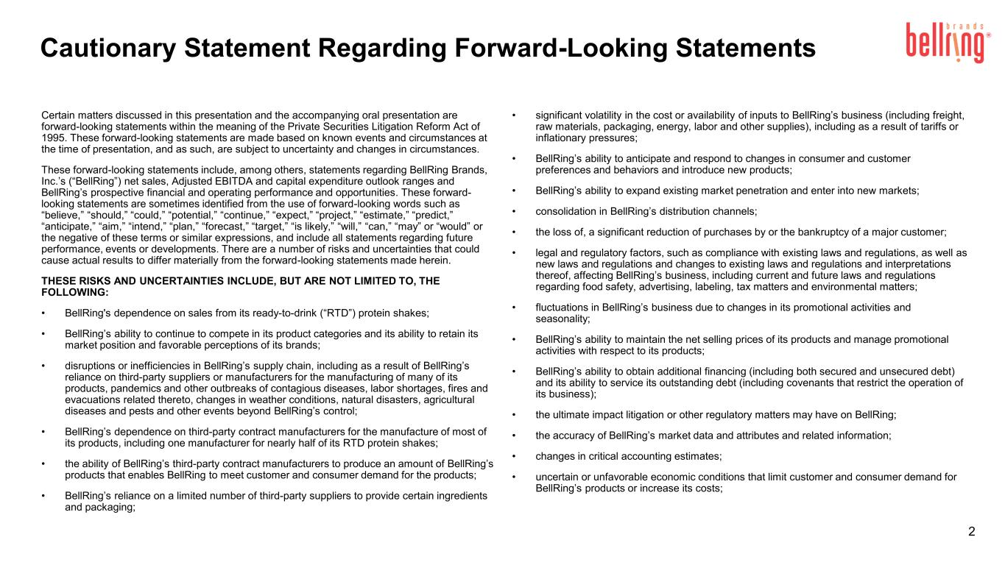
2 Certain matters discussed in this presentation and the accompanying oral presentation are forward-looking statements within the meaning of the Private Securities Litigation Reform Act of 1995. These forward-looking statements are made based on known events and circumstances at the time of presentation, and as such, are subject to uncertainty and changes in circumstances. These forward-looking statements include, among others, statements regarding BellRing Brands, Inc.’s (“BellRing”) net sales, Adjusted EBITDA and capital expenditure outlook ranges and BellRing’s prospective financial and operating performance and opportunities. These forward- looking statements are sometimes identified from the use of forward-looking words such as “believe,” “should,” “could,” “potential,” “continue,” “expect,” “project,” “estimate,” “predict,” “anticipate,” “aim,” “intend,” “plan,” “forecast,” “target,” “is likely,” “will,” “can,” “may” or “would” or the negative of these terms or similar expressions, and include all statements regarding future performance, events or developments. There are a number of risks and uncertainties that could cause actual results to differ materially from the forward-looking statements made herein. THESE RISKS AND UNCERTAINTIES INCLUDE, BUT ARE NOT LIMITED TO, THE FOLLOWING: • BellRing's dependence on sales from its ready-to-drink (“RTD”) protein shakes; • BellRing’s ability to continue to compete in its product categories and its ability to retain its market position and favorable perceptions of its brands; • disruptions or inefficiencies in BellRing’s supply chain, including as a result of BellRing’s reliance on third-party suppliers or manufacturers for the manufacturing of many of its products, pandemics and other outbreaks of contagious diseases, labor shortages, fires and evacuations related thereto, changes in weather conditions, natural disasters, agricultural diseases and pests and other events beyond BellRing’s control; • BellRing’s dependence on third-party contract manufacturers for the manufacture of most of its products, including one manufacturer for nearly half of its RTD protein shakes; • the ability of BellRing’s third-party contract manufacturers to produce an amount of BellRing’s products that enables BellRing to meet customer and consumer demand for the products; • BellRing’s reliance on a limited number of third-party suppliers to provide certain ingredients and packaging; • significant volatility in the cost or availability of inputs to BellRing’s business (including freight, raw materials, packaging, energy, labor and other supplies), including as a result of tariffs or inflationary pressures; • BellRing’s ability to anticipate and respond to changes in consumer and customer preferences and behaviors and introduce new products; • BellRing’s ability to expand existing market penetration and enter into new markets; • consolidation in BellRing’s distribution channels; • the loss of, a significant reduction of purchases by or the bankruptcy of a major customer; • legal and regulatory factors, such as compliance with existing laws and regulations, as well as new laws and regulations and changes to existing laws and regulations and interpretations thereof, affecting BellRing’s business, including current and future laws and regulations regarding food safety, advertising, labeling, tax matters and environmental matters; • fluctuations in BellRing’s business due to changes in its promotional activities and seasonality; • BellRing’s ability to maintain the net selling prices of its products and manage promotional activities with respect to its products; • BellRing’s ability to obtain additional financing (including both secured and unsecured debt) and its ability to service its outstanding debt (including covenants that restrict the operation of its business); • the ultimate impact litigation or other regulatory matters may have on BellRing; • the accuracy of BellRing’s market data and attributes and related information; • changes in critical accounting estimates; • uncertain or unfavorable economic conditions that limit customer and consumer demand for BellRing’s products or increase its costs; Cautionary Statement Regarding Forward-Looking Statements

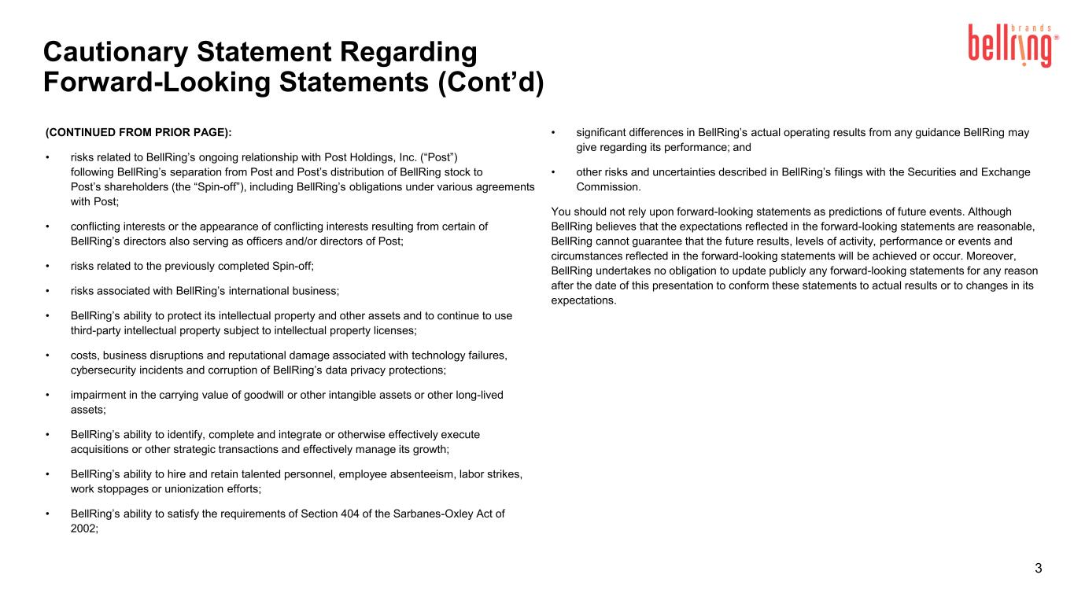
Cautionary Statement Regarding Forward-Looking Statements (Cont’d) 3 (CONTINUED FROM PRIOR PAGE): • risks related to BellRing’s ongoing relationship with Post Holdings, Inc. (“Post”) following BellRing’s separation from Post and Post’s distribution of BellRing stock to Post’s shareholders (the “Spin-off”), including BellRing’s obligations under various agreements with Post; • conflicting interests or the appearance of conflicting interests resulting from certain of BellRing’s directors also serving as officers and/or directors of Post; • risks related to the previously completed Spin-off; • risks associated with BellRing’s international business; • BellRing’s ability to protect its intellectual property and other assets and to continue to use third-party intellectual property subject to intellectual property licenses; • costs, business disruptions and reputational damage associated with technology failures, cybersecurity incidents and corruption of BellRing’s data privacy protections; • impairment in the carrying value of goodwill or other intangible assets or other long-lived assets; • BellRing’s ability to identify, complete and integrate or otherwise effectively execute acquisitions or other strategic transactions and effectively manage its growth; • BellRing’s ability to hire and retain talented personnel, employee absenteeism, labor strikes, work stoppages or unionization efforts; • BellRing’s ability to satisfy the requirements of Section 404 of the Sarbanes-Oxley Act of 2002; • significant differences in BellRing’s actual operating results from any guidance BellRing may give regarding its performance; and • other risks and uncertainties described in BellRing’s filings with the Securities and Exchange Commission. You should not rely upon forward-looking statements as predictions of future events. Although BellRing believes that the expectations reflected in the forward-looking statements are reasonable, BellRing cannot guarantee that the future results, levels of activity, performance or events and circumstances reflected in the forward-looking statements will be achieved or occur. Moreover, BellRing undertakes no obligation to update publicly any forward-looking statements for any reason after the date of this presentation to conform these statements to actual results or to changes in its expectations.

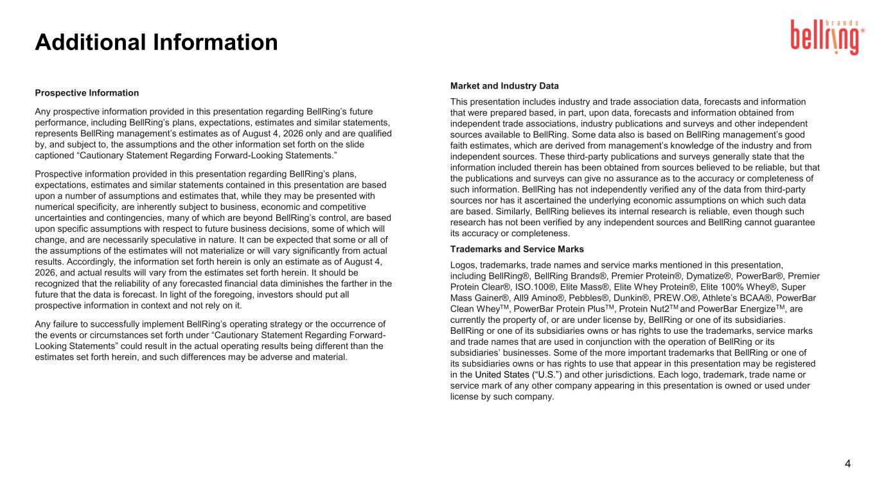
Additional Information 4 Prospective Information Any prospective information provided in this presentation regarding BellRing’s future performance, including BellRing’s plans, expectations, estimates and similar statements, represents BellRing management’s estimates as of August 4, 2026 only and are qualified by, and subject to, the assumptions and the other information set forth on the slide captioned “Cautionary Statement Regarding Forward-Looking Statements.” Prospective information provided in this presentation regarding BellRing’s plans, expectations, estimates and similar statements contained in this presentation are based upon a number of assumptions and estimates that, while they may be presented with numerical specificity, are inherently subject to business, economic and competitive uncertainties and contingencies, many of which are beyond BellRing’s control, are based upon specific assumptions with respect to future business decisions, some of which will change, and are necessarily speculative in nature. It can be expected that some or all of the assumptions of the estimates will not materialize or will vary significantly from actual results. Accordingly, the information set forth herein is only an estimate as of August 4, 2026, and actual results will vary from the estimates set forth herein. It should be recognized that the reliability of any forecasted financial data diminishes the farther in the future that the data is forecast. In light of the foregoing, investors should put all prospective information in context and not rely on it. Any failure to successfully implement BellRing’s operating strategy or the occurrence of the events or circumstances set forth under “Cautionary Statement Regarding Forward- Looking Statements” could result in the actual operating results being different than the estimates set forth herein, and such differences may be adverse and material. Market and Industry Data This presentation includes industry and trade association data, forecasts and information that were prepared based, in part, upon data, forecasts and information obtained from independent trade associations, industry publications and surveys and other independent sources available to BellRing. Some data also is based on BellRing management’s good faith estimates, which are derived from management’s knowledge of the industry and from independent sources. These third-party publications and surveys generally state that the information included therein has been obtained from sources believed to be reliable, but that the publications and surveys can give no assurance as to the accuracy or completeness of such information. BellRing has not independently verified any of the data from third-party sources nor has it ascertained the underlying economic assumptions on which such data are based. Similarly, BellRing believes its internal research is reliable, even though such research has not been verified by any independent sources and BellRing cannot guarantee its accuracy or completeness. Trademarks and Service Marks Logos, trademarks, trade names and service marks mentioned in this presentation, including BellRing®, BellRing Brands®, Premier Protein®, Dymatize®, PowerBar®, Premier Protein Clear®, ISO.100®, Elite Mass®, Elite Whey Protein®, Elite 100% Whey®, Super Mass Gainer®, All9 Amino®, Pebbles®, Dunkin®, PREW.O®, Athlete’s BCAA®, PowerBar Clean WheyTM, PowerBar Protein PlusTM, Protein Nut2TM and PowerBar EnergizeTM, are currently the property of, or are under license by, BellRing or one of its subsidiaries. BellRing or one of its subsidiaries owns or has rights to use the trademarks, service marks and trade names that are used in conjunction with the operation of BellRing or its subsidiaries’ businesses. Some of the more important trademarks that BellRing or one of its subsidiaries owns or has rights to use that appear in this presentation may be registered in the United States (“U.S.”) and other jurisdictions. Each logo, trademark, trade name or service mark of any other company appearing in this presentation is owned or used under license by such company.

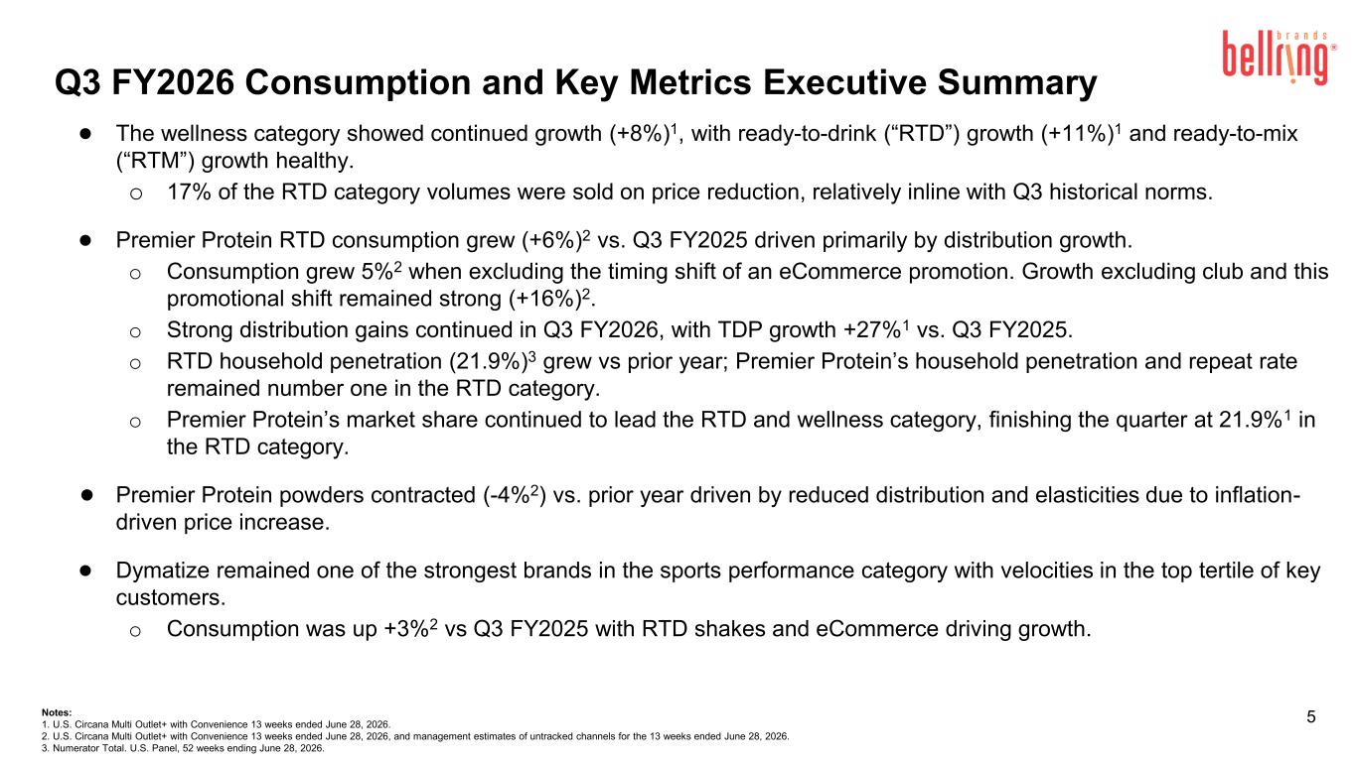
5 Q3 FY2026 Consumption and Key Metrics Executive Summary ● The wellness category showed continued growth (+8%)1, with ready-to-drink (“RTD”) growth (+11%)1 and ready-to-mix (“RTM”) growth healthy. o 17% of the RTD category volumes were sold on price reduction, relatively inline with Q3 historical norms. ● Premier Protein RTD consumption grew (+6%)2 vs. Q3 FY2025 driven primarily by distribution growth. o Consumption grew 5%2 when excluding the timing shift of an eCommerce promotion. Growth excluding club and this promotional shift remained strong (+16%)2. o Strong distribution gains continued in Q3 FY2026, with TDP growth +27%1 vs. Q3 FY2025. o RTD household penetration (21.9%)3 grew vs prior year; Premier Protein’s household penetration and repeat rate remained number one in the RTD category. o Premier Protein’s market share continued to lead the RTD and wellness category, finishing the quarter at 21.9%1 in the RTD category. ● Premier Protein powders contracted (-4%2) vs. prior year driven by reduced distribution and elasticities due to inflation- driven price increase. ● Dymatize remained one of the strongest brands in the sports performance category with velocities in the top tertile of key customers. o Consumption was up +3%2 vs Q3 FY2025 with RTD shakes and eCommerce driving growth. Notes: 1. U.S. Circana Multi Outlet+ with Convenience 13 weeks ended June 28, 2026. 2. U.S. Circana Multi Outlet+ with Convenience 13 weeks ended June 28, 2026, and management estimates of untracked channels for the 13 weeks ended June 28, 2026. 3. Numerator Total. U.S. Panel, 52 weeks ending June 28, 2026.

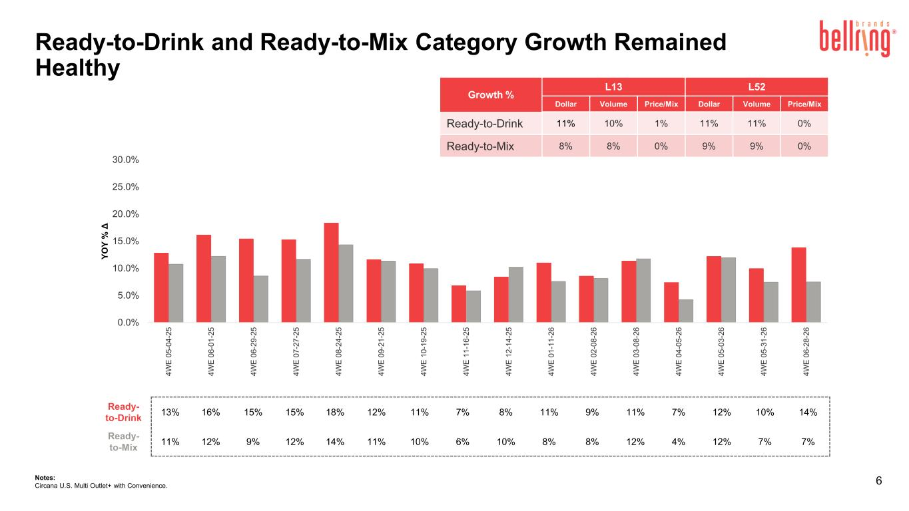
6 Ready-to-Drink and Ready-to-Mix Category Growth Remained Healthy Notes: Circana U.S. Multi Outlet+ with Convenience. Ready- to-Drink 13% 16% 15% 15% 18% 12% 11% 7% 8% 11% 9% 11% 7% 12% 10% 14% Ready- to-Mix 11% 12% 9% 12% 14% 11% 10% 6% 10% 8% 8% 12% 4% 12% 7% 7% 0.0% 5.0% 10.0% 15.0% 20.0% 25.0% 30.0% 4 W E 0 5 -0 4 -2 5 4 W E 0 6 -0 1 -2 5 4 W E 0 6 -2 9 -2 5 4 W E 0 7 -2 7 -2 5 4 W E 0 8 -2 4 -2 5 4 W E 0 9 -2 1 -2 5 4 W E 1 0 -1 9 -2 5 4 W E 1 1 -1 6 -2 5 4 W E 1 2 -1 4 -2 5 4 W E 0 1 -1 1 -2 6 4 W E 0 2 -0 8 -2 6 4 W E 0 3 -0 8 -2 6 4 W E 0 4 -0 5 -2 6 4 W E 0 5 -0 3 -2 6 4 W E 0 5 -3 1 -2 6 4 W E 0 6 -2 8 -2 6 Y O Y % Δ Growth % L13 L52 Dollar Volume Price/Mix Dollar Volume Price/Mix Ready-to-Drink 11% 10% 1% 11% 11% 0% Ready-to-Mix 8% 8% 0% 9% 9% 0%

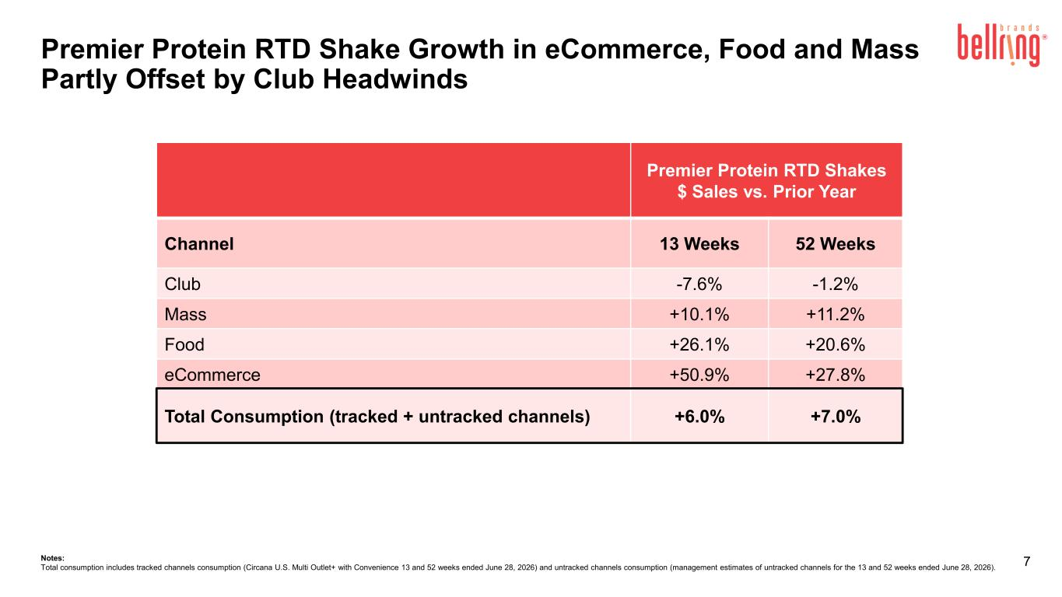
7 Premier Protein RTD Shakes $ Sales vs. Prior Year Channel 13 Weeks 52 Weeks Club -7.6% -1.2% Mass +10.1% +11.2% Food +26.1% +20.6% eCommerce +50.9% +27.8% Total Consumption (tracked + untracked channels) +6.0% +7.0% Notes: Total consumption includes tracked channels consumption (Circana U.S. Multi Outlet+ with Convenience 13 and 52 weeks ended June 28, 2026) and untracked channels consumption (management estimates of untracked channels for the 13 and 52 weeks ended June 28, 2026). Premier Protein RTD Shake Growth in eCommerce, Food and Mass Partly Offset by Club Headwinds

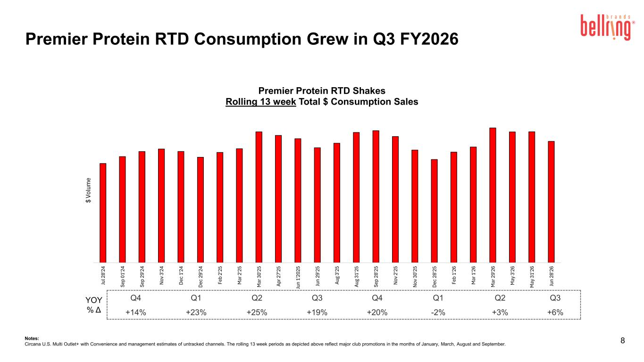
Ju l 2 8' 24 Se p 01 '2 4 Se p 29 '2 4 N ov 3 '2 4 D ec 1 '2 4 D ec 2 9' 24 Fe b 2' 25 M ar 2 '2 5 M ar 3 0' 25 Ap r 2 7' 25 Ju n 1' 20 25 Ju n 29 '2 5 Au g 3' 25 Au g 31 '2 5 Se p 28 '2 5 N ov 2 '2 5 N ov 3 0' 25 D ec 2 8' 25 Fe b 1' 26 M ar 1 '2 6 M ar 2 9' 26 M ay 3 '2 6 M ay 3 1' 26 Ju n 28 '2 6 $ Vo lu m e Premier Protein RTD Shakes Rolling 13 week Total $ Consumption Sales 8Notes: Circana U.S. Multi Outlet+ with Convenience and management estimates of untracked channels. The rolling 13 week periods as depicted above reflect major club promotions in the months of January, March, August and September. Q4 Q1 Q2 Q3 Q4 Q1 Q2 Q3 +14% +23% +25% +19% +20% -2% +3% +6% YOY % Δ Premier Protein RTD Consumption Grew in Q3 FY2026

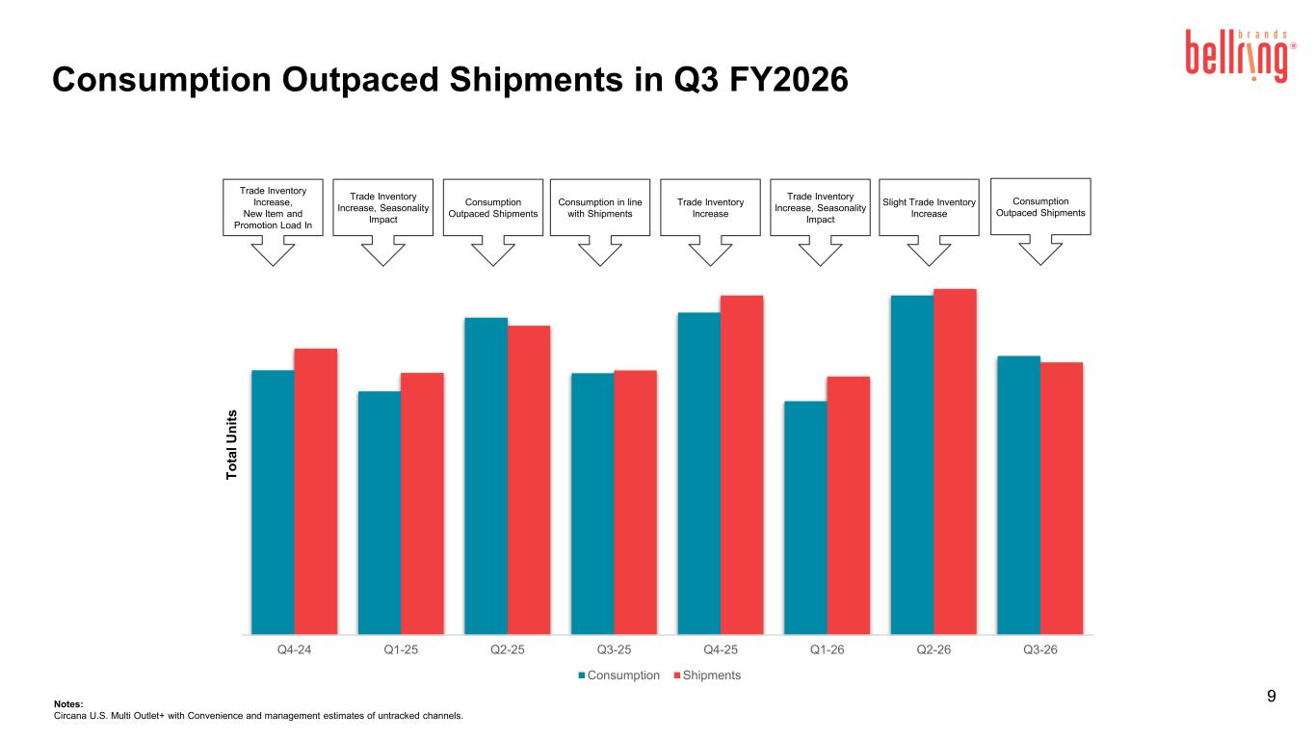
9 Consumption Outpaced Shipments Trade Inventory Increase, New Item and Promotion Load In Consumption Outpaced Shipments Trade Inventory Increase Trade Inventory Increase, Seasonality Impact Consumption in line with Shipments Trade Inventory Increase, Seasonality Impact Notes: Circana U.S. Multi Outlet+ with Convenience and management estimates of untracked channels. Slight Trade Inventory Increase Consumption Outpaced Shipments in Q3 FY2026 Q4-24 Q1-25 Q2-25 Q3-25 Q4-25 Q1-26 Q2-26 Q3-26 T o ta l U n it s Consumption Shipments

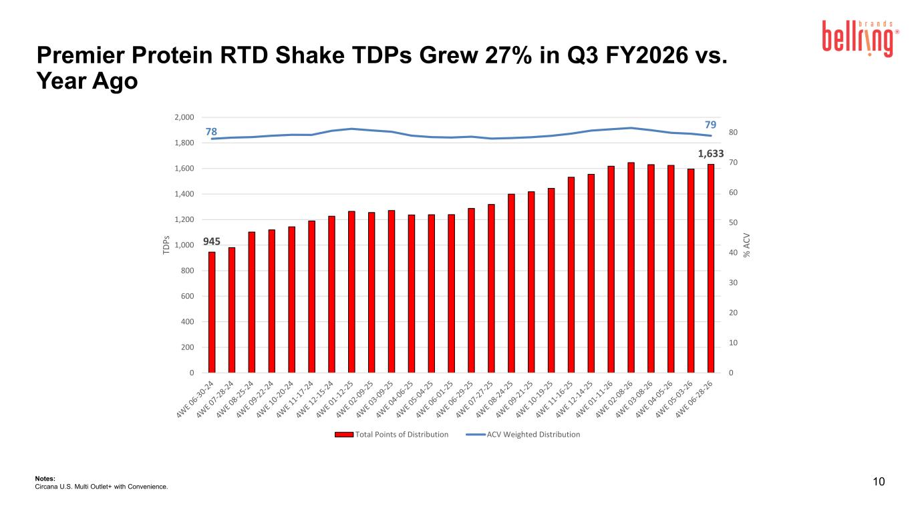
10Notes: Circana U.S. Multi Outlet+ with Convenience. 945 1,633 78 79 0 10 20 30 40 50 60 70 80 0 200 400 600 800 1,000 1,200 1,400 1,600 1,800 2,000 % A C V TD P s Total Points of Distribution ACV Weighted Distribution Premier Protein RTD Shake TDPs Grew 27% in Q3 FY2026 vs. Year Ago

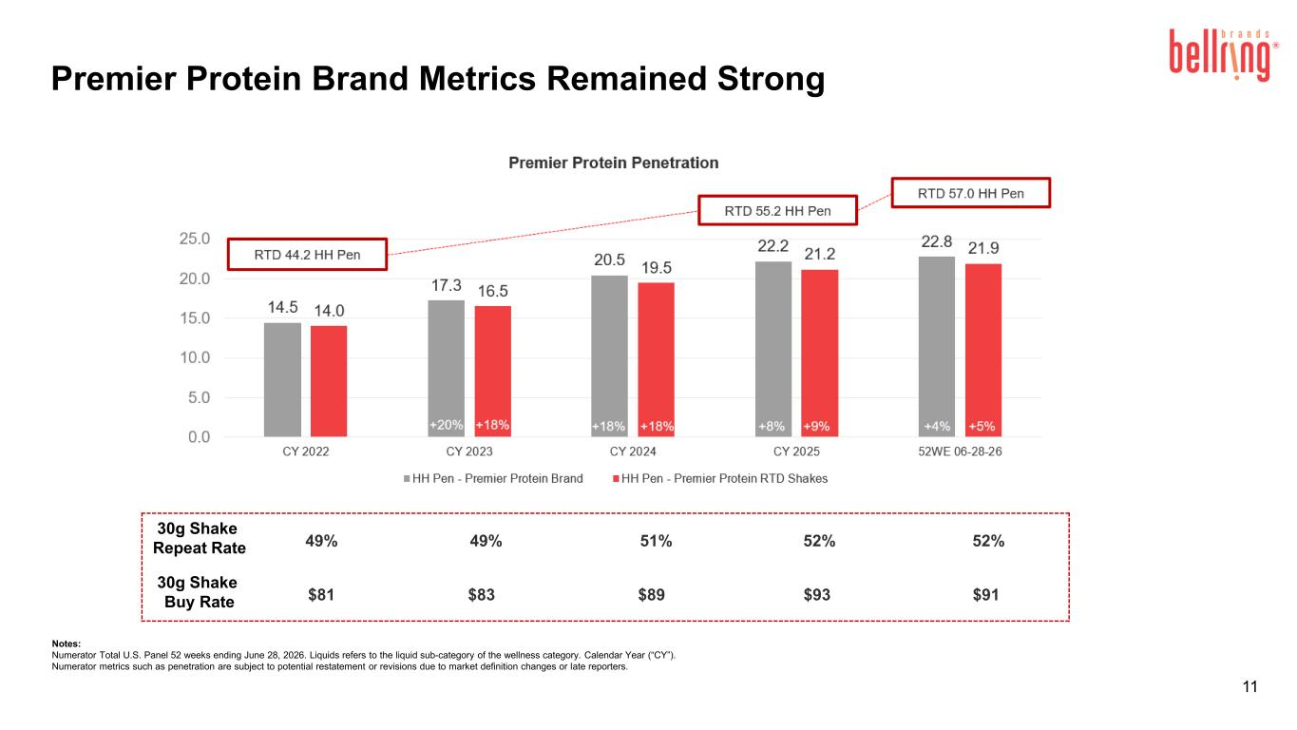
11 +17%+17%+17%+19% +9%+9% +8%+6% Notes: Numerator Total U.S. Panel 52 weeks ending June 28, 2026. Liquids refers to the liquid sub-category of the wellness category. Calendar Year (“CY”). Numerator metrics such as penetration are subject to potential restatement or revisions due to market definition changes or late reporters. 30g Shake Repeat Rate 49% 49% 51% 52% 52% 30g Shake Buy Rate $81 $83 $89 $93 $91 Premier Protein Brand Metrics Remained Strong

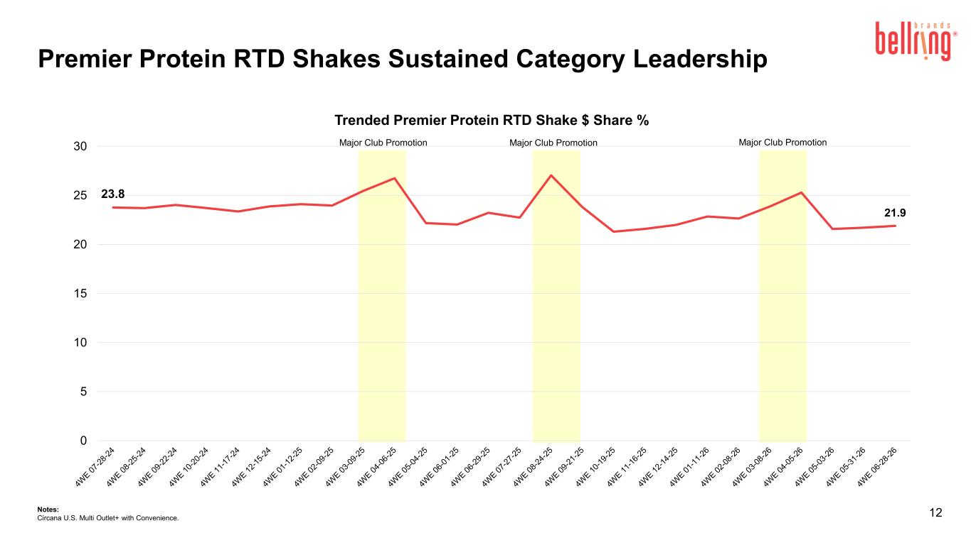
23.8 21.9 0 5 10 15 20 25 30 Trended Premier Protein RTD Shake $ Share % 12 Major Club Promotion Major Club PromotionMajor Club Promotion Notes: Circana U.S. Multi Outlet+ with Convenience. Premier Protein RTD Shakes Sustained Category Leadership

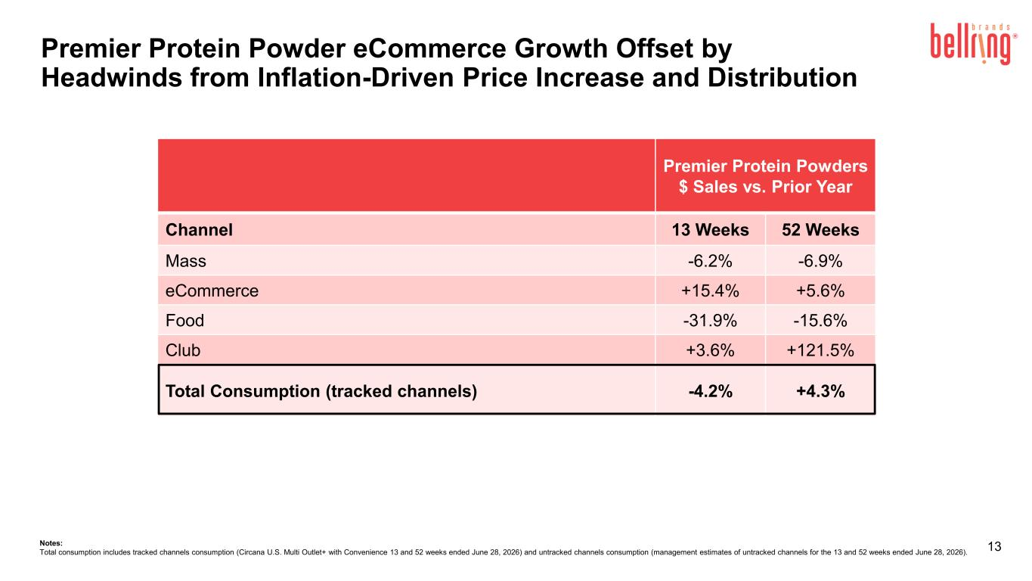
13 Premier Protein Powders $ Sales vs. Prior Year Channel 13 Weeks 52 Weeks Mass -6.2% -6.9% eCommerce +15.4% +5.6% Food -31.9% -15.6% Club +3.6% +121.5% Total Consumption (tracked channels) -4.2% +4.3% Premier Protein Powder eCommerce Growth Offset by Headwinds from Inflation-Driven Price Increase and Distribution Notes: Total consumption includes tracked channels consumption (Circana U.S. Multi Outlet+ with Convenience 13 and 52 weeks ended June 28, 2026) and untracked channels consumption (management estimates of untracked channels for the 13 and 52 weeks ended June 28, 2026).

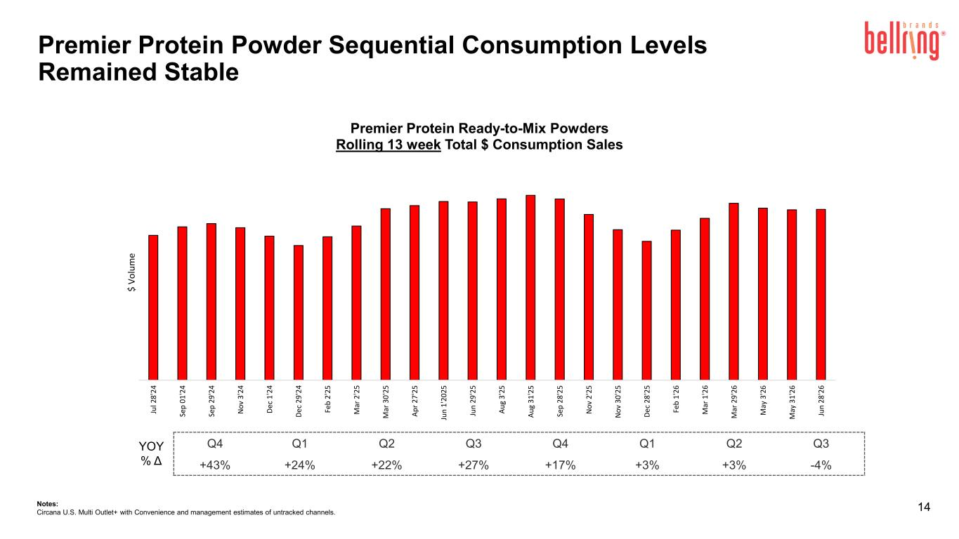
Premier Protein Powder Sequential Consumption Levels Remained Stable 14 Q4 Q1 Q2 Q3 Q4 Q1 Q2 Q3 +43% +24% +22% +27% +17% +3% +3% -4% YOY % Δ Ju l 2 8 '2 4 Se p 0 1 '2 4 Se p 2 9 '2 4 N o v 3 '2 4 D ec 1 '2 4 D ec 2 9 '2 4 Fe b 2 '2 5 M ar 2 '2 5 M ar 3 0 '2 5 A p r 2 7 '2 5 Ju n 1 '2 0 25 Ju n 2 9 '2 5 A u g 3 '2 5 A u g 3 1 '2 5 Se p 2 8 '2 5 N o v 2 '2 5 N o v 3 0 '2 5 D ec 2 8 '2 5 Fe b 1 '2 6 M ar 1 '2 6 M ar 2 9 '2 6 M ay 3 '2 6 M ay 3 1 '2 6 Ju n 2 8 '2 6 $ V o lu m e Premier Protein Ready-to-Mix Powders Rolling 13 week Total $ Consumption Sales Notes: Circana U.S. Multi Outlet+ with Convenience and management estimates of untracked channels.

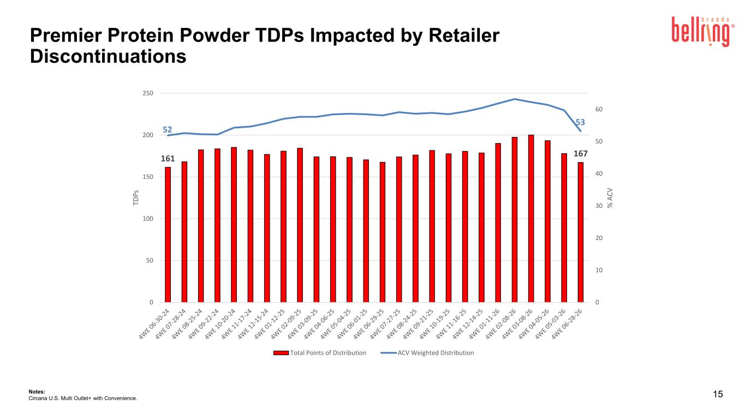
15Notes: Circana U.S. Multi Outlet+ with Convenience. 161 167 52 53 0 10 20 30 40 50 60 0 50 100 150 200 250 % A C V TD P s Total Points of Distribution ACV Weighted Distribution Premier Protein Powder TDPs Impacted by Retailer Discontinuations

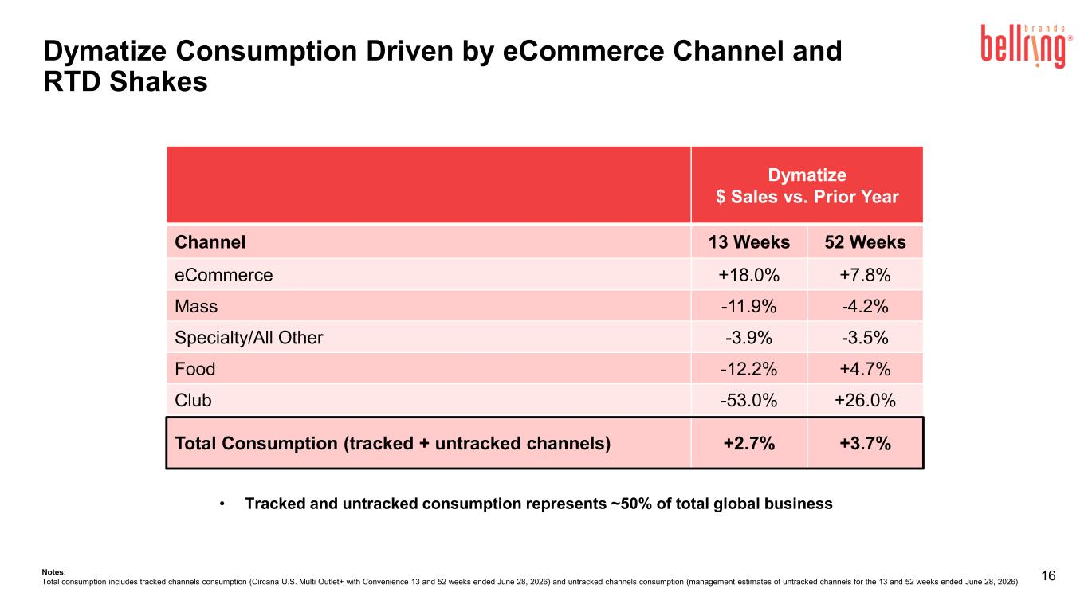
16 • Tracked and untracked consumption represents ~50% of total global business Dymatize $ Sales vs. Prior Year Channel 13 Weeks 52 Weeks eCommerce +18.0% +7.8% Mass -11.9% -4.2% Specialty/All Other -3.9% -3.5% Food -12.2% +4.7% Club -53.0% +26.0% Total Consumption (tracked + untracked channels) +2.7% +3.7% Notes: Total consumption includes tracked channels consumption (Circana U.S. Multi Outlet+ with Convenience 13 and 52 weeks ended June 28, 2026) and untracked channels consumption (management estimates of untracked channels for the 13 and 52 weeks ended June 28, 2026). Dymatize Consumption Driven by eCommerce Channel and RTD Shakes

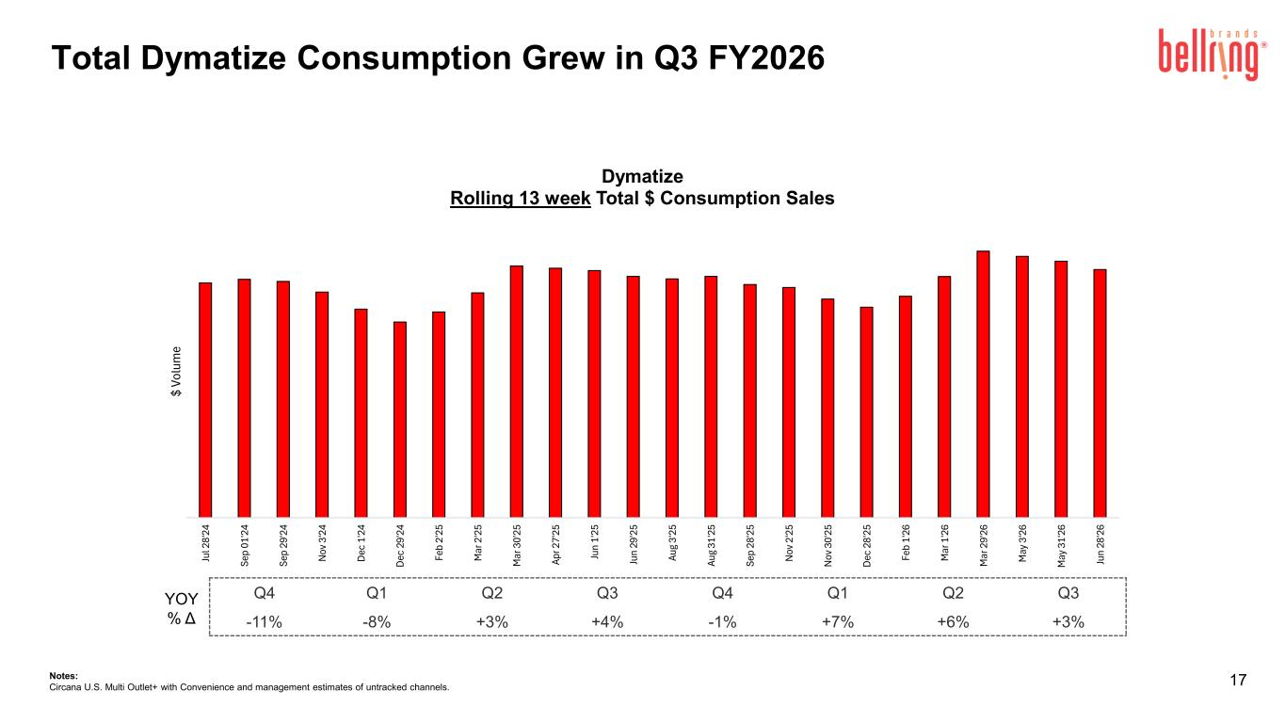
17Notes: Circana U.S. Multi Outlet+ with Convenience and management estimates of untracked channels. YOY % Δ Ju l 2 8' 24 Se p 01 '2 4 Se p 29 '2 4 N ov 3 '2 4 D ec 1 '2 4 D ec 2 9' 24 Fe b 2' 25 M ar 2 '2 5 M ar 3 0' 25 Ap r 2 7' 25 Ju n 1' 25 Ju n 29 '2 5 Au g 3' 25 Au g 31 '2 5 Se p 28 '2 5 N ov 2 '2 5 N ov 3 0' 25 D ec 2 8' 25 Fe b 1' 26 M ar 1 '2 6 M ar 2 9' 26 M ay 3 '2 6 M ay 3 1' 26 Ju n 28 '2 6 $ Vo lu m e Dymatize Rolling 13 week Total $ Consumption Sales Q4 Q1 Q2 Q3 Q4 Q1 Q2 Q3 -11% -8% +3% +4% -1% +7% +6% +3% Total Dymatize Consumption Grew in Q3 FY2026

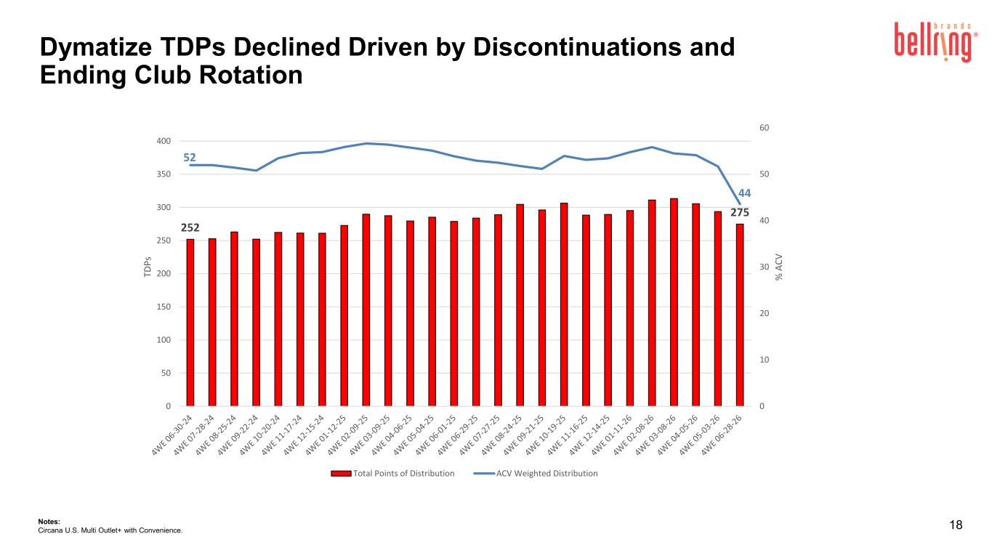
18Notes: Circana U.S. Multi Outlet+ with Convenience. 252 275 52 44 0 10 20 30 40 50 60 0 50 100 150 200 250 300 350 400 % A C V TD P s Total Points of Distribution ACV Weighted Distribution Dymatize TDPs Declined Driven by Discontinuations and Ending Club Rotation

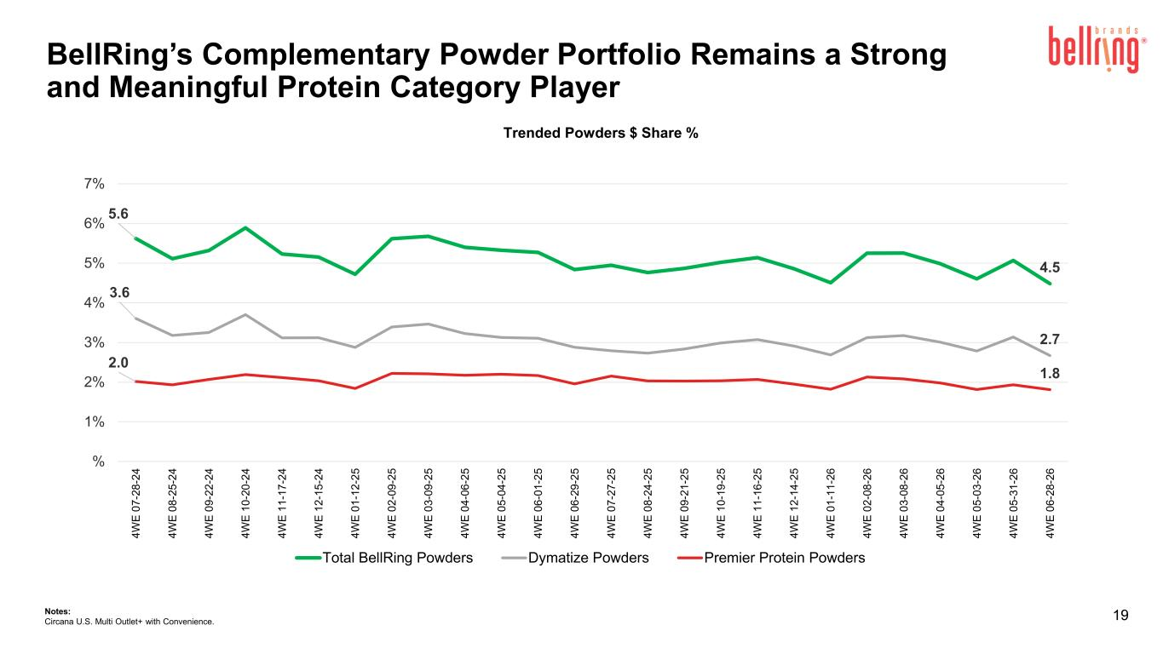
19 Trended Powders $ Share % Notes: Circana U.S. Multi Outlet+ with Convenience. 5.6 4.5 3.6 2.7 2.0 1.8 % 1% 2% 3% 4% 5% 6% 7% 4 W E 0 7 -2 8 -2 4 4 W E 0 8 -2 5 -2 4 4 W E 0 9 -2 2 -2 4 4 W E 1 0 -2 0 -2 4 4 W E 1 1 -1 7 -2 4 4 W E 1 2 -1 5 -2 4 4 W E 0 1 -1 2 -2 5 4 W E 0 2 -0 9 -2 5 4 W E 0 3 -0 9 -2 5 4 W E 0 4 -0 6 -2 5 4 W E 0 5 -0 4 -2 5 4 W E 0 6 -0 1 -2 5 4 W E 0 6 -2 9 -2 5 4 W E 0 7 -2 7 -2 5 4 W E 0 8 -2 4 -2 5 4 W E 0 9 -2 1 -2 5 4 W E 1 0 -1 9 -2 5 4 W E 1 1 -1 6 -2 5 4 W E 1 2 -1 4 -2 5 4 W E 0 1 -1 1 -2 6 4 W E 0 2 -0 8 -2 6 4 W E 0 3 -0 8 -2 6 4 W E 0 4 -0 5 -2 6 4 W E 0 5 -0 3 -2 6 4 W E 0 5 -3 1 -2 6 4 W E 0 6 -2 8 -2 6 Total BellRing Powders Dymatize Powders Premier Protein Powders BellRing’s Complementary Powder Portfolio Remains a Strong and Meaningful Protein Category Player



