UNITED STATES

SECURITIES AND EXCHANGE COMMISSION

Washington, D.C. 20549

______________________

FORM 8-K

CURRENT REPORT

Pursuant to Section 13 OR 15(d) of The

Securities Exchange Act of 1934

Date of Report (Date of earliest event reported): February 2, 2026
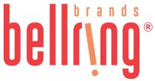

BellRing Brands, Inc.

 | (Exact name of registrant as specified in its charter)
Delaware |  | 001-39093 | 87-3296749
(State or other jurisdiction of incorporation) | (Commission File Number) |  | (IRS Employer Identification No.)
1 N Brentwood Blvd., Suite 1550 | St. Louis | Missouri | 63105
(Address of Principal Executive Offices) |  |  | (Zip Code)

Registrant’s telephone number, including area code: (314) 644-7652

Check the appropriate box below if the Form 8-K filing is intended to simultaneously satisfy the filing obligation of the registrant under any of the following provisions:

- Written communications pursuant to Rule 425 under the Securities Act (17 CFR 230.425)

- Soliciting material pursuant to Rule 14a-12 under the Exchange Act (17 CFR 240.14a-12)

- Pre-commencement communications pursuant to Rule 14d-2(b) under the Exchange Act (17 CFR 240.14d-2(b))

- Pre-commencement communications pursuant to Rule 13e-4(c) under the Exchange Act (17 CFR 240.13e-4(c))

Securities registered pursuant to Section 12(b) of the Act:
 | Title of each class |  | Trading Symbol(s) |  |  | Name of each exchange on which registered
Common Stock, $0.01 par value per share |  |  |  | BRBR |  |  | New York Stock Exchange

Indicate by check mark whether the registrant is an emerging growth company as defined in Rule 405 of the Securities Act of 1933 (§230.405 of this chapter) or Rule 12b-2 of the Securities Exchange Act of 1934 (§240.12b-2 of this chapter).

Emerging growth company ☐

If an emerging growth company, indicate by check mark if the registrant has elected not to use the extended transition period for complying with any new or revised financial accounting standards provided pursuant to Section 13(a) of

the Exchange Act.☐

Item 2.02. Results of Operation and Financial Condition.

On February 3, 2026, BellRing Brands, Inc. (the "Company") issued a press release announcing results for its first fiscal quarter ended December 31, 2025. A copy of the press release is attached hereto as Exhibit 99.1 and incorporated herein by reference.

In addition, on February 3, 2025, the Company published to the "Investor Relations" section of its website, www.bellringbrands.com, a supplemental presentation related to results for its first fiscal quarter ended December 31, 2025. A copy of the presentation is attached hereto as Exhibit 99.2 and incorporated herein by reference.

The information contained in Item 2.02, including Exhibit 99.1 and Exhibit 99.2 attached hereto, shall not be deemed to be "filed" for purposes of Section 18 of the Securities Exchange Act of 1934, as amended (the "Exchange Act"), or otherwise subject to the liabilities of that Section, nor shall they be deemed incorporated by reference into any filings under the Securities Act of 1933, as amended, or the Exchange Act, except as expressly set forth by specific reference in such filing.

Item 5.02. Departure of Directors or Certain Officers; Election of Directors; Appointment of Certain Officers; Compensatory Arrangements of Certain Officers.

On February 3, 2026, the Company issued a press release announcing that, on February 2, 2026, Darcy H. Davenport notified the Board of Directors of BellRing Brands, Inc. of her retirement as President and Chief Executive Officer of the Company, effective on the earlier of the appointment of a new CEO or September 30, 2026. A copy of the press release is attached hereto as Exhibit 99.3 and incorporated herein by reference

The retirement of Ms. Davenport did not result from any disagreement with the Company on any matter relating to its operations, policies or practices.

9.01. Financial Statements and Exhibits.

(d) Exhibits
Exhibit No. |  | Description
99.1 |  | Earnings Press Release dated February 3, 2026
99.2 |  | First Fiscal Quarter Ended December 31, 2025 Supplemental Presentation
99.3 |  | Leadership Transition Press Release dated February 3, 2026
104 |  | Cover Page Interactive Data File (the cover page iXBRL tags are embedded within the Inline XBRL document)

Pursuant to the requirements of the Securities Exchange Act of 1934, the registrant has duly caused this report to be signed on its behalf by the undersigned thereunto duly authorized.

Date: February 3, 2026 | BellRing Brands, Inc.
 | (Registrant)
 | By: | /s/ Paul A. Rode
 | Name: | Paul A. Rode
 | Title: | Chief Financial Officer

Exhibit 99.1
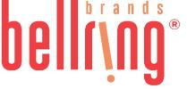

BellRing Brands Reports Results for the First Quarter of Fiscal Year 2026; Narrows Fiscal Year 2026 Outlook

St. Louis - February 3, 2026 - BellRing Brands, Inc. (NYSE:BRBR) (“BellRing”), a holding company operating in the global proactive wellness category, today reported results for the first fiscal quarter ended December 31, 2025.

Highlights:

- First quarter net sales of $537.3 million, up 1% year-over-year

- Operating profit of $78.5 million, net earnings of $43.7 million and Adjusted EBITDA* of $90.3 million

- Narrowed fiscal year 2026 net sales outlook of $2.41-$2.46 billion and Adjusted EBITDA* outlook of $425-$440 million

- Repurchased $97 million or approximately 2.5% of common shares outstanding in the quarter

*Adjusted EBITDA and Adjusted EBITDA as a percentage of net sales are non-GAAP measures. For additional information regarding non-GAAP measures, see the related explanations presented under “Use of Non-GAAP Measures” later in this release. BellRing provides Adjusted EBITDA and Adjusted EBITDA as a percentage of net sales guidance only on a non-GAAP basis and does not provide a reconciliation of its forward-looking Adjusted EBITDA or Adjusted EBITDA as a percentage of net sales non-GAAP guidance measure to the most directly comparable GAAP measure due to the inherent difficulty in forecasting and quantifying certain amounts that are necessary for such reconciliation, including the adjustments described under “Outlook” later in this release.

“We delivered first quarter results ahead of our guidance, primarily due to favorable timing, and our operating plans remain on track,” said Darcy H. Davenport, President and Chief Executive Officer of BellRing. “Our 2026 outlook has been modestly narrowed, reflecting increased category promotional frequency and higher whey protein costs, and continues to anticipate growth and second half acceleration as demand initiatives ramp. We remain highly focused on executing our strategic priorities of stepping up brand investment, accelerating our innovation pipeline and sharpening multi-channel execution to reach even more consumers.”

First Quarter Consumption Trends

Dollar consumption of Premier Protein ready-to-drink (“RTD”) shakes decreased 2.2%, Premier Protein powder products increased 2.9% and Dymatize powder and RTD products increased 7.5% in the 13-week period ended December 28, 2025, as compared to the same period in 2024 (inclusive of Circana United States (“U.S.”) Multi Outlet Plus with Convenience and management estimates of untracked channels). For additional information regarding consumption metrics, see the supplemental presentation on BellRing’s website, which can be accessed by visiting the Investor Relations section.

First Quarter Operating Results

Net sales were $537.3 million, an increase of 0.8%, or $4.4 million, compared to the prior year period, driven by 0.7% increase in volume and 0.1% increase in price/mix. The first quarter of 2026 benefited from some timing of customer orders that were previously expected in the second quarter and Dymatize strength. As expected, the first quarter of 2026 reflected tough prior year comparisons in the club channel including non-repeating promotions for both Premier Protein and Dymatize.

Premier Protein net sales decreased 1.2%, driven by 1.0% decrease in price/mix and 0.2% decrease in volume. Premier Protein RTD shake net sales decreased 2.2%, driven by 1.9% decrease in price/mix and 0.3% decrease in volume.

Lower net pricing reflected incremental promotional investment.

Dymatize net sales increased 15.8% driven by strong volume growth, particularly in the international channel.

Gross profit was $160.8 million, or 29.9% of net sales, a decrease of $38.8 million, compared to $199.6 million, or 37.5% of net sales, in the prior year period. Gross profit was impacted by significant input cost inflation, inclusive of tariffs, unfavorable mix and lapping $5.0 million of non-recurring cost favorability in the prior year period.

Selling, general and administrative (“SG&A”) expenses were $78.0 million, or 14.5% of net sales, a decrease of $2.1 million compared to $80.1 million, or 15.0% of net sales, in the prior year period. Marketing and consumer advertising expenses were

1

$12.4 million, a decrease of $2.7 million compared to the prior year period, driven by a reduction for Dymatize. SG&A expenses in the first quarter of 2026 included $1.3 million of office relocation and separation costs, both of which are discussed later in this release and were treated as adjustments for non-GAAP measures.

Operating profit was $78.5 million, a decrease of $36.8 million, compared to $115.3 million in the prior year period driven by lower gross margins.

Interest expense, net was $20.0 million and $14.4 million in the first quarter of 2026 and 2025, respectively, with the increase primarily driven by higher outstanding borrowings under BellRing’s revolving credit facility. Income tax expense was $14.8 million in the first quarter of 2026 compared to $24.0 million in the first quarter of 2025. The effective income tax rate was 25.3% and 23.8% in the first quarter of 2026 and 2025, respectively.

Net earnings were $43.7 million, a decrease of $33.2 million, compared to $76.9 million in the prior year period. Net earnings per diluted common share were $0.36 compared to $0.59 in the prior year period. Adjusted net earnings* were $44.7 million, a decrease of $31.5 million, compared to $76.2 million in the prior year period. Adjusted diluted earnings per common share* were $0.37 compared to $0.58 in the prior year period.

Adjusted EBITDA* was $90.3 million, a decrease of $35.0 million, compared to $125.3 million in the prior year period.

*Adjusted net earnings, Adjusted diluted earnings per common share and Adjusted EBITDA are non-GAAP measures. For additional information regarding non-GAAP measures, see the related explanations presented under “Use of Non-GAAP Measures” later in this release.

Share Repurchases

During the first quarter of 2026, BellRing repurchased 3.0 million shares for $96.9 million at an average price of $31.95 per share. As of December 31, 2025, BellRing had $543.1 million remaining under its share repurchase authorization.

Outlook

For fiscal year 2026, BellRing management has narrowed its previously issued guidance, as shown in the table below. As previously indicated, net sales growth is expected to accelerate beyond the first quarter as merchandising initiatives, advertising and innovation become more meaningful.

Metric | Fiscal Year 2026
Net Sales | $2.41-$2.46 billion
Net Sales Growth | 4% to 6%
Adjusted EBITDA | $425-$440 million
Adjusted EBITDA as a percentage of Net Sales | Approximately 18%
Capital Expenditures | $8 million

BellRing provides Adjusted EBITDA and Adjusted EBITDA as a percentage of net sales guidance only on a non-GAAP basis and does not provide a reconciliation of its forward-looking Adjusted EBITDA and Adjusted EBITDA as a percentage of net sales non-GAAP guidance measure to the most directly comparable GAAP measure due to the inherent difficulty in forecasting and quantifying certain amounts that are necessary for such reconciliation, including adjustments that could be made for mark-to-market adjustments on commodity hedges and other charges reflected in BellRing’s reconciliation of historical numbers, the amounts of which, based on historical experience, could be significant. For additional information regarding BellRing’s non-GAAP measures, see the related explanations presented under “Use of Non-GAAP Measures.”

Use of Non-GAAP Measures

BellRing uses certain non-GAAP measures in this release to supplement the financial measures prepared in accordance with U.S. generally accepted accounting principles (“GAAP”). These non-GAAP measures include Adjusted gross profit, Adjusted gross profit margin, Adjusted net earnings, Adjusted diluted earnings per common share, Adjusted EBITDA and Adjusted EBITDA as a percentage of net sales. The reconciliation of each of these non-GAAP measures to the most directly comparable GAAP measure is provided later in this release under “Explanation and Reconciliation of Non-GAAP Measures.”

Management uses certain of these non-GAAP measures, including Adjusted EBITDA and Adjusted EBITDA as a percentage of net sales, as key metrics in the evaluation of underlying company performance, in making financial, operating and planning decisions and, in part, in the determination of bonuses for its executive officers and employees. Additionally, BellRing is required to comply with certain covenants and limitations that are based on variations of EBITDA in its financing documents. Management believes the use of these non-GAAP measures provides increased transparency and assists investors in

2

understanding the underlying operating performance of BellRing and in the analysis of ongoing operating trends. Non-GAAP measures are not prepared in accordance with GAAP, as they exclude certain items as described later in this release. These non-GAAP measures may not be comparable to similarly titled measures of other companies. For additional information regarding BellRing’s non-GAAP measures, see the related explanations provided under “Explanation and Reconciliation of Non-GAAP Measures” later in this release.

Conference Call to Discuss Earnings Results and Outlook

BellRing will host a conference call on Tuesday, February 3, 2026 at 8:30 a.m. ET to discuss financial results for the first quarter of fiscal year 2026 and fiscal year 2026 outlook and to respond to questions. Darcy H. Davenport, President and Chief Executive Officer, and Paul A. Rode, Chief Financial Officer, will participate in the call.

Interested parties may join the conference call by registering in advance at the following link: BellRing Q1 2026 Earnings Conference Call. Upon registration, participants will receive a dial-in number and a unique passcode to access the conference call. Interested parties are invited to listen to the webcast of the conference call, which can be accessed by visiting the Investor Relations section of BellRing’s website at www.bellring.com. A slide presentation containing supplemental material will also be available at the same location on BellRing’s website. A webcast replay also will be available for a limited period on BellRing’s website in the Investor Relations section.

Prospective Financial Information

Prospective financial information is necessarily speculative in nature, and it can be expected that some or all of the assumptions underlying the prospective financial information described above will not materialize or will vary significantly from actual results. For further discussion of some of the factors that may cause actual results to vary materially from the information provided above, see “Forward-Looking Statements” below. Accordingly, the prospective financial information provided above is only an estimate of what BellRing’s management believes is realizable as of the date of this release. It also should be recognized that the reliability of any forecasted financial data diminishes the farther in the future that the data is forecasted. In light of the foregoing, the information should be viewed in context and undue reliance should not be placed upon it.

Forward-Looking Statements

Certain matters discussed in this release and on BellRing’s conference call are forward-looking statements, including BellRing’s net sales, Adjusted EBITDA, Adjusted EBITDA as a percentage of net sales and capital expenditures outlook for fiscal year 2026. These forward-looking statements are sometimes identified from the use of forward-looking words such as “believe,” “should,” “could,” “potential,” “continue,” “expect,” “project,” “estimate,” “predict,” “anticipate,” “aim,” “intend,” “plan,” “forecast,” “target,” “is likely,” “will,” “can,” “may” or “would” or the negative of these terms or similar expressions, and include all statements regarding future performance, earnings projections, events or developments. There are a number of risks and uncertainties that could cause actual results to differ materially from the forward-looking statements made herein. These risks and uncertainties include, but are not limited to, the following:

- BellRing’s dependence on sales from its RTD protein shakes;

- BellRing’s ability to continue to compete in its product categories and its ability to retain its market position and favorable perceptions of its brands;

- disruptions or inefficiencies in BellRing’s supply chain, including as a result of BellRing’s reliance on third-party suppliers or manufacturers for the manufacturing of many of its products, pandemics and other outbreaks of contagious diseases, labor shortages, fires and evacuations related thereto, changes in weather conditions, natural disasters, agricultural diseases and pests and other events beyond BellRing’s control;
- BellRing’s dependence on third-party contract manufacturers for the manufacture of most of its products, including one manufacturer for nearly half of its RTD protein shakes;

- the ability of BellRing’s third-party contract manufacturers to produce an amount of BellRing’s products that enables BellRing to meet customer and consumer demand for the products;

- BellRing’s reliance on a limited number of third-party suppliers to provide certain ingredients and packaging;

- significant volatility in the cost or availability of inputs to BellRing’s business (including freight, raw materials, packaging, energy, labor and other supplies), including as a result of tariffs or inflationary pressures;

- BellRing’s ability to anticipate and respond to changes in consumer and customer preferences and behaviors and introduce new products;

- BellRing’s ability to expand existing market penetration and enter into new markets;

- consolidation in BellRing’s distribution channels;

- the loss of, a significant reduction of purchases by or the bankruptcy of a major customer;

- legal and regulatory factors, such as compliance with existing laws and regulations, as well as new laws and regulations and changes to existing laws and regulations and interpretations thereof, affecting BellRing’s business,

3

including current and future laws and regulations regarding food safety, advertising, labeling, tax matters and environmental matters;

- fluctuations in BellRing’s business due to changes in its promotional activities and seasonality;

- BellRing’s ability to maintain the net selling prices of its products and manage promotional activities with respect to its products;

- BellRing’s ability to obtain additional financing (including both secured and unsecured debt) and its ability to service its outstanding debt (including covenants that restrict the operation of its business);

- the accuracy of BellRing’s market data and attributes and related information;

- changes in critical accounting estimates;

- uncertain or unfavorable economic conditions that limit customer and consumer demand for BellRing’s products or increase its costs;

- risks related to BellRing’s ongoing relationship with Post Holdings, Inc. (“Post”) following BellRing’s separation from Post and Post’s distribution of BellRing stock to Post’s shareholders (“ the Spin-off”), including BellRing’s obligations under various agreements with Post;
- conflicting interests or the appearance of conflicting interests resulting from certain of BellRing’s directors also serving as officers and/or directors of Post;

- risks related to the previously completed Spin-off;

- the ultimate impact litigation or other regulatory matters may have on BellRing;

- risks associated with BellRing’s international business;

- BellRing’s ability to protect its intellectual property and other assets and to continue to use third-party intellectual property subject to intellectual property licenses;

- costs, business disruptions and reputational damage associated with technology failures, cybersecurity incidents and corruption of BellRing’s data privacy protections;

- impairment in the carrying value of goodwill or other intangible assets or other long-lived assets;

- BellRing’s ability to identify, complete and integrate or otherwise effectively execute acquisitions or other strategic transactions and effectively manage its growth;

- BellRing’s ability to hire and retain talented personnel, employee absenteeism, labor strikes, work stoppages or unionization efforts;

- BellRing’s ability to satisfy the requirements of Section 404 of the Sarbanes-Oxley Act of 2002;

- significant differences in BellRing’s actual operating results from any guidance BellRing may give regarding its performance; and

- other risks and uncertainties described in BellRing’s filings with the Securities and Exchange Commission.

These forward-looking statements represent BellRing’s judgment as of the date of this release. BellRing disclaims, however, any intent or obligation to update these forward-looking statements.

About BellRing Brands, Inc.

BellRing Brands, Inc. (NYSE: BRBR) is a dynamic and fast-growing consumer brands business with the purpose of Changing Lives with Good Energy. Focused on growing the proactive wellness category, the company’s brands include Premier Protein, the #1 ready-to-drink protein and proactive wellness brand, and Dymatize, the brand behind the #1 hydrolyzed protein powder. A culture-driven, pure-play company, BellRing Brands believes nutrition is at the core of a healthy world and produces products with best-in-class nutritional profiles and exceptional flavors. Its products are distributed in over 90 countries across club, mass, food, eCommerce, specialty, drug and convenience. To learn more visit www.bellring.com.

Contact:

Investor Relations

Jennifer Meyer

jennifer.meyer@bellringbrands.com

(415) 814-9388

4

CONDENSED CONSOLIDATED STATEMENTS OF OPERATIONS (Unaudited)

(in millions, except for per share data)

 |  | Three Months Ended December 31,
 | 2025 |  |  |  | 2024
Net Sales | $ | 537.3 |  | $ | 532.9
Cost of goods sold |  | 376.5 |  |  | 333.3
Gross Profit |  | 160.8 |  |  | 199.6
Selling, general and administrative expenses |  | 78.0 |  |  | 80.1
Amortization of intangible assets |  | 4.3 |  |  | 4.2
Operating Profit |  | 78.5 |  |  | 115.3
Interest expense, net |  | 20.0 |  |  | 14.4
Earnings before Income Taxes |  | 58.5 |  |  | 100.9
Income tax expense |  | 14.8 |  |  | 24.0
Net Earnings | $ | 43.7 |  | $ | 76.9
Earnings per Common Share:
Basic | $ | 0.37 |  | $ | 0.60
Diluted | $ | 0.36 |  | $ | 0.59
Weighted-Average Common Shares Outstanding:
Basic |  | 119.3 |  |  | 128.9
Diluted |  | 119.9 |  |  | 131.1

5

CONDENSED CONSOLIDATED BALANCE SHEETS (Unaudited)

(in millions)

 |  | December 31, 2025 |  |  | September 30, 2025
 | ASSETS
Current Assets
Cash and cash equivalents | $ |  | 64.1 |  | $ | 71.8
Restricted cash |  |  | 12.9 |  |  | 17.3
Receivables, net |  |  | 246.0 |  |  | 223.4
Inventories |  |  | 435.2 |  |  | 330.4
Prepaid expenses and other current assets |  |  | 28.1 |  |  | 22.6
Total Current Assets |  |  | 786.3 |  |  | 665.5
Property, net |  |  | 26.5 |  |  | 19.0
Goodwill |  |  | 65.9 |  |  | 65.9
Intangible assets, net |  |  | 120.7 |  |  | 125.0
Deferred income taxes |  |  | 27.6 |  |  | 32.4
Other assets |  |  | 33.3 |  |  | 33.2
Total Assets |  | $ | 1,060.3 |  | $ | 941.0
 | LIABILITIES AND STOCKHOLDERS’ DEFICIT
Current Liabilities
Accounts payable | $ |  | 178.6 |  | $ | 119.5
Other current liabilities |  |  | 173.4 |  |  | 163.3
Total Current Liabilities |  |  | 352.0 |  |  | 282.8
Long-term debt |  |  | 1,184.6 |  |  | 1,084.3
Deferred income taxes |  |  | 0.4 |  |  | 0.4
Other liabilities |  |  | 34.0 |  |  | 27.4
Total Liabilities |  |  | 1,571.0 |  |  | 1,394.9
Stockholders’ Deficit
Common stock |  |  | 1.4 |  |  | 1.4
Additional paid-in capital |  |  | 46.0 |  |  | 48.7
Retained earnings |  |  | 316.3 |  |  | 272.6
Accumulated other comprehensive loss |  |  | (1.0) |  |  | (1.0)
Treasury stock, at cost |  |  | (873.4) |  |  | (775.6)
Total Stockholders’ Deficit |  |  | (510.7) |  |  | (453.9)
Total Liabilities and Stockholders’ Deficit |  | $ | 1,060.3 |  | $ | 941.0
 | SELECTED CONDENSED CONSOLIDATED CASH FLOWS INFORMATION (Unaudited)
 | (in millions)
 |  | Three Months Ended December 31,
 |  | 2025 |  |  | 2024
Cash (used in) provided by:
Operating activities | $ |  | (3.1) |  | $ | 3.0
Investing activities |  |  | (4.2) |  |  | (1.3)
Financing activities |  |  | (5.3) |  |  | (23.2)
Effect of exchange rate changes on cash, cash equivalents and restricted cash |  |  | 0.5 |  |  | —
Net decrease in cash, cash equivalents and restricted cash |  | $ | (12.1) |  | $ | (21.5)

6

EXPLANATION AND RECONCILIATION OF NON-GAAP MEASURES

BellRing uses certain non-GAAP measures in this release to supplement the financial measures prepared in accordance with U.S. generally accepted accounting principles (“GAAP”). These non-GAAP measures include Adjusted gross profit, Adjusted gross profit margin, Adjusted net earnings, Adjusted diluted earnings per common share, Adjusted EBITDA and Adjusted EBITDA as a percentage of net sales. The reconciliation of each of these non-GAAP measures to the most directly comparable GAAP measure is provided in the tables following this section. Non-GAAP measures are not prepared in accordance with GAAP, as they exclude certain items as described below. These non-GAAP measures may not be comparable to similarly titled measures of other companies.

Adjusted gross profit and Adjusted gross profit margin

BellRing believes Adjusted gross profit is useful to investors in evaluating BellRing’s underlying profitability of its revenue-generating activities as it excludes mark-to-market adjustments on commodity hedges (which are primarily non-cash and not consistent across periods; see the explanation below for more information). BellRing believes Adjusted gross profit margin (Adjusted gross profit as a percentage of net sales) is useful to investors in evaluating BellRing’s operating performance because it allows for more meaningful comparison of operating performance across periods.

Adjusted net earnings and Adjusted diluted earnings per common share

BellRing believes Adjusted net earnings and Adjusted diluted earnings per common share are useful to investors in evaluating BellRing’s operating performance because they exclude items that affect the comparability of BellRing’s financial results and could potentially distort an understanding of the trends in business performance.

Adjusted net earnings and Adjusted diluted earnings per common share are adjusted for the following items:

- Mark-to-market adjustments on commodity hedges: BellRing has excluded the impact of mark-to-market adjustments on commodity hedges due to the inherent uncertainty and volatility associated with such amounts based on changes in assumptions with respect to fair value estimates. Additionally, these adjustments are primarily non-cash items and the amount and frequency of such adjustments are not consistent.
- Office relocation costs: BellRing has excluded certain duplicative costs associated with new office moves as the amount and frequency of such expenses are not consistent. Additionally, BellRing believes that these costs do not reflect expected ongoing future operating expenses and do not contribute to a meaningful evaluation of BellRing’s current operating performance or comparisons of BellRing’s operating performance to other periods.
- Foreign currency gain/loss on intercompany loans: BellRing has excluded the impact of foreign currency fluctuations related to intercompany loans denominated in currencies other than the functional currency of the respective legal entity in evaluating BellRing’s performance to allow for more meaningful comparisons of performance to other periods.
- Separation costs: BellRing has excluded certain expenses incurred to transition services to BellRing from Post ahead of the anticipated termination of the master services agreement with Post, as the amount and frequency of such expenses are not consistent. Additionally, BellRing believes that these costs do not reflect expected ongoing future operating expenses and do not contribute to a meaningful evaluation of BellRing’s current operating performance or comparisons of BellRing’s operating performance to other periods.
- Income tax effect on adjustments: BellRing has included the income tax impact of the non-GAAP adjustments using a rate described in the applicable footnote of the reconciliation tables, as BellRing believes that its GAAP effective income tax rate as reported is not representative of the income tax expense impact of the adjustments.

Adjusted EBITDA and Adjusted EBITDA as a percentage of net sales

BellRing believes that Adjusted EBITDA is useful to investors in evaluating BellRing’s operating performance and liquidity because (i) BellRing believes it is widely used to measure a company’s operating performance without regard to items such as depreciation and amortization, which can vary depending upon accounting methods and the book value of assets, (ii) it presents a measure of corporate performance exclusive of BellRing’s capital structure and the method by which the assets were acquired and (iii) it is a financial indicator of a company’s ability to service its debt, as BellRing is required to comply with certain covenants and limitations that are based on variations of EBITDA in its financing documents. Management uses Adjusted EBITDA to provide forward-looking guidance and to forecast future results. BellRing believes that Adjusted EBITDA as a percentage of net sales is useful to investors in evaluating BellRing’s operating performance because it allows for more meaningful comparison of operating performance across periods.

Adjusted EBITDA reflects adjustments for income tax expense, interest expense, net and depreciation and amortization, and the following adjustments discussed above: mark-to-market adjustments on commodity hedges, office relocation costs, foreign currency gain/loss on intercompany loans and separation costs. Additionally, Adjusted EBITDA reflects an adjustment for the following item:

7

- Stock-based compensation: BellRing’s compensation strategy includes the use of BellRing stock-based compensation to attract and retain executives and employees by aligning their long-term compensation interests with BellRing’s stockholders’ investment interests. BellRing’s director compensation strategy includes an election by any director who earns retainers in which the director may elect to defer compensation granted as a director to BellRing common stock, earning a match on the deferral, both of which are stock-settled upon the director’s retirement from the BellRing board of directors. BellRing has excluded stock-based compensation as stock-based compensation can vary significantly based on reasons such as the timing, size and nature of the awards granted and subjective assumptions which are unrelated to operational decisions and performance in any particular period and does not contribute to meaningful comparisons of BellRing’s operating performance to other periods.

RECONCILIATION OF GROSS PROFIT TO ADJUSTED GROSS PROFIT (Unaudited)

(in millions)

 |  | Three Months Ended December 31,
 | 2025 |  |  |  | 2024
Gross Profit | $ | 160.8 |  | $ | 199.6
Mark-to-market adjustments on commodity hedges |  | — |  |  | (1.5)
Adjusted Gross Profit | $ | 160.8 |  | $ | 198.1
Gross Profit as a percentage of Net Sales |  | 29.9 % |  |  | 37.5 %
Adjusted Gross Profit as a percentage of Net Sales |  | 29.9 % |  |  | 37.2 %

8

RECONCILIATION OF NET EARNINGS TO ADJUSTED NET EARNINGS (Unaudited)

(in millions)

 |  | Three Months Ended December 31,
 | 2025 |  |  |  | 2024
Net Earnings | $ | 43.7 |  | $ | 76.9
Adjustments:
Mark-to-market adjustments on commodity hedges |  | — |  |  | (1.5)
Office relocation costs |  | 0.9 |  |  | —
Foreign currency loss on intercompany loans |  | — |  |  | 0.6
Separation costs |  | 0.4 |  |  | —
Total Net Adjustments |  | 1.3 |  |  | (0.9)
Income tax effect on adjustments ⁽¹⁾ |  | (0.3) |  |  | 0.2
Adjusted Net Earnings | $ | 44.7 |  | $ | 76.2

- Income tax effect on adjustments was calculated on all items using a rate of 24.0%.

 | RECONCILIATION OF DILUTED EARNINGS PER COMMON SHARE
 | TO ADJUSTED DILUTED EARNINGS PER COMMON SHARE (Unaudited)
 |  |  | Three Months Ended December 31,
 |  | 2025 |  |  |  | 2024
Diluted Earnings per Common Share |  | $ | 0.36 |  | $ | 0.59
Adjustments:
Mark-to-market adjustments on commodity hedges |  |  | — |  |  | (0.01)
Office relocation costs |  |  | 0.01 |  |  | —
Total Net Adjustments |  |  | 0.01 |  |  | (0.01)
Income tax effect on adjustments⁽¹⁾ |  |  | — |  |  | —
Adjusted Diluted Earnings per Common Share |  | $ | 0.37 |  | $ | 0.58

- Income tax effect on adjustments was calculated on all items using a rate of 24.0%.

9

RECONCILIATION OF NET EARNINGS TO ADJUSTED EBITDA (Unaudited)

(in millions)

 |  | Three Months Ended December 31,
 | 2025 |  |  |  | 2024
Net Earnings | $ | 43.7 |  | $ | 76.9
Income tax expense |  | 14.8 |  |  | 24.0
Interest expense, net |  | 20.0 |  |  | 14.4
Depreciation and amortization |  | 4.9 |  |  | 4.6
Stock-based compensation |  | 5.6 |  |  | 6.3
Mark-to-market adjustments on commodity hedges |  | — |  |  | (1.5)
Office relocation costs |  | 0.9 |  |  | —
Foreign currency loss on intercompany loans |  | — |  |  | 0.6
Separation costs |  | 0.4 |  |  | —
Adjusted EBITDA | $ | 90.3 |  | $ | 125.3
Net Earnings as a percentage of Net Sales |  | 8.1 % |  |  | 14.4 %
Adjusted EBITDA as a percentage of Net Sales |  | 16.8 % |  |  | 23.5 %

10



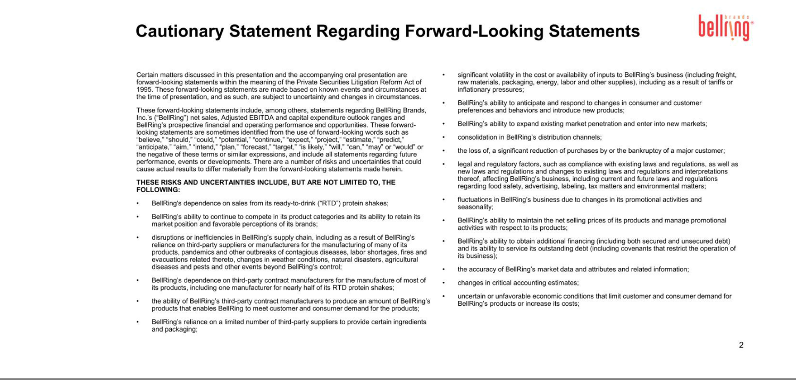

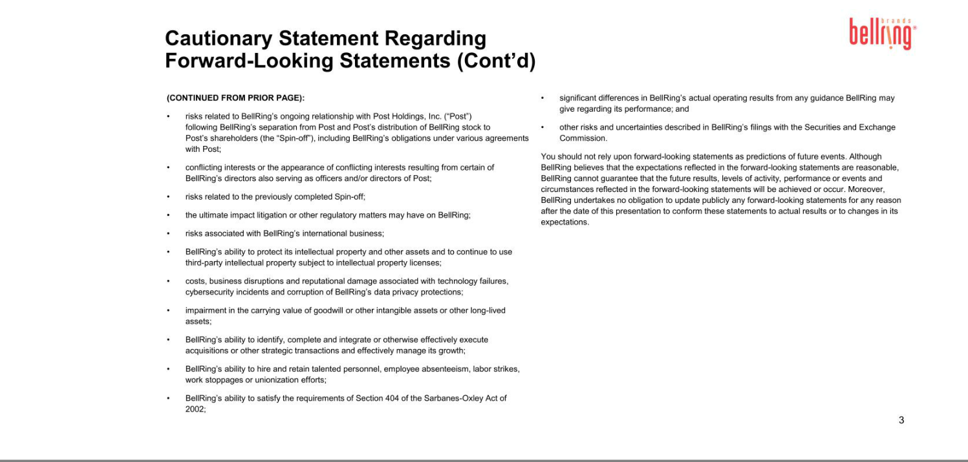

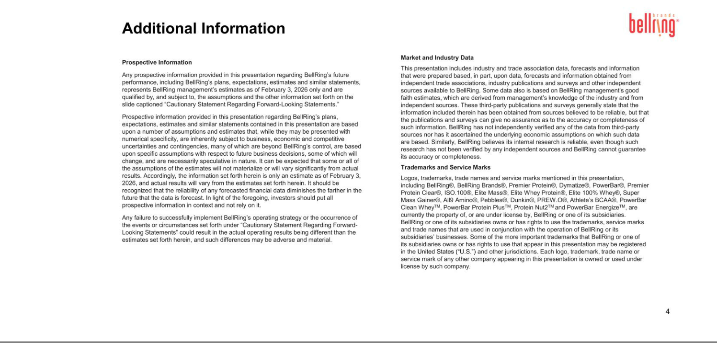

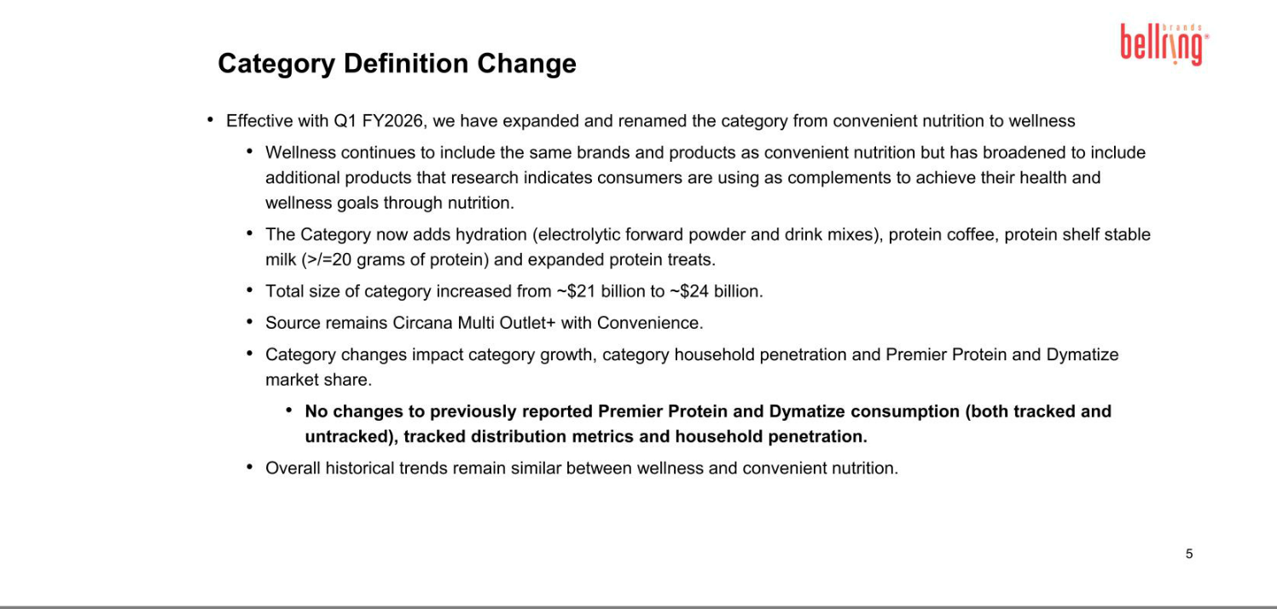

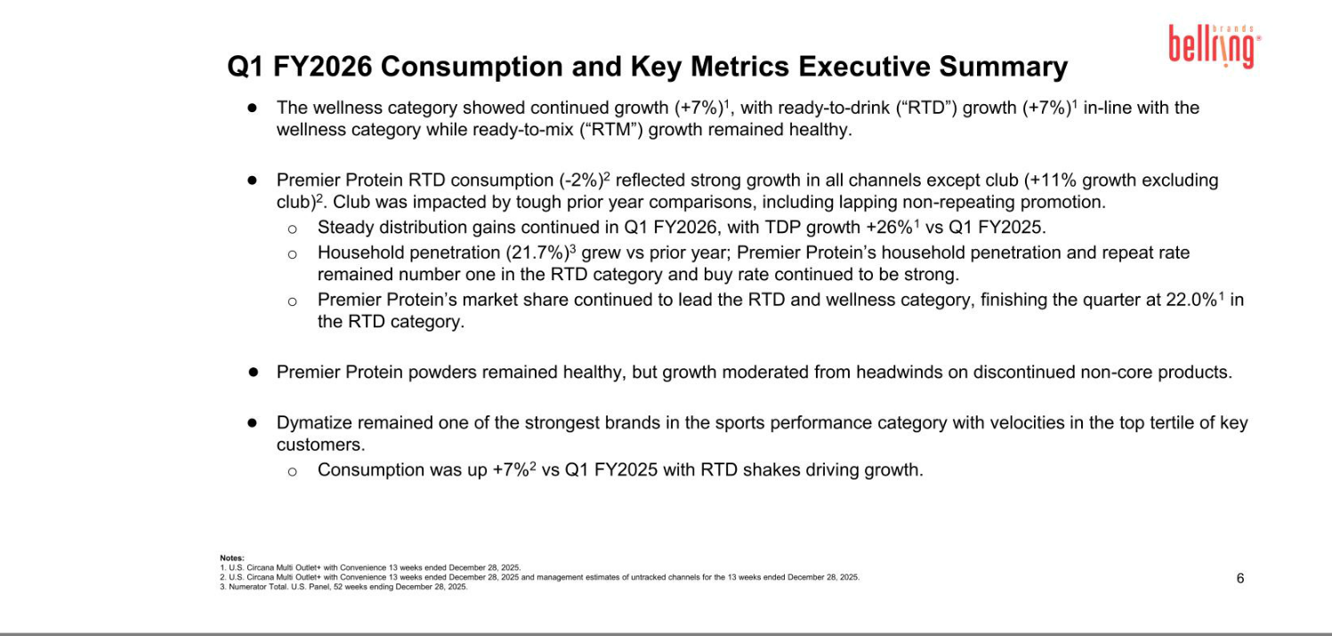

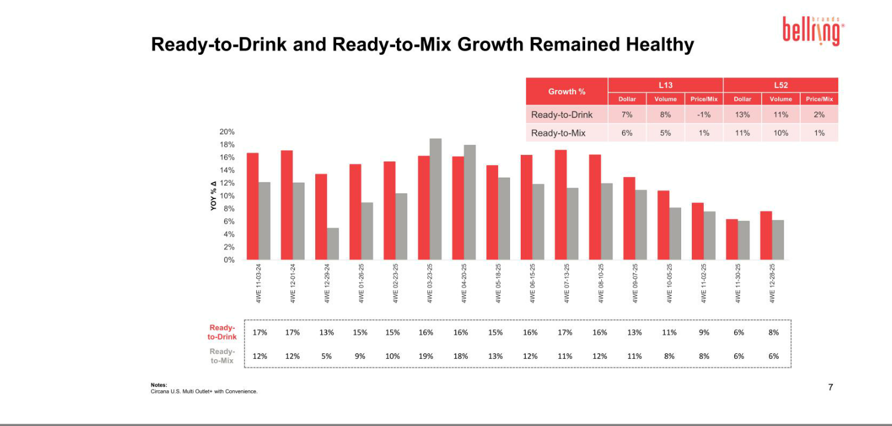

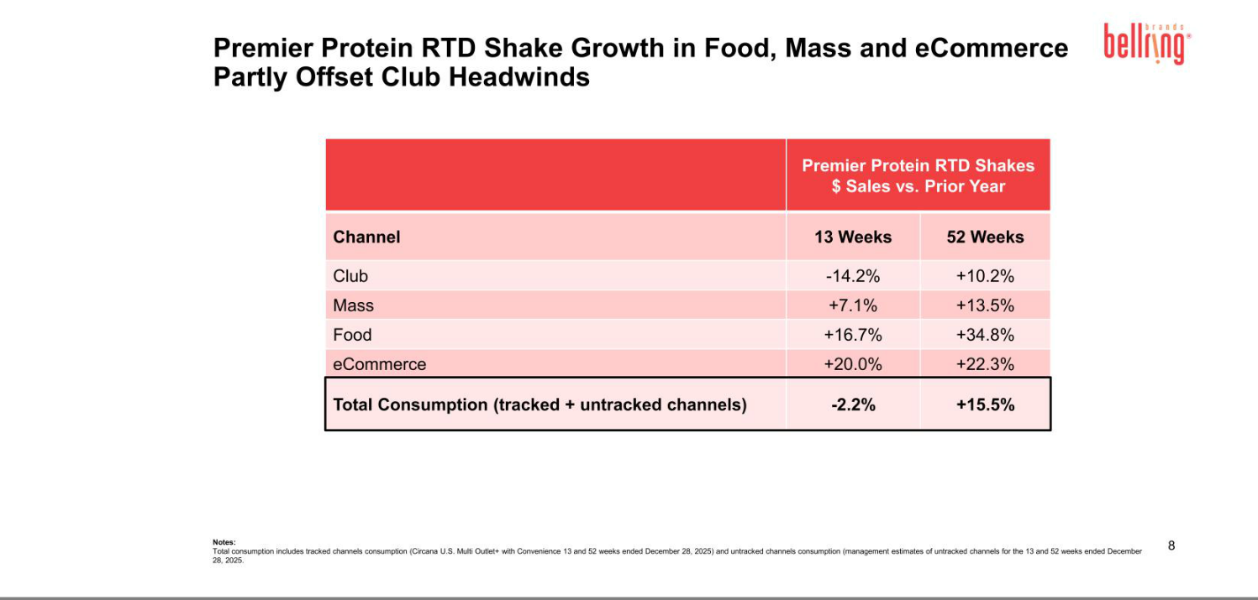

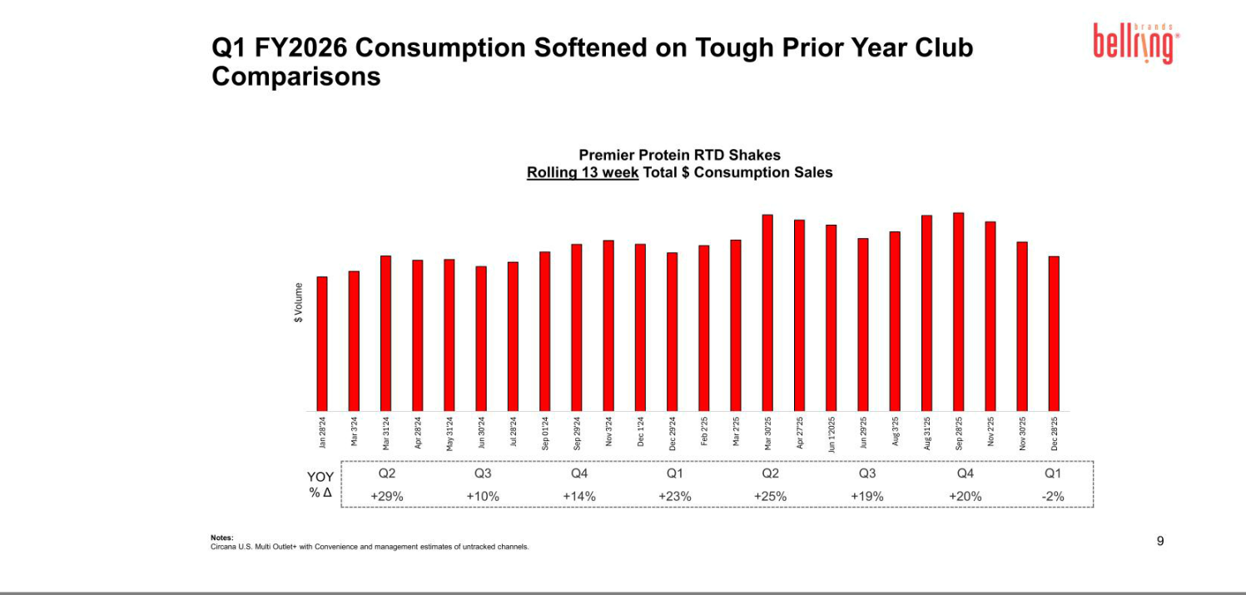

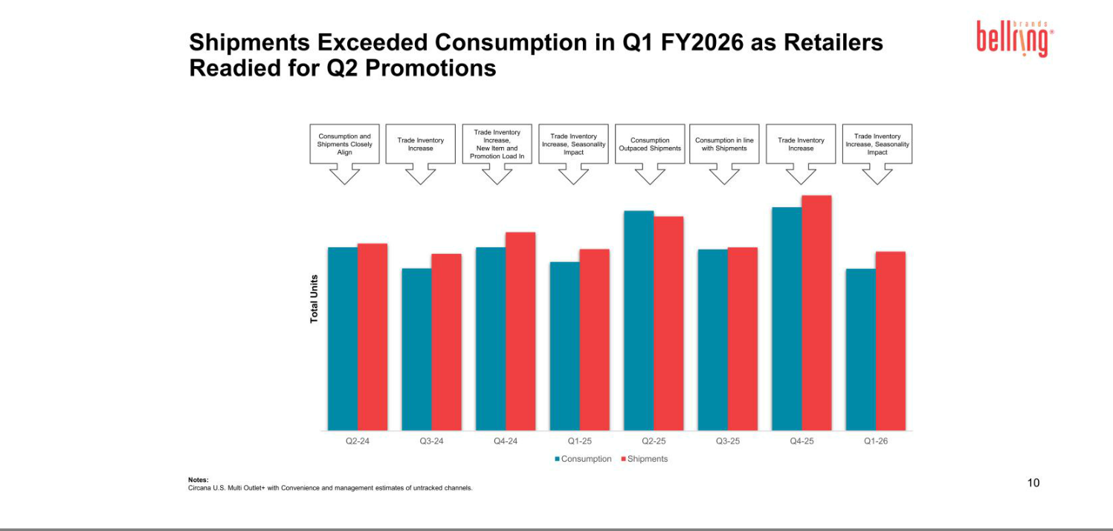

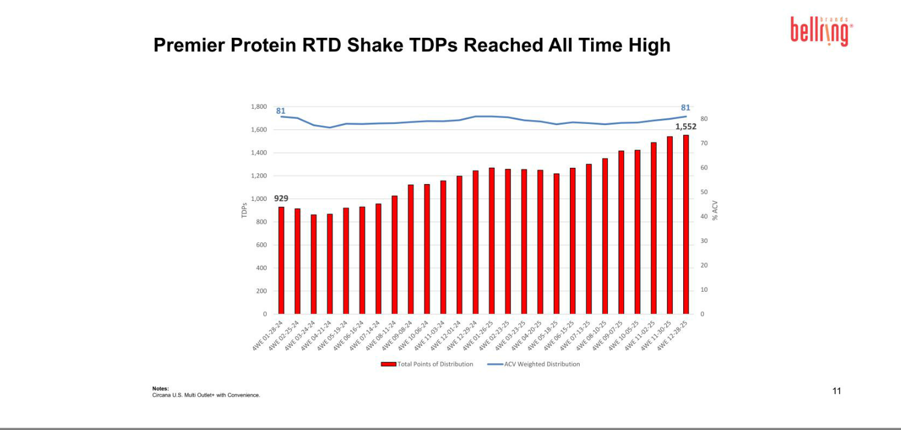

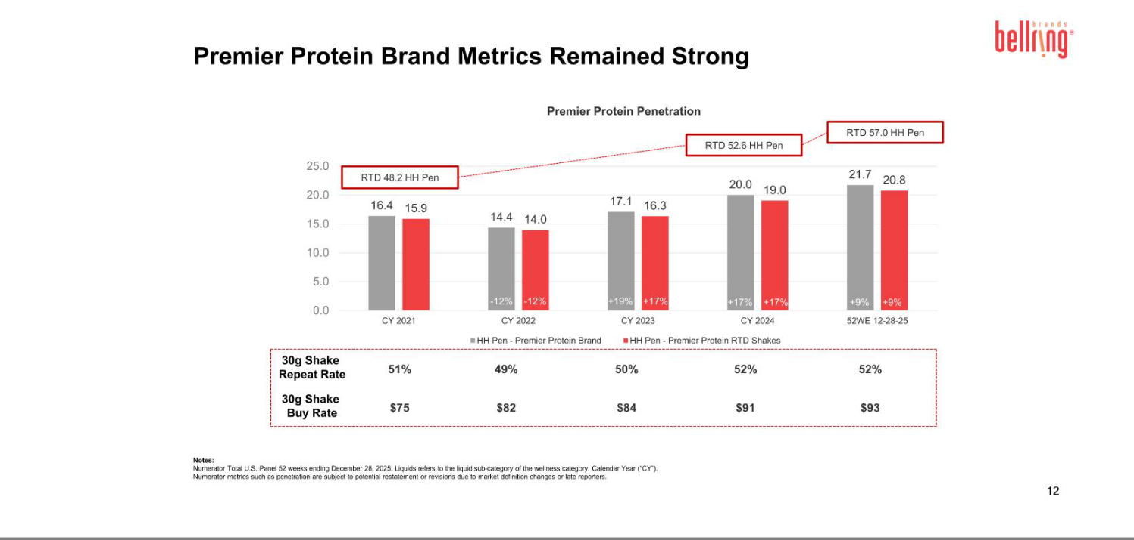

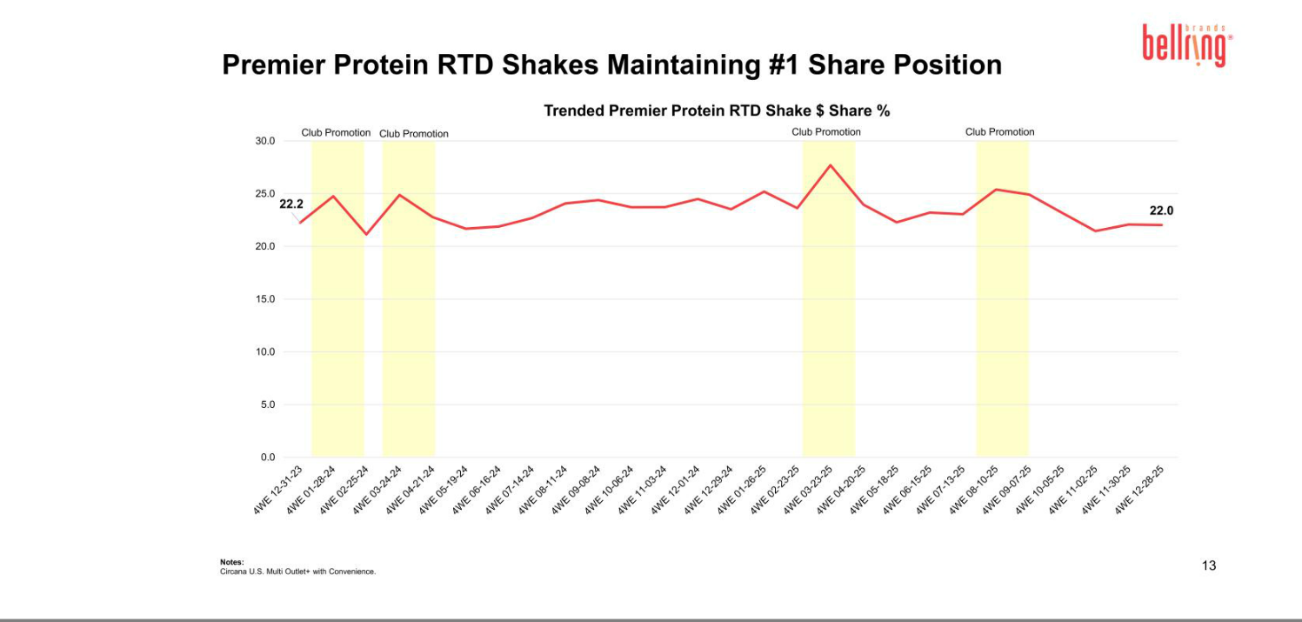

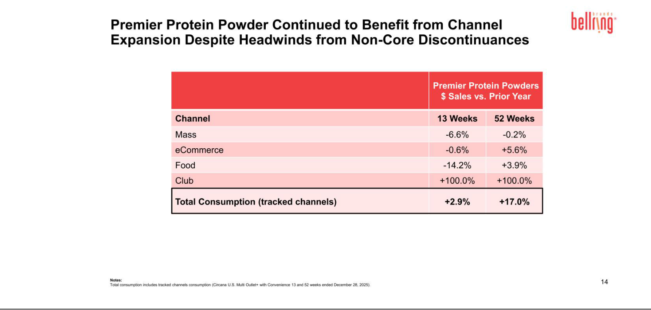

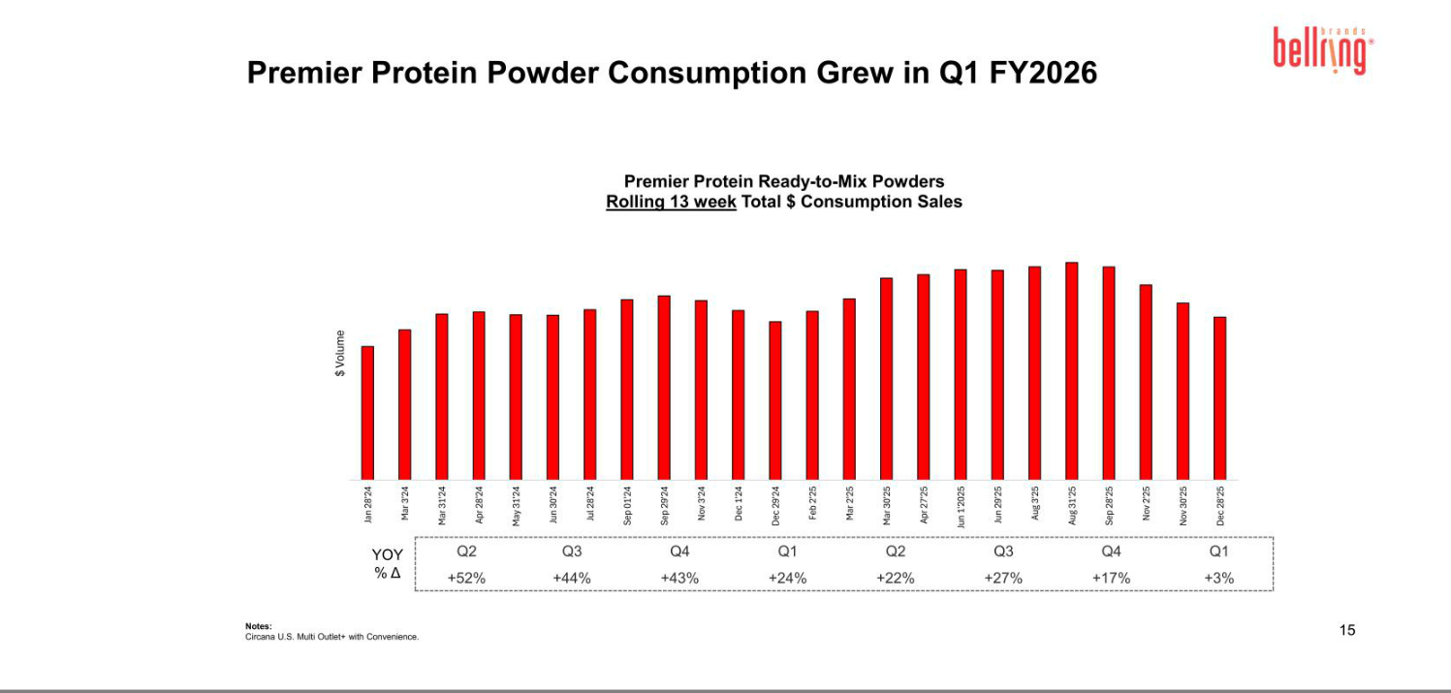

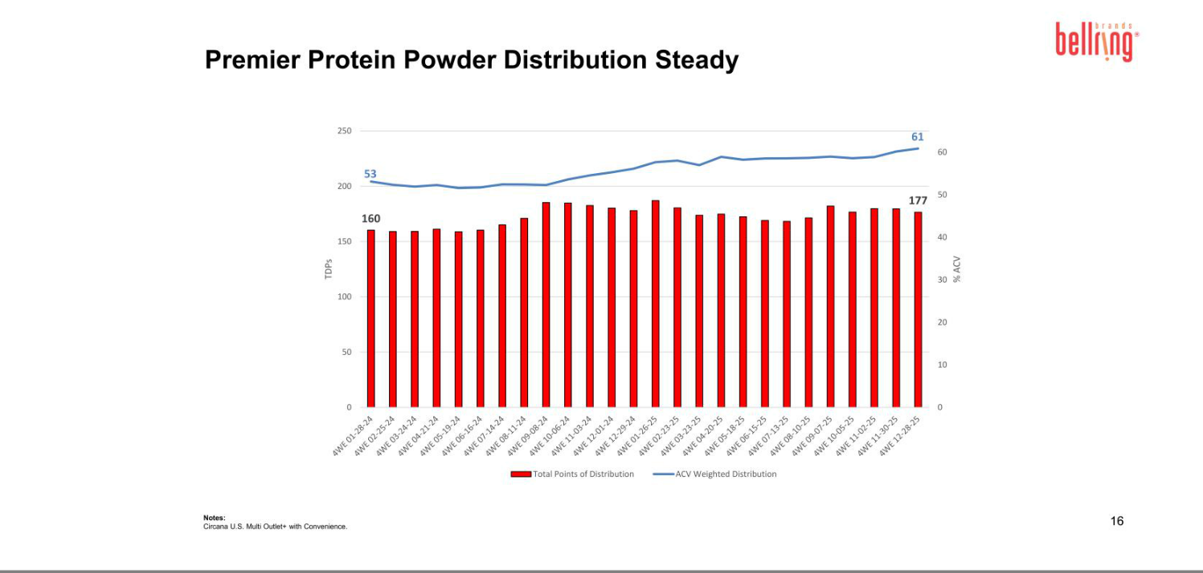

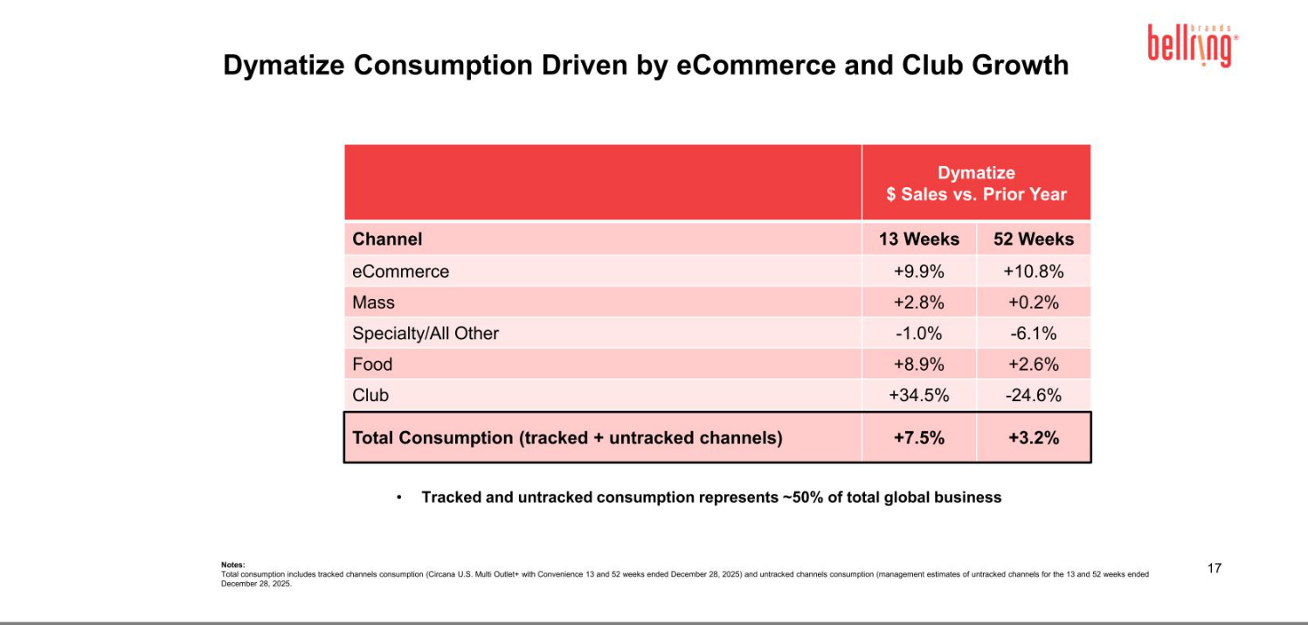

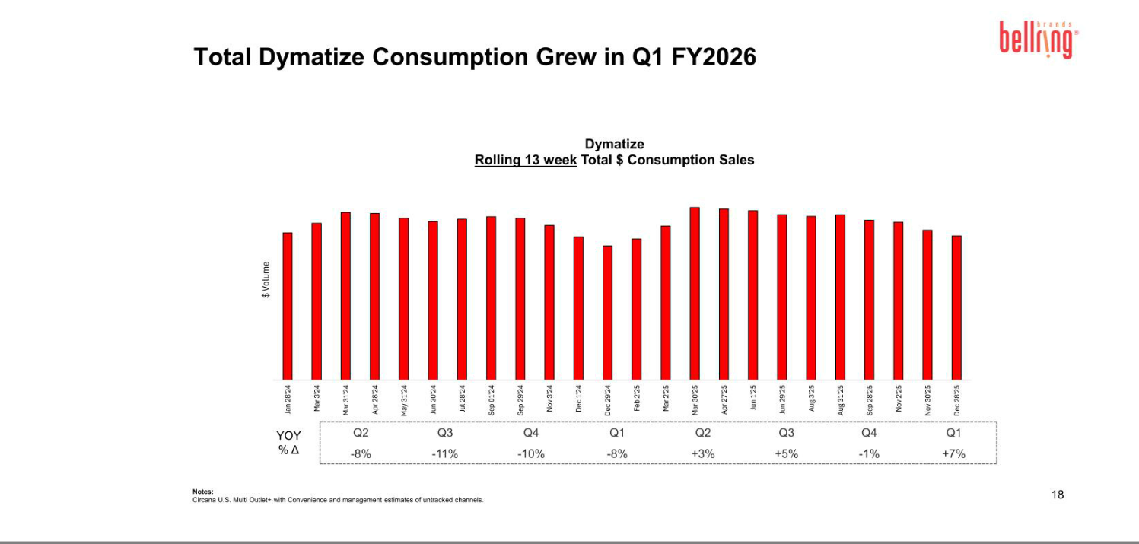

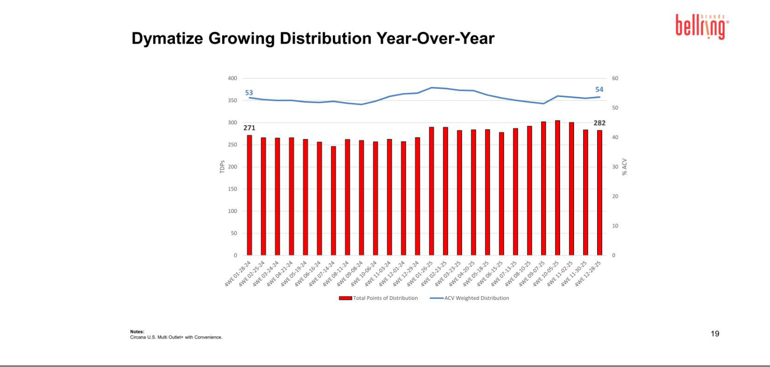

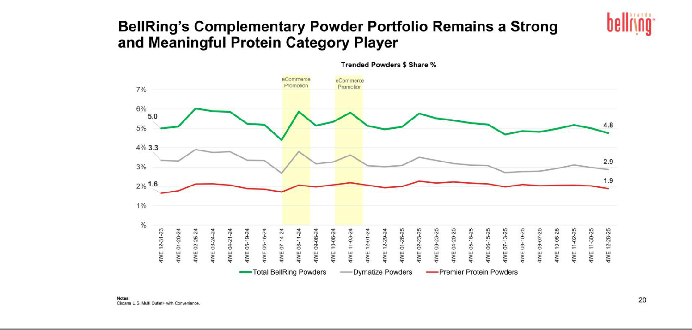



Exhibit 99.3

BellRing Brands Announces Leadership Transition Plan

St. Louis - February 3, 2026 - BellRing Brands, Inc. (NYSE:BRBR) (“BellRing”)(the “Company”) today announced that its President and Chief Executive Officer Darcy Davenport has decided to retire from the Company, effective upon the earlier of the appointment of a new Chief Executive Officer or September 30, 2026, the end of the Company’s fiscal year.

Ms. Davenport will continue to serve as President and Chief Executive Officer and as a member of the Board until the effective date of the transition, after which she will serve in an advisory role to ensure a smooth transition of leadership responsibilities and provide strategic support. The Board has commenced a comprehensive external search to identify the Company’s next CEO.

“On behalf of the BellRing Board, I want to thank Darcy for her leadership and incredible contributions to the Company,” said Robert V. Vitale, Chairman of the Board of Directors. “Darcy started with Premier Nutrition as Vice President, Marketing in 2011 and became the leader of Premier Nutrition Company after Post Holdings acquired it in 2014. Managing the integration of Dymatize and PowerBar into Premier Nutrition, she led sales growth from $140 million to over $2.3 billion and helped create a pure-play company focused on proactive wellness. Under Darcy’s leadership, BellRing has built a portfolio of category-leading products, expanded key customer relationships and laid a strong foundation for long-term growth. We appreciate her continued leadership through this transition and look forward to working with her in an advisory capacity to continue to help shape our strategy.”

Ms. Davenport said, “It has been an honor to lead BellRing and work alongside such a talented team. I am proud of what we have accomplished together, the company culture of good energy that we have created and the roadmap we have established for the future. As the Board conducts its search, I remain focused on achieving our fiscal 2026 objectives and continuing to execute on our strategic priorities. The foundation of BellRing is strong, and I look forward to helping the Board and the Company’s new CEO advance toward its next chapter of growth.”

Forward-Looking Statements

Forward-looking statements, within the meaning of Section 27A of the Securities Act of 1933, as amended, and Section 21E of the Securities Exchange Act of 1934, as amended, are made in this press release. These forward-looking statements are sometimes identified from the use of forward-looking words such as “believe,” “should,” “could,” “potential,” “continue,” “expect,” “project,” “estimate,” “predict,” “anticipate,” “aim,” “intend,” “plan,” “forecast,” “target,” “is likely,” “will,” “can,” “may” or “would” or the negative of these terms or similar expressions elsewhere in this press release. All forward-looking statements are subject to a number of important factors, risks, uncertainties and assumptions that could cause actual results to differ materially from those described in any forward-looking statements. These factors and risks include, but are not limited to, financial, operational and legal risks and uncertainties detailed from time to time in BellRing’s cautionary statements contained in its filings with the Securities and Exchange Commission. These forward-looking statements represent BellRing’s judgment as of the date of this press release. BellRing disclaims, however, any intent or obligation to update these forward-looking statements.

About BellRing Brands, Inc.

BellRing Brands, Inc. (NYSE: BRBR) is a dynamic and fast-growing consumer brands business with the purpose of Changing Lives with Good Energy. Focused on growing the proactive wellness category, the company’s brands include Premier Protein,

the #1 ready-to-drink protein and proactive wellness brand, and Dymatize, the brand behind the #1 hydrolyzed protein powder. A culture-driven, pure-play company, BellRing Brands believes nutrition is at the core of a healthy world and produces products with best-in-class nutritional profiles and exceptional flavors. Its products are distributed in over 90 countries across club, mass, food, eCommerce, specialty, drug and convenience. To learn more visit www.bellring.com.

Contact:

Investor Relations

Jennifer Meyer

jennifer.meyer@bellringbrands.com

(415) 814-9388

