UNITED STATES

SECURITIES AND EXCHANGE COMMISSION

Washington, D.C. 20549

______________________

FORM 8-K

CURRENT REPORT

Pursuant to Section 13 OR 15(d) of The

Securities Exchange Act of 1934

Date of Report (Date of earliest event reported): May 6, 2021
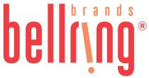

BellRing Brands, Inc.

 | (Exact name of registrant as specified in its charter)
Delaware |  | 001-39093 | 83-4096323
(State or other jurisdiction of incorporation) | (Commission File Number) |  | (IRS Employer Identification No.)
2503 S. Hanley Road | St. Louis | Missouri | 63144
(Address of Principal Executive Offices) |  |  | (Zip Code)

Registrant’s telephone number, including area code: (314) 644-7600

Check the appropriate box below if the Form 8-K filing is intended to simultaneously satisfy the filing obligation of the registrant under any of the following provisions:

- Written communications pursuant to Rule 425 under the Securities Act (17 CFR 230.425)

- Soliciting material pursuant to Rule 14a-12 under the Exchange Act (17 CFR 240.14a-12)

- Pre-commencement communications pursuant to Rule 14d-2(b) under the Exchange Act (17 CFR 240.14d-2(b))

- Pre-commencement communications pursuant to Rule 13e-4(c) under the Exchange Act (17 CFR 240.13e-4(c))

Securities registered pursuant to Section 12(b) of the Act:
 | Title of each class |  | Trading Symbol(s) |  |  | Name of each exchange on which registered
Class A Common Stock, $0.01 par value per share |  |  |  | BRBR |  |  | New York Stock Exchange

Indicate by check mark whether the registrant is an emerging growth company as defined in Rule 405 of the Securities Act of 1933 (§230.405 of this chapter) or Rule 12b-2 of the Securities Exchange Act of 1934 (§240.12b-2 of this chapter).

Emerging growth company ☒

If an emerging growth company, indicate by check mark if the registrant has elected not to use the extended transition period for complying with any new or revised financial accounting standards provided pursuant to Section 13(a) of

the Exchange Act. ☒

Item 2.02. Results of Operation and Financial Condition.

On May 6, 2021, BellRing Brands, Inc. (the "Company") issued a press release announcing results for its second fiscal quarter ended March 31, 2021 and providing a financial outlook for fiscal year 2021. A copy of the press release is attached hereto as Exhibit 99.1 and incorporated herein by reference. In addition, on May 6, 2021, the Company published to the "Investor Relations" section of its website, www.bellringbrands.com, a supplemental presentation related to results for its second fiscal quarter ended March 31, 2021. A copy of the presentation is attached hereto as Exhibit 99.2 and incorporated herein by reference.

The information contained in Item 2.02, including Exhibit 99.1 and Exhibit 99.2 attached hereto, shall not be deemed to be "filed" for purposes of Section 18 of the Securities Exchange Act of 1934, as amended (the "Exchange Act"), or otherwise subject to the liabilities of that Section, nor shall they be deemed incorporated by reference into any filings under the Securities Act of 1933, as amended, or the Exchange Act, except as expressly set forth by specific reference in such filing.

Item 5.02. Departure of Directors or Certain Officers; Election of Directors; Appointment of Certain Officers; Compensatory Arrangements of Certain Officers.

(d) Newly Elected Directors.

On May 5, 2021, the Board of Directors (the “Board”) of the Company appointed Chonda J. Nwamu to serve as a Class III director of the Board, effective May 5, 2021. With the addition of Ms. Nwamu, the Board of Directors now consists of six members. Ms. Nwamu’s initial term will expire at the Company’s Annual Meeting of Shareholders in 2022. The Board has determined that Ms. Nwamu is independent under the listing standards of the New York Stock Exchange and the Company’s Corporate Governance Guidelines.

Ms. Nwamu was appointed to the Board after a thorough review of her qualifications by the Corporate Governance and Compensation Committee of the Board. Ms. Nwamu will receive compensation as a non-employee director in accordance with the Company’s non-employee director compensation program described in the Company’s Annual Proxy Statement filed with the Securities and Exchange Commission on January 20, 2021. There is no arrangement or understanding between Ms. Nwamu and any other persons pursuant to which she was appointed as a director, and there are no transactions in which she has an interest requiring disclosure under Item 404(a) of Regulation S-K. The Company expects to enter into its standard form of indemnification agreement with Ms. Nwamu. A form of the indemnification agreement was previously filed by the Company as Exhibit 10.7 to the Company’s Form 8-K, filed with the Securities and Exchange Commission on October 21, 2019.

Item 7.01. Regulation FD Disclosure.

The Company issued a press release announcing the appointment of Ms. Nwamu to the Board, a copy of which is attached hereto as Exhibit 99.3 and incorporated herein by reference.

The information contained in this Item 7.01 and in the accompanying Exhibit 99.3 shall not be deemed “filed” for purposes of Section 18 of the Exchange Act, or otherwise subject to the liabilities of that Section, nor shall such information or exhibit be deemed incorporated by reference in any filing under the Exchange Act or the Securities Act of 1933, as amended, except as shall be expressly set forth by specific reference in such filing.

Item 9.01. Financial Statements and Exhibits.

(d) Exhibits

Exhibit No. |  | Description
99.1 |  | Press Release dated May 6, 2021 - Second Quarter Earnings
99.2 |  | Second Quarter Fiscal Year 2021 Supplemental Presentation
99.3 |  | Press Release dated May 6, 2021 - Appointment of Chonda J. Nwamu to Board
104 |  | Cover Page Interactive Data File (the cover page iXBRL tags are embedded within the Inline XBRL document)

Pursuant to the requirements of the Securities Exchange Act of 1934, the registrant has duly caused this report to be signed on its behalf by the undersigned thereunto duly authorized.

Date: May 6, 2021 | BellRing Brands, Inc.
 | (Registrant)
 | By: | /s/ Paul A. Rode
 | Name: | Paul A. Rode
 | Title: | Chief Financial Officer

Exhibit 99.1


BellRing Brands Reports Results for the Second Quarter of Fiscal Year 2021; Raises Fiscal Year 2021 Outlook

St. Louis - May 6, 2021 - BellRing Brands, Inc. (NYSE:BRBR) (“BellRing”), a holding company operating in the global convenient nutrition category, today reported results for the second fiscal quarter ended March 31, 2021.

Highlights:

- Net sales of $282.1 million

- Operating profit of $15.6 million; net earnings available to Class A common stockholders of $0.6 million; Adjusted net earnings available to Class A common stockholders of $6.0 million and Adjusted EBITDA of $42.2 million
- Raised fiscal year 2021 net sales guidance to $1.17-$1.20 billion and Adjusted EBITDA (non-GAAP) guidance to $214-$220 million

Second Quarter Operating Results

Net sales were $282.1 million, an increase of 9.6%, or $24.6 million, compared to the prior year period. Premier Protein net sales increased 8.2%, with volumes up 7.4%, and Premier Protein ready-to-drink (“RTD”) shake net sales increased 7.7%, with volumes up 8.0%. Premier Protein net sales benefited from RTD shake distribution gains for both existing and new products, planned incremental promotional activity and a favorable product and customer mix, which were partially offset by lapping an increase in customer trade inventory levels in the prior year period driven by consumer pantry-loading in reaction to the COVID-19 pandemic. Dollar consumption of Premier Protein RTD shakes increased 20.3% in the 13-week period ended April 3, 2021 as compared to the same period in 2020 (inclusive of Nielsen Total US xAOC including Convenience and management estimates of untracked channels). Dymatize net sales increased 28.8%, with volumes up 10.0%, and benefited from distribution gains for both existing and new products with strong growth in the international, club, mass and eCommerce channels and a favorable product and customer mix. Net sales of all other products decreased 7.3%.

Gross profit was $87.0 million, or 30.8% of net sales, a decrease of 1.4%, or $1.2 million, compared to the prior year period gross profit of $88.2 million, or 34.3% of net sales. The lower gross profit margin was driven by higher input costs (predominantly milk-based proteins and freight for RTD shakes) and planned incremental promotional activity.

Selling, general and administrative (“SG&A”) expenses were $48.2 million, or 17.1% of net sales, an increase of $0.7 million compared to the prior year period SG&A expenses of $47.5 million, or 18.4% of net sales. SG&A expenses in the second quarter of 2021 included $2.2 million of higher marketing and consumer advertising expenses and $0.7 million of restructuring and facility closure costs, which were partially offset by $0.3 million of lower costs related to BellRing’s separation from Post Holdings, Inc. (“Post”). Restructuring and facility closure costs and separation costs were treated as adjustments for non-GAAP measures.

Operating profit was $15.6 million, a decrease of 55.6%, or $19.5 million, compared to the prior year period operating profit of $35.1 million, and was negatively impacted by $17.7 million of accelerated amortization, which is discussed later in this release and was treated as an adjustment for non-GAAP measures.

Interest expense, net was $11.3 million, compared to $14.3 million in the prior year period, with the decrease primarily driven by a reduction in the aggregate principal amount of debt outstanding. Loss on refinancing of debt of $1.5 million was recorded in the second quarter of 2021 in connection with an opportunistic repricing of BellRing Brands, LLC’s (“BellRing LLC”) term loan in February 2021 and was treated as an adjustment for non-GAAP measures.

Income tax expense was $0.3 million, an effective income tax rate of 10.7%, compared to $2.2 million in the prior year period, an effective income tax rate of 10.6%. In both periods, the effective income tax rate differed significantly from the statutory rate primarily as a result of taking into account for U.S. federal, state and local income tax purposes a 28.8% distributive share of the items of income, gain, loss and deduction of BellRing LLC.

1

Net earnings available to Class A common stockholders were $0.6 million, a decrease of 85.7%, or $3.6 million, compared to $4.2 million in the prior year period. Net earnings available to Class A common stockholders excluded $1.9 million of net earnings attributable to the Company’s redeemable noncontrolling interest (“NCI”), compared to $14.4 million excluded in the prior year period. Net earnings per diluted share of Class A common stock were $0.02, compared to $0.11 in the prior year period. Adjusted net earnings available to Class A common stockholders were $6.0 million, or $0.15 per diluted share of Class A common stock, compared to the prior year period Adjusted net earnings available to Class A common stockholders of $4.5 million, or $0.11 per diluted share of Class A common stock.

Adjusted EBITDA was $42.2 million, a decrease of 2.8%, or $1.2 million, compared to the prior year period Adjusted EBITDA of $43.4 million. Adjusted EBITDA in both periods included an adjustment for the portion of BellRing LLC’s consolidated net earnings which was allocated to NCI, resulting in the calculation of Adjusted EBITDA including 100% of BellRing.

Six Month Operating Results

Net sales were $564.5 million, an increase of 12.6%, or $63.0 million, compared to the prior year period. Premier Protein net sales increased 12.7%, with volumes up 14.2%. Dymatize net sales increased 22.5%, with volumes up 10.2%. Net sales of all other products decreased 9.3%.

Gross profit was $178.9 million, or 31.7% of net sales, a decrease of 0.3%, or $0.6 million, compared to the prior year period gross profit of $179.5 million, or 35.8% of net sales. The lower gross profit margin was driven by higher input costs (predominantly milk-based proteins and freight for RTD shakes) and planned incremental promotional activity.

SG&A expenses were $86.5 million, or 15.3% of net sales, an increase of $2.5 million compared to the prior year period SG&A expenses of $84.0 million, or 16.7% of net sales. SG&A expenses in the six months ended March 31, 2021 included $5.3 million of restructuring and facility closure costs and $2.5 million of higher marketing and consumer advertising expenses, which were partially offset by $1.8 million of lower costs related to BellRing’s separation from Post in the prior year period. Restructuring and facility closure costs and separation costs were treated as adjustments for non-GAAP measures.

Operating profit was $63.4 million, a decrease of 24.9%, or $21.0 million, compared to the prior year period operating profit of $84.4 million, and was negatively impacted by $18.1 million of accelerated amortization, which is discussed later in this release and was treated as an adjustment for non-GAAP measures.

Interest expense, net was $24.1 million, compared to $25.9 million in the prior year period, with the decrease primarily driven by a reduction in the aggregate principal amount of debt outstanding. Loss on refinancing of debt of $1.5 million was recorded in the six months ended March 31, 2021 in connection with the repricing of BellRing LLC’s term loan and was treated as an adjustment for non-GAAP measures.

Income tax expense was $2.4 million, an effective income tax rate of 6.3%, compared to $8.1 million in the prior year period, an effective income tax rate of 13.8%. In both periods, the effective income tax rate differed significantly from the statutory rate primarily as a result of taking into account for U.S. federal, state and local income tax purposes a 28.8% distributive share of the items of income, gain, loss and deduction of BellRing LLC in the periods subsequent to BellRing’s initial public offering (the “IPO”).

Net earnings available to Class A common stockholders were $8.4 million, a decrease of 17.6%, or $1.8 million, compared to $10.2 million in the prior year period. Net earnings available to Class A common stockholders for the six

months ended March 31, 2021 excluded $27.0 million of net earnings attributable to the Company’s NCI, compared to $40.2 million excluded in the prior year period. Net earnings per diluted share of Class A common stock were

$0.21, compared to $0.26 in the prior year period. Adjusted net earnings available to Class A common stockholders were $15.1 million, or $0.38 per diluted share of Class A common stock, compared to the prior year period Adjusted

net earnings available to Class A common stockholders of $10.9 million, or $0.28 per diluted share of Class A common stock.

Adjusted EBITDA was $102.9 million, an increase of 0.9%, or $0.9 million, compared to the prior year period Adjusted EBITDA of $102.0 million. Adjusted EBITDA in both periods included an adjustment for the portion of BellRing LLC’s consolidated net earnings which was allocated to NCI, resulting in the calculation of Adjusted EBITDA including 100% of BellRing.

Discontinuance of Supreme Protein

BellRing management has finalized its plan to discontinue its Supreme Protein brand. In connection with this discontinuance, BellRing incurred $17.7 million and $18.1 million of accelerated amortization in the three and six months ended March 31, 2021, respectively, which was treated as an adjustment for non-GAAP measures. BellRing expects to fully amortize the

2

customer relationships and trademarks associated with the Supreme Protein brand by June 1, 2021 and, as a result, expects to record $11.8 million of accelerated amortization in its third quarter of 2021. Basis of Presentation
On October 21, 2019, BellRing closed its IPO of 39.4 million shares of Class A common stock. Upon completion of the IPO and certain transactions completed in connection with the IPO, BellRing became the holding company for BellRing LLC (which became the holding company for Post’s historical active nutrition business). Effective October 21, 2019, BellRing allocates a portion of the consolidated net earnings of BellRing LLC to NCI, reflecting the entitlement of Post to a portion of the consolidated net earnings. As of March 31, 2021, Post held 71.2% of the economic interest of BellRing LLC. Prior to October 21, 2019, Post held 100% of the economic interest of BellRing LLC, which was allocated to NCI.

For the period prior to the IPO included in the six months ended March 31, 2020, BellRing’s financial statements present the combined results of Post’s historical active nutrition business which have been prepared on a stand-alone basis and are derived from the consolidated financial statements and accounting records of Post. The combined financial statements reflect the historical results of operations, financial position and cash flows of the active nutrition business. In the opinion of management, the assumptions underlying the active nutrition business’s historical combined financial statements were reasonable.

COVID-19 Commentary

BellRing continues to monitor the impact of the COVID-19 pandemic on its business and remains focused on ensuring its ability to safeguard the health of its employees, maintaining the continuity of its supply chain and preserving financial liquidity. BellRing’s primary categories, liquid and powder, have returned to growth relatively in line with their pre-pandemic growth rates. The bar category continues to be soft when compared to the pre-pandemic period. As of March 31, 2021, BellRing had $33.2 million in cash and cash equivalents and the available borrowing capacity under BellRing LLC’s revolving credit facility was $200.0 million.

Outlook

For fiscal year 2021, BellRing management has raised its guidance range for net sales to $1.17-$1.20 billion from $1.07-$1.12 billion and Adjusted EBITDA to $214-$220 million from $207-$217 million (resulting in net sales and Adjusted EBITDA growth of 18%-21% and 9%-12%, respectively, over fiscal year 2020). BellRing management continues to expect fiscal year 2021 capital expenditures of approximately $4 million.

BellRing provides Adjusted EBITDA guidance only on a non-GAAP basis and does not provide a reconciliation of its forward-looking Adjusted EBITDA non-GAAP guidance measure to the most directly comparable GAAP measure due to the inherent difficulty in forecasting and quantifying certain amounts that are necessary for such reconciliation, including adjustments that could be made for restructuring and facility closures costs, separation costs, NCI and other charges reflected in BellRing’s reconciliation of historical numbers, the amounts of which, based on historical experience, could be significant. For additional information regarding BellRing’s non-GAAP measures, see the related explanations presented under “Use of Non-GAAP Measures.”

Use of Non-GAAP Measures

BellRing uses certain non-GAAP measures in this release to supplement the financial measures prepared in accordance with U.S. generally accepted accounting principles (“GAAP”). These non-GAAP measures include Adjusted net earnings available to Class A common stockholders, Adjusted diluted earnings per share of Class A common stock and Adjusted EBITDA. The reconciliation of each of these non-GAAP measures to the most directly comparable GAAP measure is provided later in this release under “Explanation and Reconciliation of Non-GAAP Measures.”

Management uses certain of these non-GAAP measures, including Adjusted EBITDA, as key metrics in the evaluation of underlying company performance, in making financial, operating and planning decisions and, in part, in the determination of cash bonuses for its executive officers and employees. Additionally, BellRing LLC is required to comply with certain covenants and limitations that are based on variations of EBITDA in BellRing LLC’s financing documents. Management believes the use of these non-GAAP measures provides increased transparency and assists investors in understanding the underlying operating performance of BellRing and in the analysis of ongoing operating trends. Non-GAAP measures are not prepared in accordance with GAAP, as they exclude certain items as described later in this release. These non-GAAP measures may not be comparable to similarly titled measures of other companies. For additional information regarding BellRing’s non-GAAP measures, see the related explanations provided under “Explanation and Reconciliation of Non-GAAP Measures” later in this release.

3

BellRing Conference Call to Discuss Earnings Results and Outlook

BellRing will host a conference call on Friday, May 7, 2021 at 10:30 a.m. EDT to discuss financial results for the second quarter of fiscal year 2021 and fiscal year 2021 outlook and to respond to questions. Darcy H. Davenport, President and Chief Executive Officer, and Paul A. Rode, Chief Financial Officer, will participate in the call.

Interested parties may join the conference call by dialing (833) 954-1568 in the United States and (409) 216-6583 from outside of the United States. The conference identification number is 5885539. Interested parties are invited to listen to the webcast of the conference call, which can be accessed by visiting the Investor Relations section of BellRing’s website at www.bellring.com. A slide presentation containing supplemental material will also be available at the same location on BellRing’s website.

A replay of the conference call will be available through Friday, May 21, 2021 by dialing (800) 585-8367 in the United States and (404) 537-3406 from outside of the United States and using the conference identification number 5885539. A webcast replay also will be available for a limited period on BellRing’s website in the Investor Relations section.

Prospective Financial Information

Prospective financial information is necessarily speculative in nature, and it can be expected that some or all of the assumptions underlying the prospective financial information described above will not materialize or will vary significantly from actual results. For further discussion of some of the factors that may cause actual results to vary materially from the information provided above, see “Forward-Looking Statements” below. Accordingly, the prospective financial information provided above is only an estimate of what BellRing’s management believes is realizable as of the date of this release. It also should be recognized that the reliability of any forecasted financial data diminishes the farther in the future that the data is forecasted. In light of the foregoing, the information should be viewed in context and undue reliance should not be placed upon it.

Forward-Looking Statements

Certain matters discussed in this release and on BellRing’s conference call are forward-looking statements, including BellRing’s net sales, Adjusted EBITDA and capital expenditures outlook for fiscal year 2021 and statements regarding the discontinuance of Supreme Protein, the effect of the COVID-19 pandemic on BellRing’s business and BellRing’s continuing response to the COVID-19 pandemic. These forward-looking statements are sometimes identified from the use of forward-looking words such as “believe,” “should,” “could,” “potential,” “continue,” “expect,” “project,” “estimate,” “predict,” “anticipate,” “aim,” “intend,” “plan,” “forecast,” “target,” “is likely,” “will,” “can,” “may” or “would” or the negative of these terms or similar expressions, and include all statements regarding future performance, earnings projections, events or developments. There are a number of risks and uncertainties that could cause actual results to differ materially from the forward-looking statements made herein. These risks and uncertainties include, but are not limited to, the following:

- the impact of the COVID-19 pandemic, including negative impacts on the global economy and capital markets, the health of BellRing’s employees, BellRing’s ability and the ability of its third party manufacturers to manufacture and deliver its products, operating costs, demand for its on-the-go products and its operations generally;
- BellRing’s dependence on sales from its RTD protein shakes;

- BellRing’s ability to continue to compete in its product categories and its ability to retain its market position and favorable perceptions of its brands;

- BellRing’s dependence on a limited number of third party contract manufacturers and suppliers for the manufacturing of most of its products, including one manufacturer for the substantial majority of its RTD protein shakes;

- BellRing’s reliance on a limited number of third party suppliers to provide certain ingredients and packaging;

- significant volatility in the cost or availability of inputs to BellRing’s business (including freight, raw materials, packaging, energy and other supplies);

- BellRing’s ability to anticipate and respond to changes in consumer and customer preferences and behaviors and introduce new products;

- disruptions or inefficiencies in BellRing’s supply chain, including as a result of BellRing’s reliance on third party suppliers or manufacturers for the manufacturing of many of its products, pandemics (including the COVID-19 pandemic) and other outbreaks of contagious diseases, fires and evacuations related thereto, changes in weather conditions, natural disasters, agricultural diseases and pests and other events beyond BellRing’s control;
- consolidation in BellRing’s distribution channels;

- BellRing’s ability to expand existing market penetration and enter into new markets;

- allegations that BellRing’s products cause injury or illness, product recalls and withdrawals and product liability claims and other litigation;

4

- legal and regulatory factors, such as compliance with existing laws and regulations, as well as new laws and regulations and changes to existing laws and regulations and interpretations thereof, affecting BellRing’s business, including current and future laws and regulations regarding food safety, advertising and labeling;
- BellRing’s ability to identify, complete and integrate or otherwise effectively execute acquisitions or other strategic transactions and effectively manage its growth;

- fluctuations in BellRing’s business due to changes in its promotional activities and seasonality;

- risks associated with BellRing’s international business;

- the loss of, a significant reduction of purchases by or the bankruptcy of a major customer;

- the ultimate impact litigation or other regulatory matters may have on BellRing;

- the accuracy of BellRing’s market data and attributes and related information;

- changes in estimates in critical accounting judgments;

- economic downturns that limit customer and consumer demand for BellRing’s products;

- changes in economic conditions, disruptions in the United States and global capital and credit markets, changes in interest rates, volatility in the market value of derivatives and fluctuations in foreign currency exchange rates;

- BellRing’s ability to protect its intellectual property and other assets and to continue to use third party intellectual property subject to intellectual property licenses;

- costs, business disruptions and reputational damage associated with information technology failures, cybersecurity incidents and/or information security breaches;

- impairment in the carrying value of goodwill or other intangibles;

- BellRing’s high leverage, its ability to obtain additional financing (including both secured and unsecured debt) and its ability to service its outstanding debt (including covenants that restrict the operation of its business);

- risks related to BellRing’s ongoing relationship with Post, including Post’s control over BellRing;

- ability to control the direction of BellRing’s business, conflicts of interest or disputes that may arise between Post and BellRing and BellRing’s obligations under various agreements with Post, including under the tax receivable agreement;
- risks associated with BellRing’s public company status, including the additional expenses BellRing will continue to incur to create and maintain the corporate infrastructure to operate as a public company;

- BellRing’s ability to satisfy the requirements of Section 404 of the Sarbanes-Oxley Act of 2002;

- significant differences in BellRing’s actual operating results from BellRing’s guidance regarding its performance;

- BellRing’s ability to hire and retain talented personnel, employee absenteeism, labor strikes, work stoppages or unionization efforts; and

- other risks and uncertainties described in BellRing’s filings with the Securities and Exchange Commission.

These forward-looking statements represent BellRing’s judgment as of the date of this release. BellRing disclaims, however, any intent or obligation to update these forward-looking statements.

About BellRing Brands, Inc.

BellRing Brands, Inc. is a rapidly growing leader in the global convenient nutrition category. Its primary brands, Premier Protein® and Dymatize®, appeal to a broad range of consumers across all major product forms, including ready-to-drink protein shakes, powders and nutrition bars, and are distributed across a diverse network of channels including club, food, drug, mass, eCommerce, specialty and convenience. BellRing’s commitment to consumers is to strive to make highly effective products that deliver best-in-class nutritionals and superior taste. For more information, visit www.bellring.com.

Contact:

Investor Relations

Jennifer Meyer

jennifer.meyer@bellringbrands.com

(314) 644-7665

Media Relations

Lisa Hanly

lisa.hanly@bellringbrands.com

(314) 665-3180

5

CONDENSED CONSOLIDATED STATEMENTS OF OPERATIONS (Unaudited)

(in millions, except for per share data)
 |  | Three Months Ended |  |  |  |  |  | Six Months Ended
 |  | March 31, |  |  |  |  |  | March 31,
 | 2021 |  |  |  | 2020 |  |  | 2021 |  |  | 2020
Net Sales | $ | 282.1 |  | $ | 257.5 |  | $ | 564.5 |  | $ | 501.5
Cost of goods sold |  | 195.1 |  |  | 169.3 |  |  | 385.6 |  |  | 322.0
Gross Profit |  | 87.0 |  |  | 88.2 |  |  | 178.9 |  |  | 179.5
Selling, general and administrative expenses |  | 48.2 |  |  | 47.5 |  |  | 86.5 |  |  | 84.0
Amortization of intangible assets |  | 23.2 |  |  | 5.6 |  |  | 29.1 |  |  | 11.1
Other operating income, net |  | — |  |  | — |  |  | (0.1) |  |  | —
Operating Profit |  | 15.6 |  |  | 35.1 |  |  | 63.4 |  |  | 84.4
Interest expense, net |  | 11.3 |  |  | 14.3 |  |  | 24.1 |  |  | 25.9
Loss on refinancing of debt |  | 1.5 |  |  | — |  |  | 1.5 |  |  | —
Earnings before Income Taxes |  | 2.8 |  |  | 20.8 |  |  | 37.8 |  |  | 58.5
Income tax expense |  | 0.3 |  |  | 2.2 |  |  | 2.4 |  |  | 8.1
Net Earnings Including Redeemable Noncontrolling Interest |  | 2.5 |  |  | 18.6 |  |  | 35.4 |  |  | 50.4
Less: Net earnings attributable to redeemable noncontrolling interest |  | 1.9 |  |  | 14.4 |  |  | 27.0 |  |  | 40.2
Net Earnings Available to Class A Common Stockholders | $ | 0.6 |  | $ | 4.2 |  | $ | 8.4 |  | $ | 10.2
Earnings per share of Class A Common Stock:
Basic | $ | 0.02 |  | $ | 0.11 |  | $ | 0.21 |  | $ | 0.26
Diluted | $ | 0.02 |  | $ | 0.11 |  | $ | 0.21 |  | $ | 0.26
Weighted-Average Shares of Class A Common Stock Outstanding:
Basic |  | 39.5 |  |  | 39.4 |  |  | 39.5 |  |  | 39.4
Diluted |  | 39.7 |  |  | 39.5 |  |  | 39.6 |  |  | 39.4

6

CONDENSED CONSOLIDATED BALANCE SHEETS (Unaudited)

(in millions)

 |  | March 31, 2021 |  |  |  | September 30, 2020
 | ASSETS
Current Assets
Cash and cash equivalents | $ |  | 33.2 |  | $ | 48.7
Receivables, net |  |  | 117.4 |  |  | 83.1
Inventories |  |  | 148.2 |  |  | 150.5
Prepaid expenses and other current assets |  |  | 9.1 |  |  | 7.9
Total Current Assets |  |  | 307.9 |  |  | 290.2
Property, net |  |  | 8.9 |  |  | 10.2
Goodwill |  |  | 65.9 |  |  | 65.9
Other intangible assets, net |  |  | 245.2 |  |  | 274.3
Other assets |  |  | 11.4 |  |  | 12.9
Total Assets | $ |  | 639.3 |  | $ | 653.5
 | LIABILITIES AND STOCKHOLDERS’ EQUITY
Current Liabilities
Current portion of long-term debt | $ |  | 73.2 |  | $ | 63.8
Accounts payable |  |  | 91.0 |  |  | 56.7
Other current liabilities |  |  | 35.0 |  |  | 32.6
Total Current Liabilities |  |  | 199.2 |  |  | 153.1
Long-term debt |  |  | 539.6 |  |  | 622.6
Deferred income taxes |  |  | 8.3 |  |  | 9.0
Other liabilities |  |  | 26.0 |  |  | 29.8
Total Liabilities |  |  | 773.1 |  |  | 814.5
Redeemable noncontrolling interest |  |  | 2,301.4 |  |  | 2,021.6
Stockholders’ Equity
Preferred stock |  |  | — |  |  | —
Common stock |  |  | 0.4 |  |  | 0.4
Accumulated deficit |  |  | (2,431.9) |  |  | (2,179.0)
Accumulated other comprehensive loss |  |  | (3.7) |  |  | (4.0)
Total Stockholders’ Equity |  |  | (2,435.2) |  |  | (2,182.6)
Total Liabilities and Stockholders’ Equity |  | $ | 639.3 |  | $ | 653.5
 | SELECTED CONDENSED CONSOLIDATED CASH FLOWS INFORMATION (Unaudited)
 | (in millions)
 |  |  | Six Months Ended
 |  |  | March 31,
 |  | 2021 |  |  |  | 2020
Cash provided by (used in):
Operating activities | $ |  | 73.8 |  | $ | (5.1)
Investing activities |  |  | (0.5) |  |  | (1.2)
Financing activities |  |  | (89.4) |  |  | 77.6
Effect of exchange rate changes on cash and cash equivalents |  |  | 0.6 |  |  | (0.1)
Net (decrease) increase in cash and cash equivalents | $ |  | (15.5) |  | $ | 71.2
 | 7

EXPLANATION AND RECONCILIATION OF NON-GAAP MEASURES

BellRing uses certain non-GAAP measures in this release to supplement the financial measures prepared in accordance with U.S. generally accepted accounting principles (“GAAP”). These non-GAAP measures include Adjusted net earnings available to Class A common stockholders, Adjusted diluted earnings per share of Class A common stock and Adjusted EBITDA. The reconciliation of each of these non-GAAP measures to the most directly comparable GAAP measure is provided in the tables following this section. Non-GAAP measures are not prepared in accordance with GAAP, as they exclude certain items as described below. These non-GAAP measures may not be comparable to similarly titled measures of other companies.

Adjusted net earnings available to Class A common stockholders and Adjusted diluted earnings per share of Class A common stock

BellRing believes Adjusted net earnings available to Class A common stockholders and Adjusted diluted earnings per share of Class A common stock are useful to investors in evaluating BellRing’s operating performance because they exclude items that affect the comparability of BellRing’s financial results and could potentially distort an understanding of the trends in business performance.

Adjusted net earnings available to Class A common stockholders and Adjusted diluted earnings per share of Class A common stock are adjusted for the following items:

- Accelerated amortization: BellRing has excluded non-cash accelerated amortization charges recorded in connection with discontinuance of brands as the amount and frequency of such charges are not consistent. Additionally, BellRing believes that these charges do not reflect expected ongoing future operating expenses and do not contribute to a meaningful evaluation of BellRing’s current operating performance or comparisons of BellRing’s operating performance to other periods.
- Restructuring and facility closure costs, including accelerated depreciation: BellRing has excluded certain costs associated with facility closures as the amount and frequency of such adjustments are not consistent. Additionally, BellRing believes that these costs do not reflect expected ongoing future operating expenses and do not contribute to a meaningful evaluation of BellRing’s current operating performance or comparisons of BellRing’s operating performance to other periods.
- Separation costs: BellRing has excluded certain expenses incurred to effect its separation from Post and to support its transition into a separate stand-alone, publicly-traded entity as the amount and frequency of such adjustments are not consistent. Additionally, BellRing believes that these costs do not reflect expected ongoing future operating expenses and do not contribute to a meaningful evaluation of BellRing’s current operating performance or comparisons of BellRing’s operating performance to other periods.
- Loss on refinancing of debt: BellRing has excluded losses recorded on refinancing of debt, inclusive of the write-off of debt issuance costs as such losses are inconsistent in amount and frequency. Additionally, BellRing believes that these losses do not reflect expected ongoing future operating expenses and do not contribute to a meaningful evaluation of BellRing’s current operating performance or comparisons of BellRing’s operating performance to other periods.
- Foreign currency gain/loss on intercompany loans: BellRing has excluded the impact of foreign currency fluctuations related to intercompany loans denominated in currencies other than the functional currency of the respective legal entity in evaluating BellRing’s performance to allow for more meaningful comparisons of performance to other periods.
- NCI adjustment: BellRing has included an adjustment to reflect the removal of non-GAAP adjustments which are attributable to noncontrolling interest in the calculation of Adjusted net earnings available to Class A common stockholders and Adjusted diluted earnings per share of Class A common stock.
- Income tax effect on adjustments: BellRing has included the income tax impact of the non-GAAP adjustments using a rate described in the applicable footnote of the reconciliation tables, as BellRing believes that its GAAP effective income tax rate as reported is not representative of the income tax expense impact of the adjustments.

Adjusted EBITDA

BellRing believes that Adjusted EBITDA is useful to investors in evaluating BellRing’s operating performance and liquidity because (i) BellRing believes it is widely used to measure a company’s operating performance without regard to items such as depreciation and amortization, which can vary depending upon accounting methods and the book value of assets, (ii) it presents a measure of corporate performance exclusive of BellRing’s capital structure and the method by which the assets were acquired and (iii) it is a financial indicator of a company’s ability to service its debt, as BellRing LLC is required to comply with certain covenants and limitations that are based on variations of EBITDA in BellRing LLC’s financing documents. Management uses Adjusted EBITDA to provide forward-looking guidance to forecast future results.

Adjusted EBITDA reflects adjustments for income tax expense, interest expense, net and depreciation and amortization including accelerated depreciation and amortization and the adjustments for restructuring and facility closure costs excluding

8

accelerated depreciation, separation costs, loss on refinancing of debt and foreign currency gain/loss on intercompany loans, as discussed above. Additionally, Adjusted EBITDA reflects adjustments for the following items:

- NCI adjustment: BellRing has included adjustments for the portion of its consolidated net earnings/loss which was allocated to NCI, allowing for the calculation of Adjusted EBITDA to include 100% of BellRing as BellRing’s management evaluates BellRing’s operating performance on a basis that includes 100% of BellRing.
- Stock-based compensation: BellRing’s compensation strategy after the IPO includes the use of BellRing stock-based compensation to attract and retain executives and employees by aligning their long-term compensation interests with BellRing’s stockholders’ investment interests. BellRing’s director compensation strategy includes an election by any director who earns retainers in which the director may elect to defer compensation granted as a director to BellRing Class A common stock, earning a match on the deferral, both of which are stock-settled upon the director’s retirement from the BellRing board of directors. BellRing’s compensation strategy prior to the IPO included the use of Post stock-based compensation to attract and retain executives and employees by aligning their long-term compensation interests with Post’s shareholders’ investment interests; after the IPO, BellRing continues to be charged for Post stock-based compensation through the master services agreement with Post. BellRing has excluded stock-based compensation as stock-based compensation can vary significantly based on reasons such as the timing, size and nature of the awards granted and subjective assumptions which are unrelated to operational decisions and performance in any particular period and does not contribute to meaningful comparisons of BellRing’s operating performance to other periods.

9

RECONCILIATION OF NET EARNINGS AVAILABLE TO CLASS A COMMON STOCKHOLDERS

TO ADJUSTED NET EARNINGS AVAILABLE TO CLASS A COMMON STOCKHOLDERS (Unaudited)
(in millions)

 |  | Three Months Ended
 |  | March 31, |  |  |  |  |  | Six Months Ended March 31, |  |  | October 31, 2019 to March 31,
 | 2021 |  |  |  | 2020 |  |  | 2021 |  |  | 2020
Net Earnings Available to Class A Common Stockholders | $ | 0.6 |  | $ | 4.2 |  | $ | 8.4 |  | $ | 10.2
Adjustments:
Accelerated amortization |  | 17.7 |  |  | — |  |  | 18.1 |  |  | —
Restructuring and facility closure costs, including accelerated depreciation |  | 0.8 |  |  | — |  |  | 5.5 |  |  | —
Separation costs after the IPO |  | — |  |  | 0.3 |  |  | — |  |  | 0.7
Loss on refinancing of debt |  | 1.5 |  |  | — |  |  | 1.5 |  |  | —
Foreign currency loss on intercompany loans |  | 0.3 |  |  | — |  |  | — |  |  | —
NCI adjustment |  | (14.5) |  |  | — |  |  | (17.9) |  |  | —
Total Net Adjustments |  | 5.8 |  |  | 0.3 |  |  | 7.2 |  |  | 0.7
Income tax effect on adjustments ⁽¹⁾ |  | (0.4) |  |  | — |  |  | (0.5) |  |  | —
Adjusted Net Earnings Available to Class A Common Stockholders | $ | 6.0 |  | $ | 4.5 |  | $ | 15.1 |  | $ | 10.9

- For the three and six months ended March 31, 2021, the income tax effect was calculated using a rate of 7.0%, which represents the effective income tax rate on BellRing’s 28.8% distributive share. For the three months ended March 31, 2020 and the October 21, 2019 to March 31, 2020 period, the income tax effect was calculated using a rate of 0.0%, as the amounts were primarily non-deductible separation costs for income tax purposes.

RECONCILIATION OF DILUTED EARNINGS PER SHARE OF CLASS A COMMON STOCK

TO ADJUSTED DILUTED EARNINGS PER SHARE OF CLASS A COMMON STOCK (Unaudited)

 |  | Three Months Ended
 |  | March 31, |  |  |  |  |  | Six Months Ended March 31, |  |  | October 31, 2019 to March 31,
 | 2021 |  |  |  | 2020 |  |  | 2021 |  |  | 2020
Diluted Earnings per share of Class A Common Stock | $ | 0.02 |  | $ | 0.11 |  | $ | 0.21 |  | $ | 0.26
Adjustments:
Accelerated amortization |  | 0.44 |  |  | — |  |  | 0.45 |  |  | —
Restructuring and facility closure costs, including accelerated depreciation |  | 0.02 |  |  | — |  |  | 0.14 |  |  | —
Separation costs after the IPO |  | — |  |  | — |  |  | — |  |  | 0.02
Loss on refinancing of debt |  | 0.04 |  |  | — |  |  | 0.04 |  |  | —
Foreign currency loss on intercompany loans |  | 0.01 |  |  | — |  |  | — |  |  | —
NCI adjustment |  | (0.37) |  |  | — |  |  | (0.45) |  |  | —
Total Net Adjustments |  | 0.14 |  |  | — |  |  | 0.18 |  |  | 0.02
Income tax effect on adjustments ⁽¹⁾ |  | (0.01) |  |  | — |  |  | (0.01) |  |  | —
Adjusted Diluted Earnings per share of Class A Common Stock | $ | 0.15 |  | $ | 0.11 |  | $ | 0.38 |  | $ | 0.28

- For the three and six months ended March 31, 2021, the income tax effect was calculated using a rate of 7.0%, which represents the effective income tax rate on BellRing’s 28.8% distributive share. For the three months ended March 31, 2020 and the October 21, 2019 to March 31, 2020 period, the income tax effect was calculated using a rate of 0.0%, as the amounts were primarily non-deductible separation costs for income tax purposes.

10

RECONCILIATION OF NET EARNINGS AVAILABLE TO CLASS A COMMON STOCKHOLDERS

TO ADJUSTED EBITDA (Unaudited)
(in millions)
 |  | Three Months Ended |  |  |  |  |  |  | Six Months Ended
 |  |  | March 31, |  |  |  |  |  |  | March 31,
 | 2021 |  |  |  |  | 2020 |  |  | 2021 |  |  |  | 2020
Net Earnings Available to Class A Common Stockholders | $ | 0.6 | $ |  |  | 4.2 |  | $ | 8.4 | $ |  |  | 10.2
Income tax expense |  | 0.3 |  |  |  | 2.2 |  |  | 2.4 |  |  |  | 8.1
Interest expense, net |  | 11.3 |  |  |  | 14.3 |  |  | 24.1 |  |  |  | 25.9
Depreciation and amortization, including accelerated depreciation and amortization |  | 23.9 |  |  |  | 6.4 |  |  | 30.6 |  |  |  | 12.8
Restructuring and facility closure costs, excluding accelerated depreciation |  | 0.7 |  |  |  | — |  |  | 5.3 |  |  |  | —
Stock-based compensation |  | 1.7 |  |  |  | 1.6 |  |  | 3.6 |  |  |  | 3.0
Separation costs |  | — |  |  |  | 0.3 |  |  | — |  |  |  | 1.8
Loss on refinancing of debt |  | 1.5 |  |  |  | — |  |  | 1.5 |  |  |  | —
Foreign currency loss on intercompany loans |  | 0.3 |  |  |  | — |  |  | — |  |  |  | —
NCI adjustment |  | 1.9 |  |  |  | 14.4 |  |  | 27.0 |  |  |  | 40.2
Adjusted EBITDA | $ | 42.2 | $ |  |  | 43.4 |  | $ | 102.9 | $ |  |  | 102.0
Adjusted EBITDA as a percentage of Net Sales |  | 15.0 % |  |  |  | 16.9 % |  |  | 18.2 % |  |  |  | 20.3 %

11



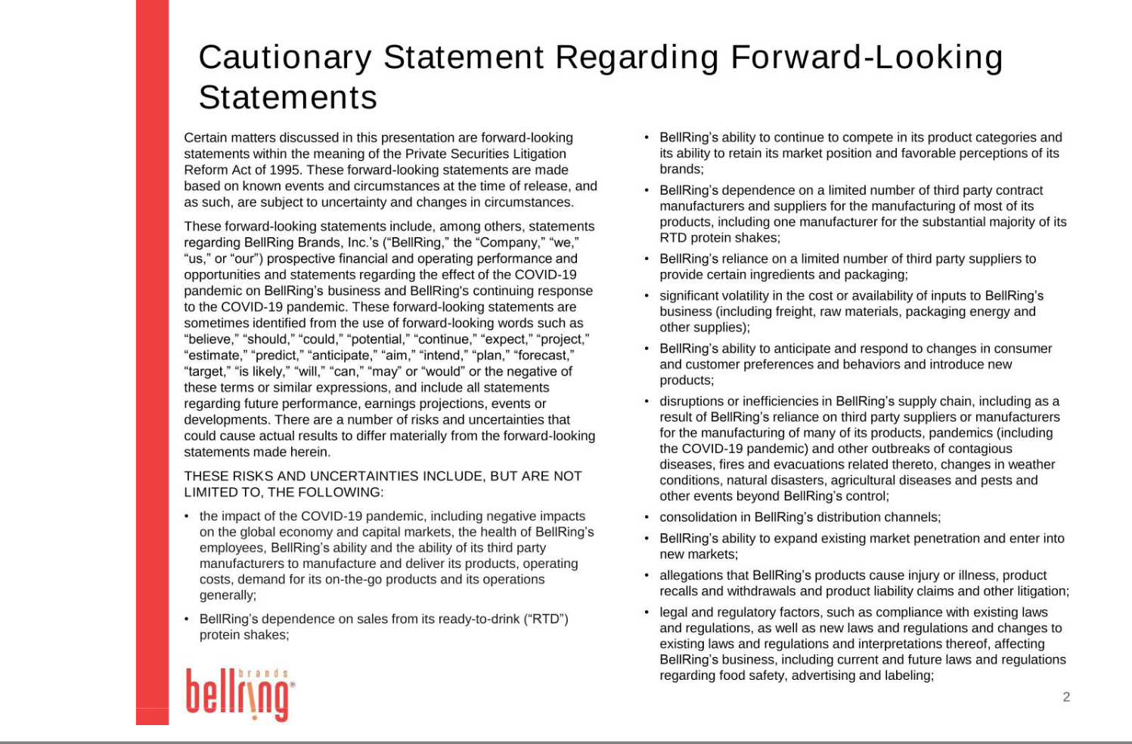

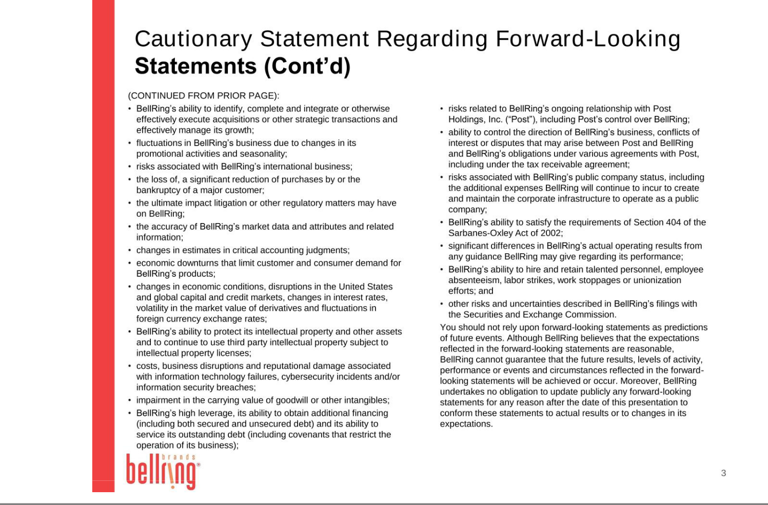

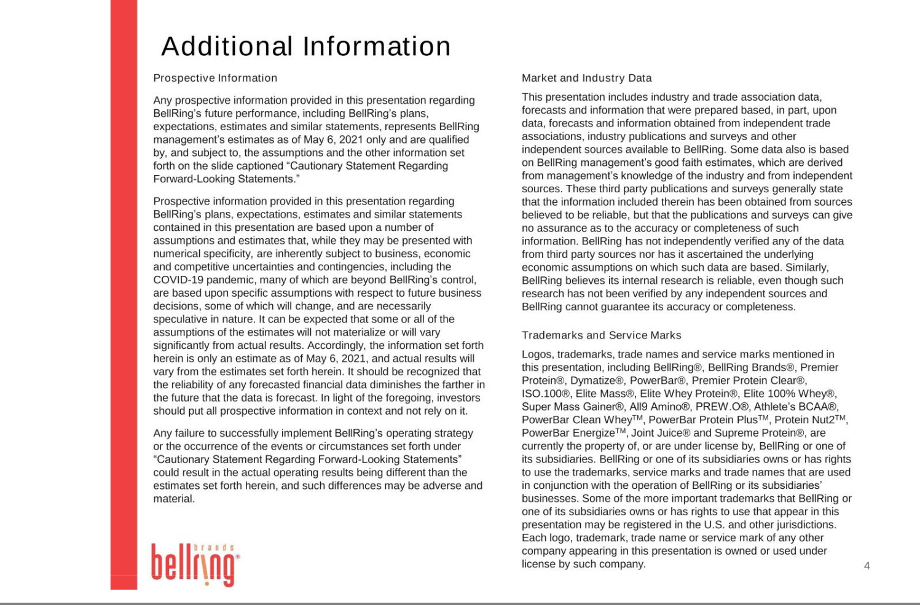

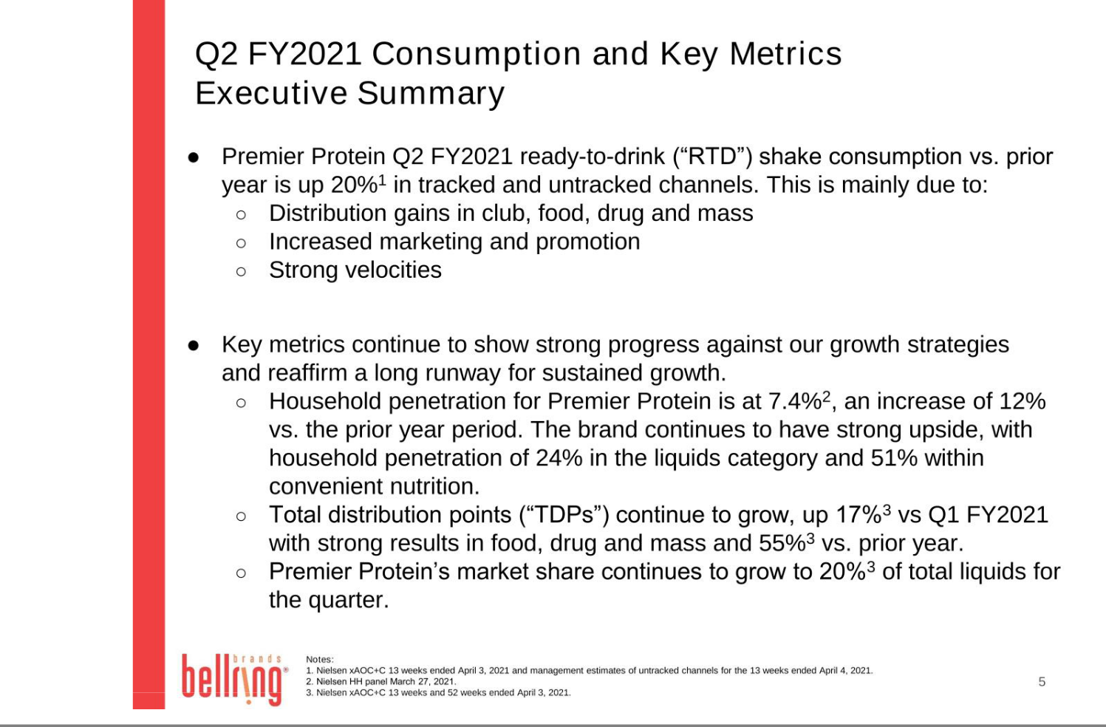

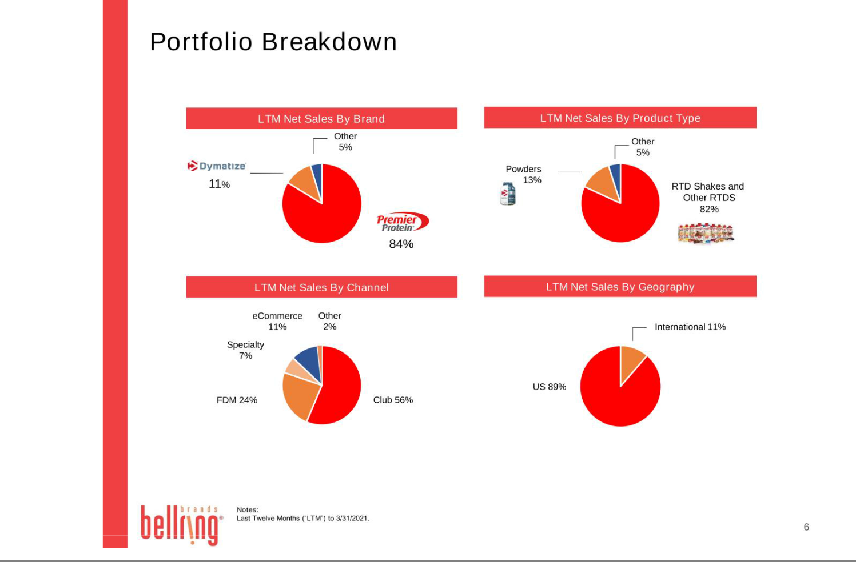

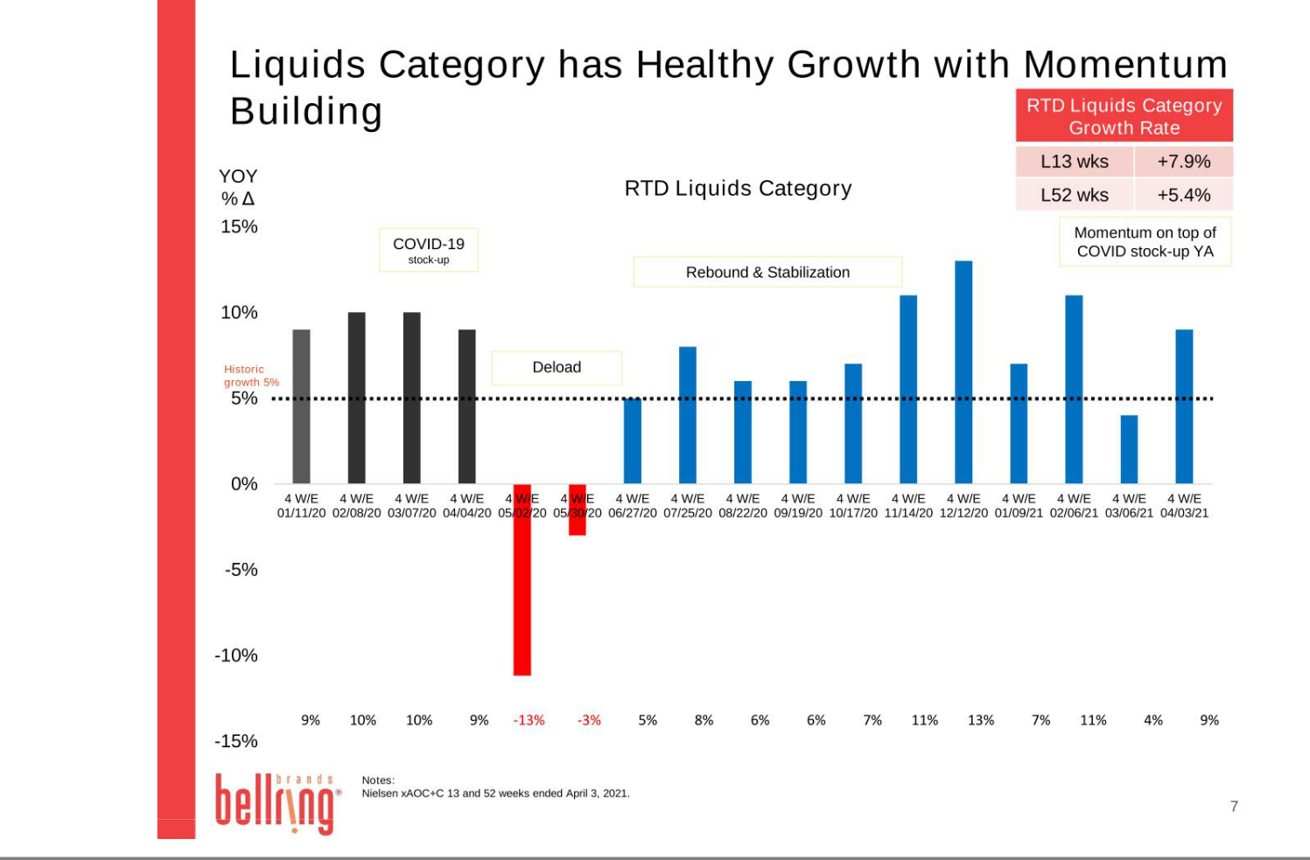

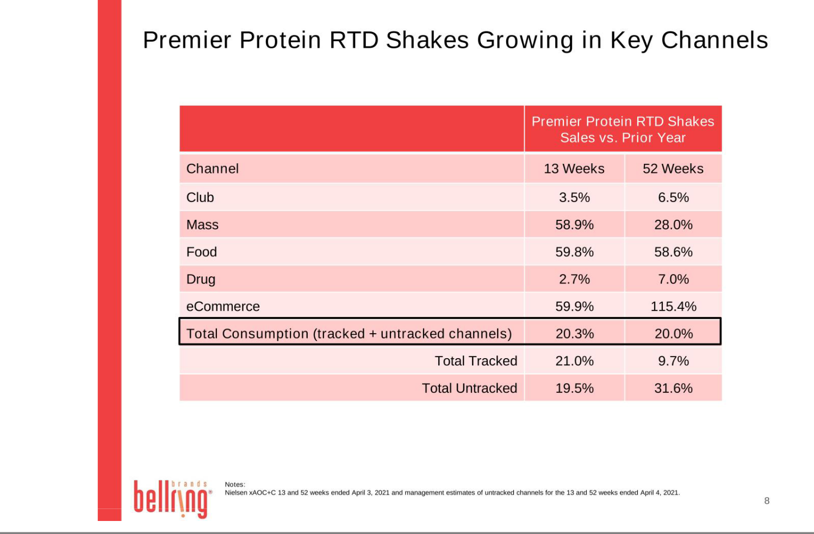

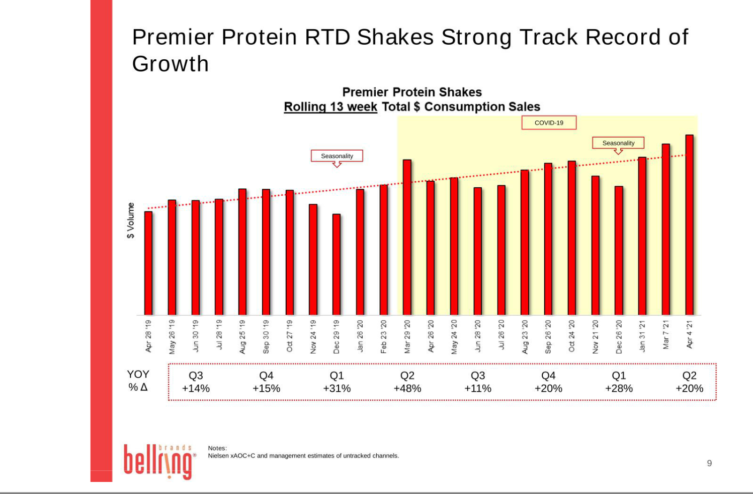

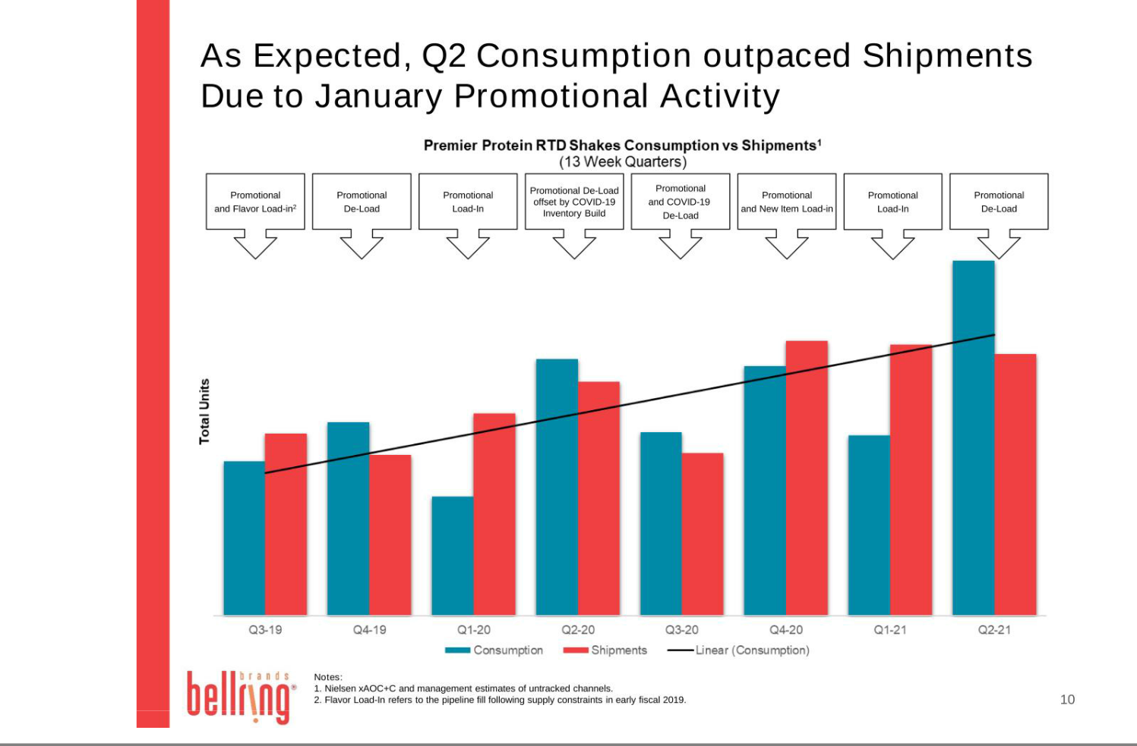

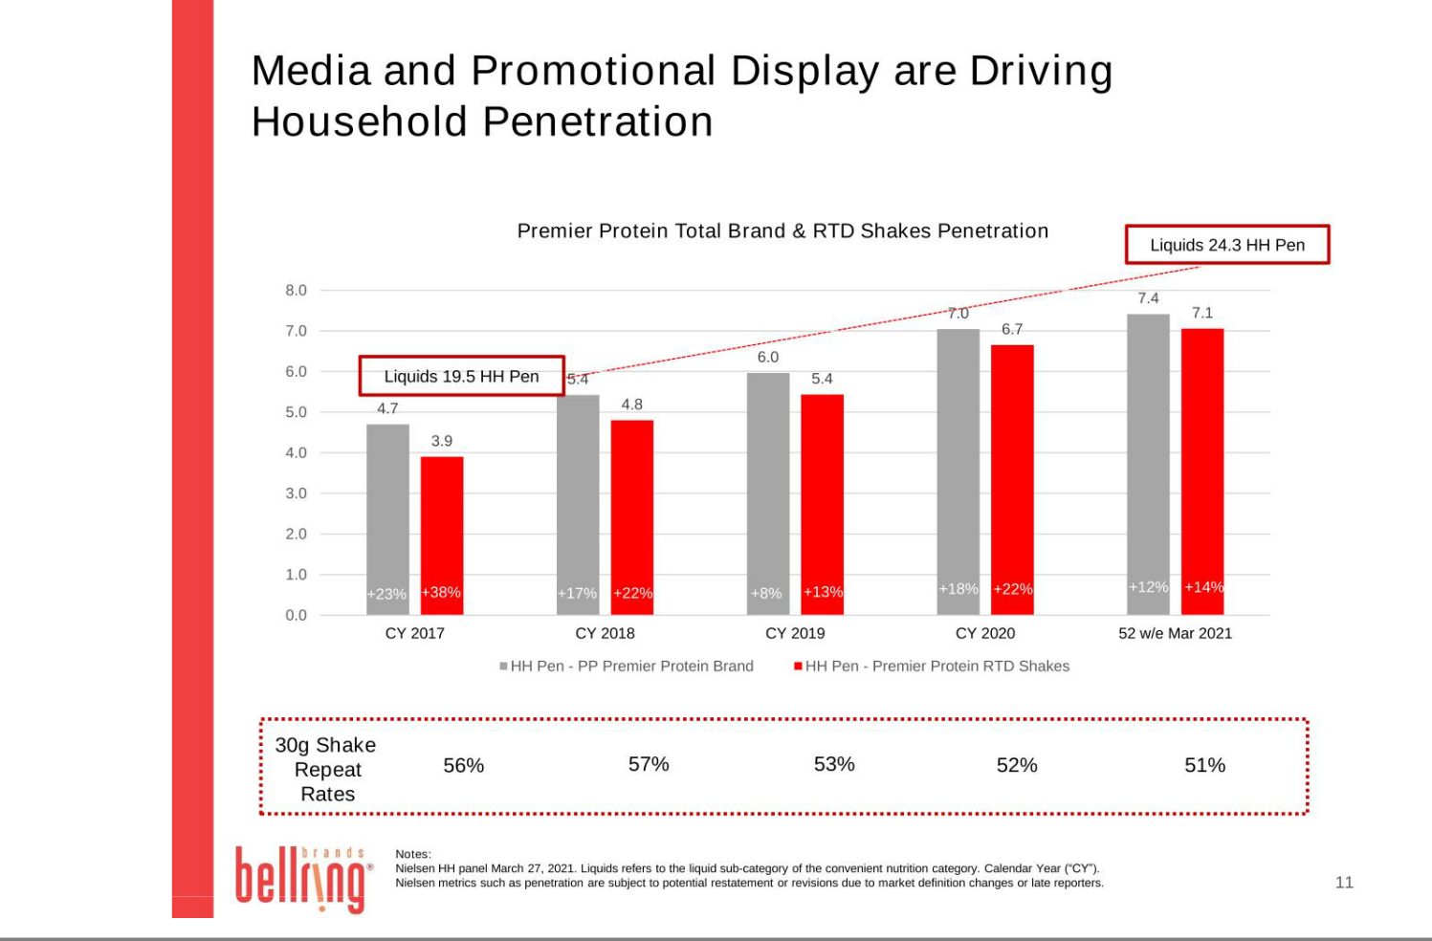

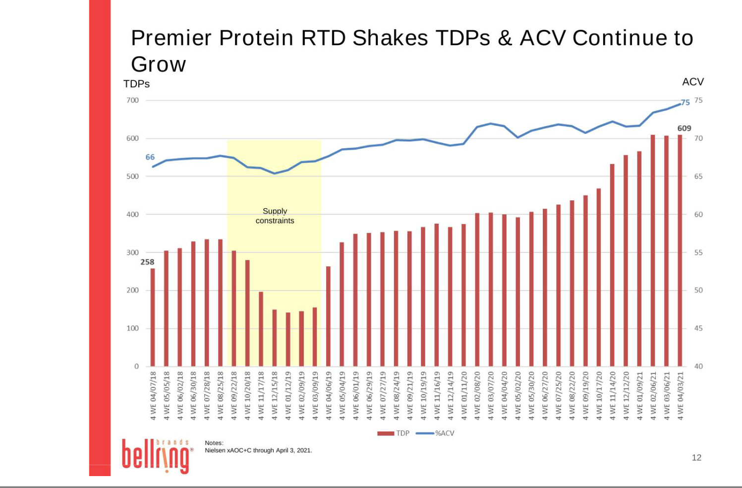

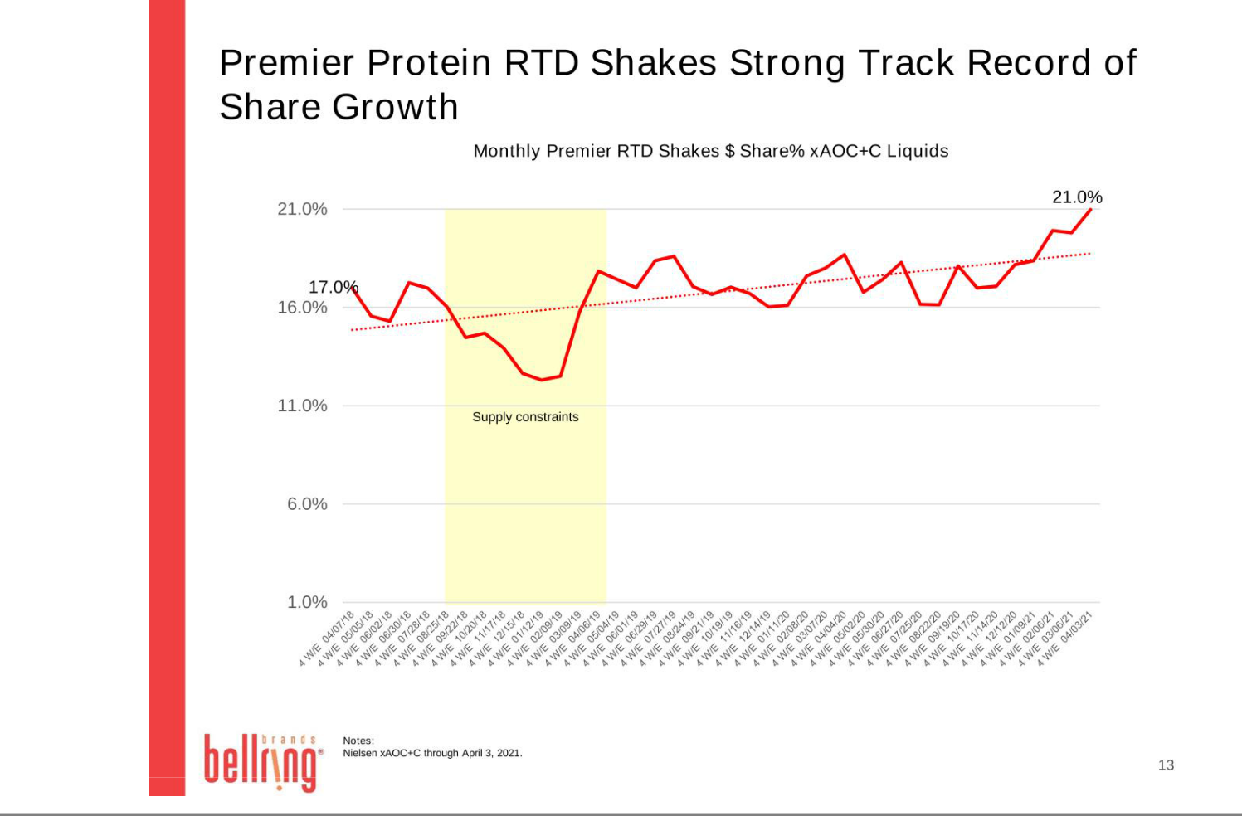



Exhibit 99.3
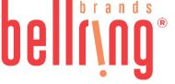

BellRing Brands Appoints Chonda Nwamu to Board of Directors

St. Louis - May 6, 2021 - BellRing Brands, Inc. (NYSE:BRBR) (“BellRing”), a holding company operating in the global convenient nutrition category, today announced that Chonda Nwamu has been appointed to its Board of Directors (the “Board”), effective May 5, 2021. With the addition of Ms. Nwamu, the Board now consists of six members.

Ms. Nwamu currently serves as the Senior Vice President, General Counsel and Secretary for Ameren Corporation, a public utility holding company. She is the primary legal advisor to Ameren’s Board of Directors and senior management, and she leads the General Counsel function, which includes the company’s legal, corporate governance, federal regulatory and legislative affairs, and enterprise ethics and compliance departments. Ms. Nwamu joined Ameren in 2016 as Vice President and Deputy General Counsel of the legal department, and was promoted to Senior Vice President in 2019. As Deputy General Counsel, she led Legal Department strategy and operations, and oversaw the department’s various practice areas including regulatory, transactional, environmental, labor and employment, and litigation and claims. Prior to joining Ameren, Ms. Nwamu served as Regulatory Counsel at a California investor-owned electric and gas utility from 2000 to May 2014 and as Managing Counsel and Senior Director from June 2014 to June 2016.

Ms. Nwamu earned her Juris Doctor degree from the University of Pennsylvania and her Bachelor of Arts degree from the University of Virginia. She previously was selected to participate as a Fellow in the Leadership Council for Legal Diversity, and the International Women’s Forum leadership programs.

Ms. Nwamu currently serves on the Board of Directors of the Boys and Girls Club of Greater St. Louis. She is committed to community service and is an advocate for diversity and inclusion in the legal profession.

About BellRing Brands, Inc.

BellRing Brands, Inc. is a rapidly growing leader in the global convenient nutrition category. Its primary brands, Premier Protein® and Dymatize®, appeal to a broad range of consumers across all major product forms, including ready-to-drink protein shakes, powders and nutrition bars, and are distributed across a diverse network of channels including club, food, drug, mass, eCommerce, specialty and convenience. BellRing’s commitment to consumers is to strive to make highly effective products that deliver best-in-class nutritionals and superior taste. For more information, visit www.bellring.com.

Contact:

Investor Relations

Jennifer Meyer

jennifer.meyer@bellringbrands.com

(314) 644-7665

Media Relations

Lisa Hanly

lisa.hanly@bellringbrands.com

(314) 665-3180

